**Dito项目管理软件**

**用户手册 V2.0**

**DITO project management**

**User manual v2.0**

# 全局说明 Global description

本系统平台为B/S开发架构，浏览器访问方式登录。支持 IE9 及以上版本及其他主流浏览器，如：谷歌浏览器等。

本系统所有权限均针对角色设置，不针对具体用户。用户可以归属一个或多个角色来获取相应的权限。

本系统权限分登录权限、菜单权限、功能权限。详见权限章节。

The system platform is based on B/S development architecture and logged in by browser access. Support IE9 and above and other mainstream browsers, such as Google browser.

All permissions in the system are set for roles, not for specific users. Users can belong to one or more roles to obtain corresponding permissions.

The system permissions are divided into login permissions, menu permissions and function permissions. See the chapter of authority for details.

## 页面说明 Page description

### 登录页面 Login page

系统登录网址： <http://www.sinohxph.com>

登录页面：

System login website: <http://www.sinohxph.com>

Login page:

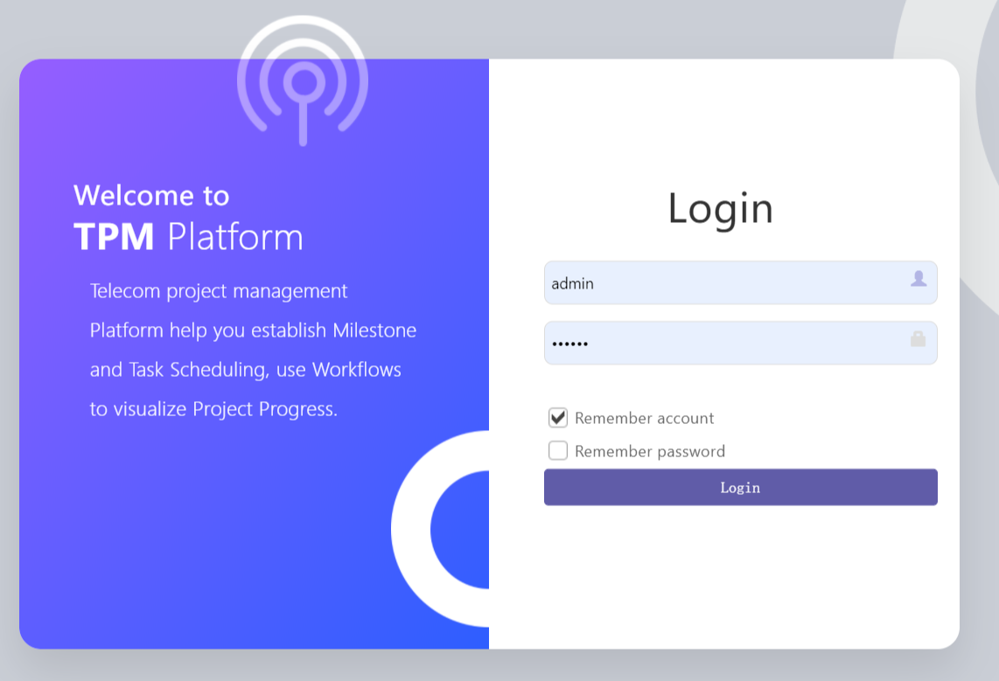

**登录页面说明：**

1. 密码不要过分简单。
2. 多次输错密码会提示输入验证码。
3. 选择“Remember accont”下次打开网址，会自动填充历史登录账户名。
4. 选择“Remember password”下次可不用输入密码直接登录。

**Login page description:**

1. The password should not be too simple.
2. If you enter the wrong password several times, you will be prompted to enter the verification code.
3. Select "Remember account" to open the web address next time, and the historical login account name will be automatically filled in.
4. Select "Remember password" to log in directly without entering a password next time.

### 工作主页面 Work main page

登录成功后显示如下页面：

After successful login, the following page is displayed:

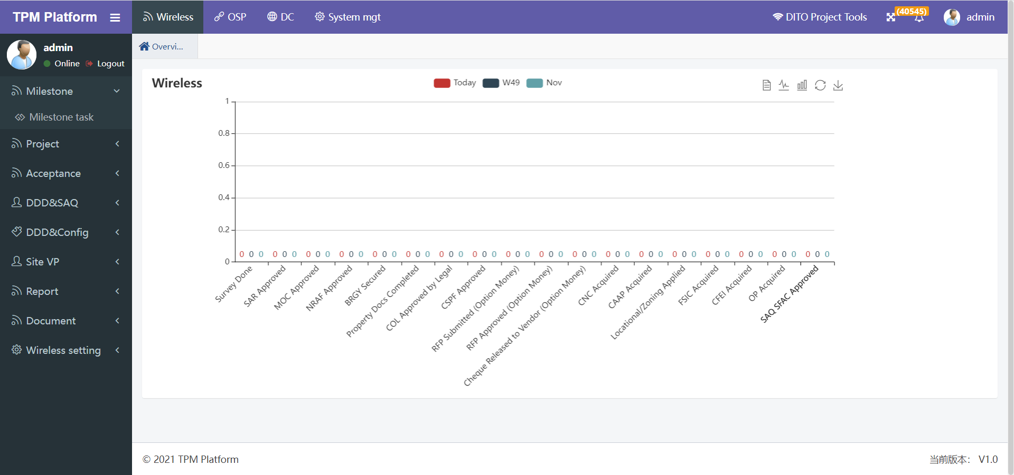

**主页面说明：**

1. TOP位置依次是：平台名称“TPM Platform”、“一级主菜单”、项目名称“DITO Project Tools”、全屏按钮、我的消息通知、我的个人信息
2. TOP下方分左右两块页面。左边是“二级菜单”，可以点击后展示“三级菜单”。右边页面是工作区域，首次登录显示定制的报表图表，点击左边三级菜单后，显示该三级菜单对应的工作页面。

**Main page description:**

1. The Top positions are: platform name "TPM platform", "primary main menu", project name "DITO Project Tools", full screen button, my message notification and my personal information
2. The bottom of Top is divided into left and right pages. On the left is the "secondary menu", which can be clicked to display the "tertiary menu". The right page is the work area. The customized report chart will be displayed after logging in for the first time. After clicking the three-level menu on the left, the work page corresponding to the three-level menu will be displayed.

## 用户说明 User description

只有存在系统中的合法用户才有登录权限。

登录系统的用户分四类：

1. 管理员：管理系统、管理用户。由开发人员赋权限，本系统页面不开放。
2. 项目组：项目管理
3. 分包商：项目分包商
4. 业主：项目业主

不同用户权限也不同，登录系统后会看到的菜单。当前可登录用户账号如下：

Only legal users in the system have login permission.

There are four types of users logging in to the system:

1. Administrator: manage system and users. Authorized by the developer, the system page is not open.
2. Project team: Project Management
3. Subcontractor: Project vendor
4. Owner: project owner

Different users have different permissions. You will see the menu after logging in to the system. Currently available user accounts are as follows:

### 管理员 Administrators

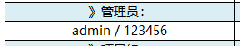

### 项目组 Project team

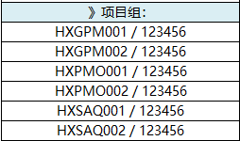

### 分包商 Subcontractor

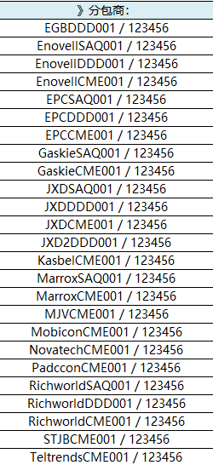

### 业主 Owner

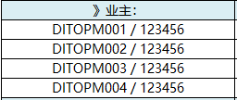

## 角色说明 Role description

用户与角色是是一对多的关系。一个用户可以归属多个角色，每个角色拥有的权限该用户均拥有。角色定义如下：

The relationship between users and roles is one to many. A user can belong to multiple roles, and each role has permissions that the user has. Roles are defined as follows:

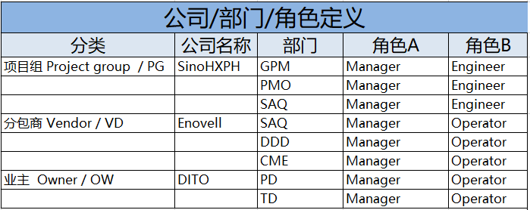

系统角色分类说明：

管理员：1个角色

项目组：3个部门，1个部门2个角色，共6个角色

分包商：3个部门，1个部门2个角色，共6个角色。

业主 ：2个部门，1个部门2个角色，共4个角色

后期角色可以任意添加。

Description of system role classification:

Administrator: 1 role

Project team: 3 departments, 1 Department, 2 roles, 6 roles in total

Subcontractor: 3 departments, 1 Department, 2 roles, 6 roles in total.

Owner: 2 departments, 1 Department, 2 roles, 4 roles in total

Later roles can be added at will.

## 权限说明 Authorization description

### 菜单权限 Menu authorization

1. 菜单由角色来控制。不同的角色可以赋予不同菜单权限。该角色用户登录后只能看到其归属角色下的菜单。
2. 菜单的权限需要管理员才能操作。
3. 新建用户是看不到任何菜单的，也即没有任何权限。需要赋予权限才能正常使用。
4. 菜单赋权需要管理员角色登录，在详见菜单：  
   “System mgt”->“System setting” -> “Role manage”中
5. Menus are controlled by roles. Different roles can give different menu permissions. Users in this role can only see the menu under their own role after logging in.
6. The permissions of the menu need to be operated by an administrator.
7. New users cannot see any menus, that is, they do not have any permissions. Permission is required for normal use.
8. You need to log in as an administrator in the menu. See the menu for details:

"System Mgt" - > "system setting" - > "role management"

### 功能权限 Function authorization

* **功能权限是指同一个菜单功能中，用户可以查看、操作的权限。比如：**

1. 可以指定用户只能查看基站基础数据，但不能修改，也可以即能查看也允许修改。
2. 可以指定用户只能查看或修改某一基站指定的字段信息数据。
3. 可以指定用户只能操作指定的基站，如某一分包商只能看到和操作归属他的基站。

* **Function permission refers to the permission that users can view and operate in the same menu function. For example:**

1. You can specify that users can only view the basic data of the SITE, but cannot modify it, or they can view it or modify it.
2. You can specify that users can only view or modify the field information data specified by a site.
3. You can specify that the user can only operate the specified site. For example, a vendor can only see and operate the site belonging to him.

* **对于功能权限，最主要的有如下两个：**

1. **基站权限控制**

由角色控制那些用户可以看到那些基站，当前基站权限逻辑如下：

* **For function permissions, the following two are the most important:**

1. **Site authority control**

The role controls which users can see which sites. The current site permission logic is as follows:

|  |  |  |
| --- | --- | --- |
| **角色** | **基站权限** | **备注** |
| 管理员 | 全部基站 |  |
| 项目组 | 全部基站 |  |
| 分包商SAQ | 归属于该SAQ分包商的基站 | SAQVendor字段等于该分包商 |
| 分包商DDD | 归属于该DDD分包商的基站 | DDDVendor字段等于该分包商 |
| 分包商CME | 归属于该CME分包商的基站 | CMEVendor字段等于该分包商 |
| 业主 | 全部基站 |  |

1. **基站字段权限控制**

由角色控制那些用户可以看到基站的那些字段，

1. 每个字段其实就对应EXCEL文档中的某个任务列，也可以理解成一个任务。
2. 当前所有任务都是日期类型的字段。
3. 具体赋权详见菜单：

“Wireless” -> ” System mgt” -> ”Role column”中，字段数量比较多，这里不罗列。

1. **Site field permission control**

The role controls the fields that users can see in the site,

1. Each field actually corresponds to a task column in the excel document, and can also be understood as a task.
2. All current tasks are date type fields.
3. See menu for details:

There are many fields in “Wireless” -> ” System mgt” -> ”Role column”, which are not listed here.

|  |  |  |
| --- | --- | --- |
| **角色** | **字段权限** | **备注** |
| 管理员 | 全部字段 |  |
| 项目组 | 角色中分配的字段（当前是全部字段） | 如以后有新增字段，需角色中赋权 |
| 分包商SAQ | 角色中分配的字段 |  |
| 分包商DDD | 角色中分配的字段 |  |
| 分包商CME | 角色中分配的字段 |  |
| 业主 | 角色中分配的字段 |  |

# 首页功能 OverView function

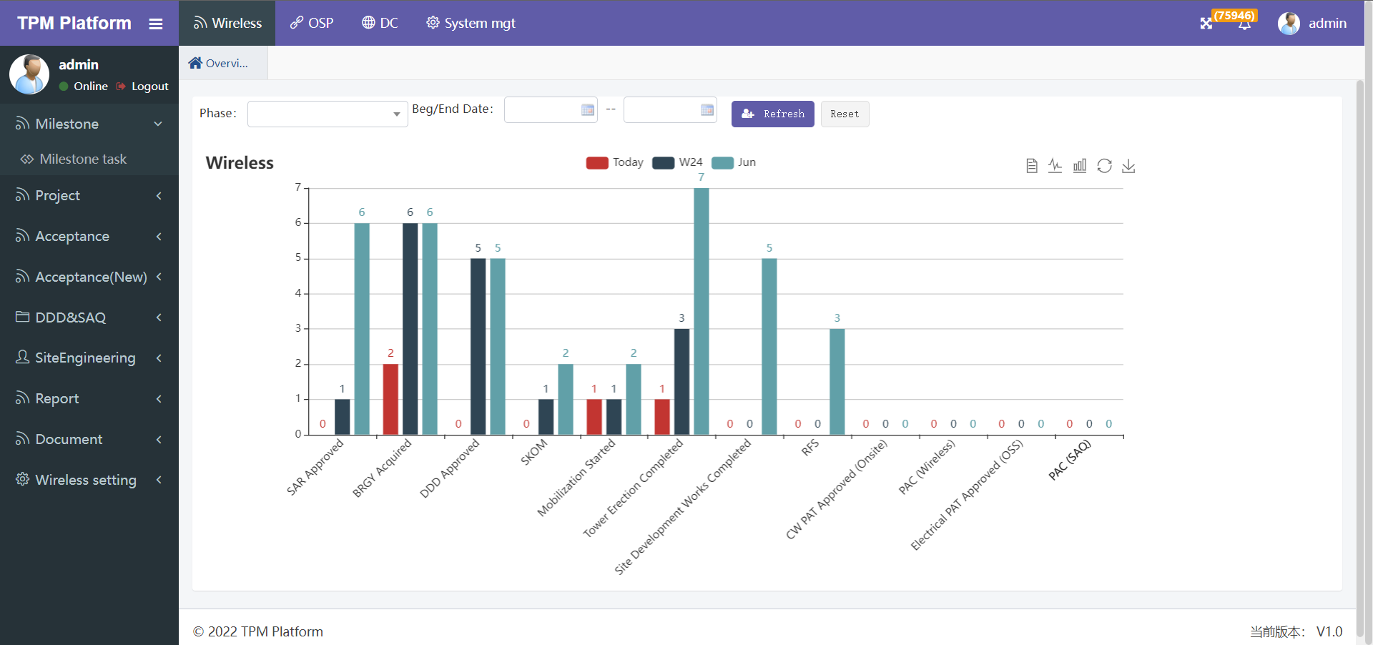

登陆后首页如上所示。

1. 首页柱状图对应的报表在报表定义菜单中定义。只要该报表命名中包含“overview”，就会被选做首页显示。
2. 柱状图默认显示各个milestone近三段时间的数据：今天、本周、本月。
3. 第一行选择选项可选：基站phase范围、起始时间段，点击搜索后，会在柱状图显示第4根柱子，表示选择范围内的数据。如下：

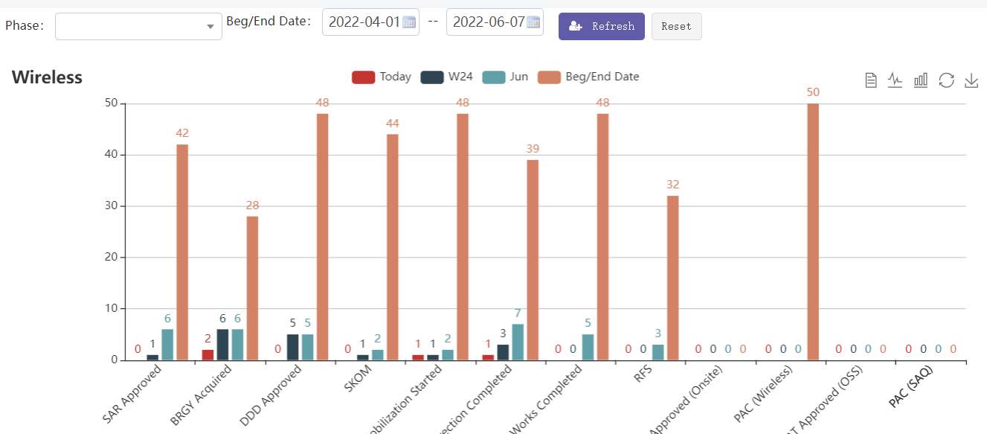

1. 当鼠标移动到柱状图前3根柱子，则显示该柱子对应的所有基站名称SITEID。如下图所示：

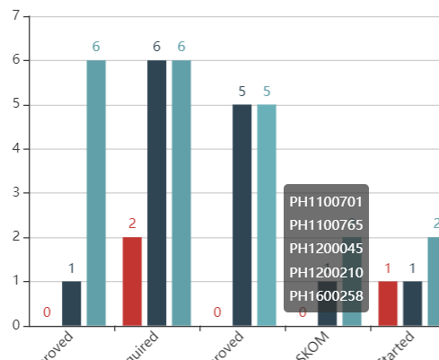

1. 首页报表数据excel格式文档，每日定时邮件发送给相关人员。相关人员在报表模块“[DailyReportMailUser](http://127.0.0.1:8080/yctpm/a/sys/menu/form?menuCode=1486519045426982912)”中设置。

After logging in, the home page is as shown above.

1. The report corresponding to the histogram on the home page is defined in the report definition menu. As long as the report name contains "overview", it will be selected for the first page display.
2. By default, the histogram displays the data of each milestone in the past three periods: today, this week, and this month.
3. The selection options in the first line are optional: site phase range, starting time period, after clicking search, the fourth column will be displayed in the histogram, indicating the data within the selection range. as follows:



1. When the mouse moves to the first 3 columns of the histogram, all site names SITEID corresponding to the column will be displayed. As shown below：



1. The report data on the home page is in excel format, and is sent to the relevant personnel by regular daily emails. The relevant personnel are set in the report module "DailyReportMailUser"。

# 菜单功能 Menu function

## Wireless

### Milestone

#### Milestone task

**工作里程碑管理**

**Work Milestone Management**

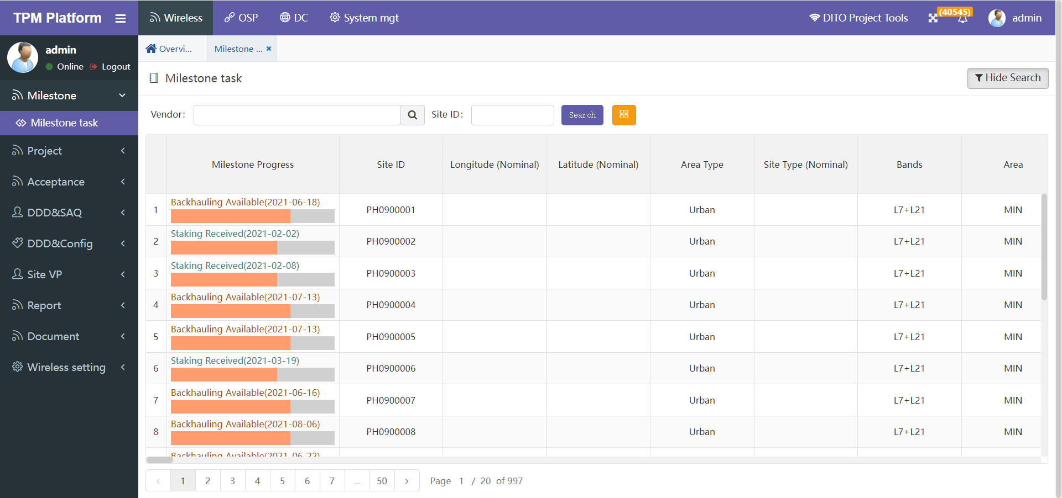

* **功能说明：Function Description:**

1. 本功能主要为项目组和分包商管理项目流程日常工作使用。
2. 首列显示的是该基站当前最新的里程碑及日期。黄色进度条表示当前进度情况。  
   计算公式：当前已完成里程碑数量 / 所有里程碑数量 * 100%
3. 基站会更加用户角色过滤，仅展示该角色权限下的基站。目前分项目组业主组 和 分包商组，前者可以看到所有基站，后者只能看到归属于自己分包商的基站。

对于分包商的身份判断逻辑说明：用户归属哪个分包商，在用户属性：Office中控制；用户归属的分包商类别（SAQ\DDD\CME），在用户属性：角色中控制。

1. 项目组和分包商登录后可查看到各自可以管理的Milestone字段信息，橙色表示可以操作，可操作的内容有：修改日期，上传文档、上传图片、下载文档、下载图片。  
   角色与字段权限对应关系，详见菜单：“Wireless” -> ” System mgt” -> ”Role column”。
2. “Search”功能：可通过Vendor和Site ID搜索符合条件的基站。
3. 黄色按钮”Column select”是选择本页面需要显示哪些Milestone，因为Milestone数量较多可选择少量显示，便于操作。
4. This function is mainly used by the project team and vendors to manage the daily work of the project process.
5. The first column shows the latest milestone and date of the site. The Yellow progress bar indicates the current progress.

Calculation formula: number of currently completed milestones / number of all milestones * 100%

1. The SITE will be more user role filtering, and only the Site under the permission of the role will be displayed. At present, the owner group and the vendor group of the sub project group can see all sites, while the latter can only see the sites belonging to its own vendors.

For the logic description of vendor identity judgment: which vendor the user belongs to is controlled in user attribute: office; The vendor category (SAQ \ DDD \ CME) to which the user belongs is controlled in user attribute: role.

1. After logging in, the project team and vendors can view the milestone field information that they can manage. Orange indicates that they can operate. The operable contents include: modification date, upload document, upload picture, Download document and download picture.

For the corresponding relationship between roles and field permissions, see the menu: “Wireless” -> ” System mgt” -> ”Role column”

1. "Search" function: search qualified sites through vendor and site ID.
2. The yellow button "Column select" is used to select which milestones need to be displayed on this page. Because there are a large number of milestones, you can select a small number to display for easy operation.

* **Milestone的操作界面：Operation interface of milestone:**

点击下图橙色日期后的编辑图标，可进入该Milestone的操作界面

Click the edit icon after the orange date in the figure below to enter the milestone operation interface

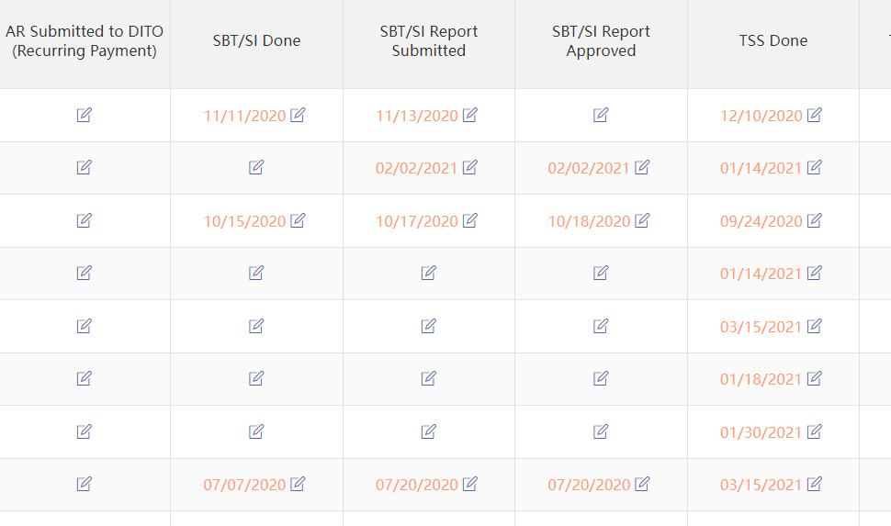

* **操作界面 Operation page**

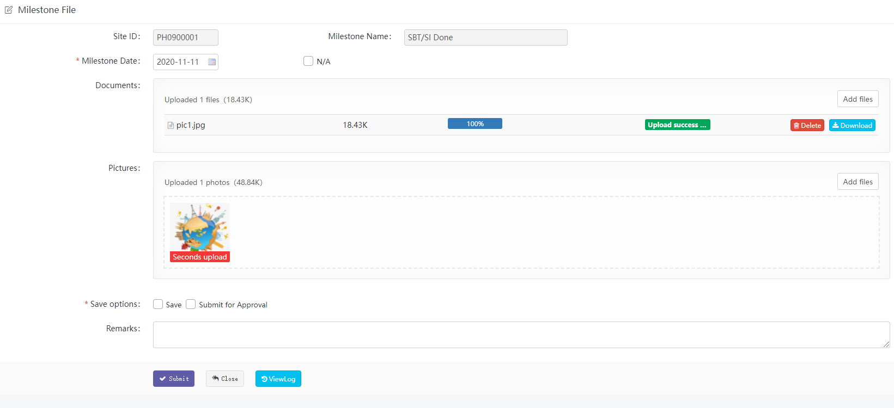

1. “Site ID” 和 “Milestone Name”不可编辑。
2. “Milestone Date” 是Milestone完成日期，与下面的”N/A”两者必选一项。
3. “N/A表示该Milestone不需要输入日期，无日期概念。
4. “Documents”表示该Milestone需要上传的文档。
5. “Pictures”表示该Milestone需要上传的图片。
6. “Save options”表示保存类型。一种是”Save”，表示只保存不递交。另一种是：”Submit for Approval”表示保存并且递交。区别是前者状态下还可以多次修改，后者递交后就不能再修改，等待下一步流程用户来审核。如果选择了”Submit for Approval”，则还需选择通知的用户：



根据你的选择，系统会邮件通知该用户来审核。

1. “Remarks”可输入备注信息。
2. “Site ID” and “Milestone Name” are not editable.
3. "Milestone Date " is the Milestone completion date, which must be selected from”N/A” below.
4. ”N/A” means that the Milestone does not need to enter a date, and there is no date concept.
5. "Documents" indicates the documents to be uploaded by the milestone.
6. "Pictures" indicates the pictures to be uploaded by the milestone.
7. "Save options" indicates the save type. One is " Save ", which means only save but not submit. The other is: "Submit for approval" means save and submit. The difference is that the former can be modified several times in the status, while the latter cannot be modified after submission, waiting for the next process user to approve. If ”Submit for Approval” is selected, you also need to select the user to be notified:

According to your choice, the system will email the user to approve.

1. "Remarks" to enter comments.

* **Milestone流程 Milestone process**

1. Milestone的文档上传、审批等每次流程信息，只要有数据就会展示在操作页面：

Milestone's document upload, approval and other process information will be displayed on the operation page as long as there is data:

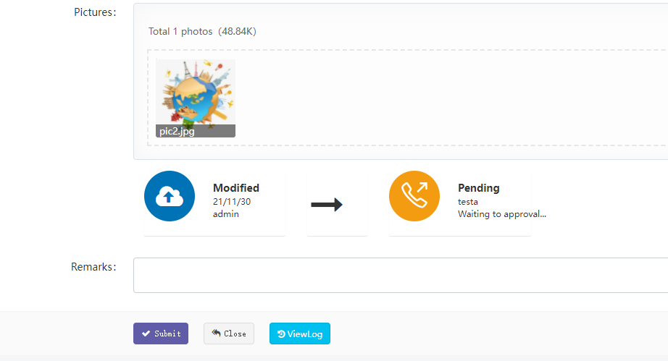

1. “ViewLog”可查看所有历史流程操作记录。

" ViewLog " can view all historical process operation records.

### Project

#### Database

本菜单主要管理基站所有配置参数。

This menu mainly manages all configuration parameters of the Site.

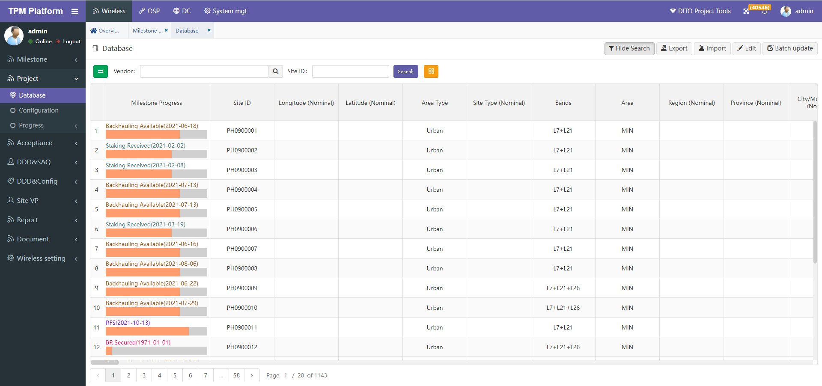

* **功能说明： Function description**

1. 本功能主要为项目组维护管理配置参数使用。

This function is mainly used by the project team to maintain and manage configuration parameters

1. 首列显示的是该基站当前最新的里程碑及日期。黄色进度条表示当前进度情况。

计算公式：当前已完成里程碑数量 / 所有里程碑数量 * 100%

The first column shows the latest milestone and date of the site. The Yellow progress bar indicates the current progress.

Calculation formula: number of currently completed milestones / number of all milestones * 100%

1. 基站查询“Search”功能有两种搜索方式：通过页面左边绿色箭头按钮可以切换。

The BTS query "search" function has two search methods: you can switch through the green arrow button on the left of the page.  
1）一般查询：可通过Vendor（多选）和Site ID（模糊查询）搜索符合条件的基站。

General query: search for qualified sites through vendor (multiple choice) and site ID (fuzzy query).

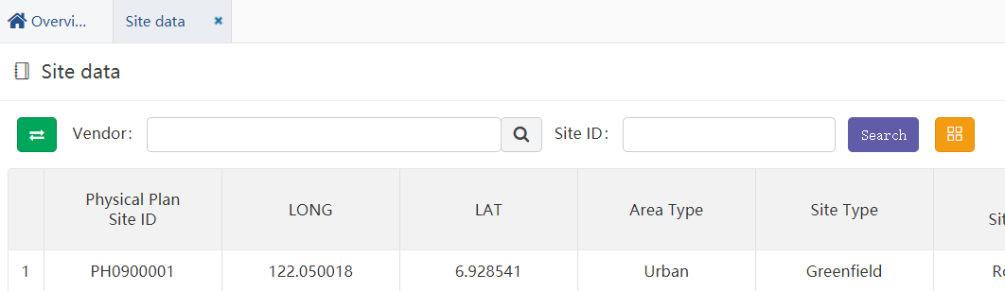

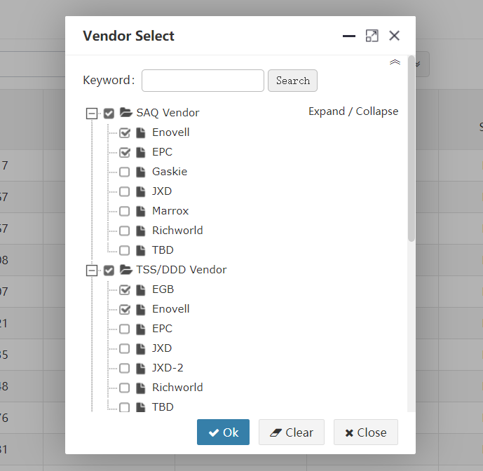

2）自定义查询：可通过预先定义好的“基站搜索策略”和“字段搜索策略”过滤。

User defined query: it can be filtered through predefined "site search strategy" and "field search strategy".

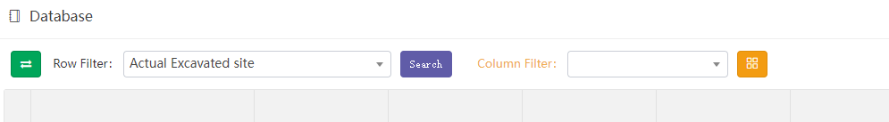

* 选择“Row filter”下拉框中已定义策略，根据权限用户能看到自己定义的和其他人公开的策略，再点search按钮可根据策略过滤搜索基站。策略定义具体见菜单：“Wireless”->“Wireless setting”-> “Filter” ->“Row filter”。

Select the policies defined in the "row filter" drop-down box. Users can see the policies defined by themselves and disclosed by others according to their permissions, and then click the search button to filter and search the site according to the policies. See the menu for policy definition: “Wireless”->“Wireless setting”-> “Filter” ->“Row filter”.

* 选择“Column filter”下拉框中已定义的列过滤筛选策略。可以过滤策略中定义的字段。如何建列筛选策略详见菜单：
* “Wireless”->“Wireless setting”-> “Filter” ->“Col filter”。

Select the defined column filter policy in the column filter drop-down box. You can filter the fields defined in the policy. How to create a filter policy is detailed in the menu:

“Wireless”->“Wireless setting”-> “Filter” ->“Col filter”。

1. 黄色按钮”Column select”是选择本页面需要显示哪些字段，因为字段数量较多可选择少量显示，便于操作。

The yellow button " Column select" is used to select which fields need to be displayed on this page. Because there are a large number of fields, you can select a small number to display for easy operation.

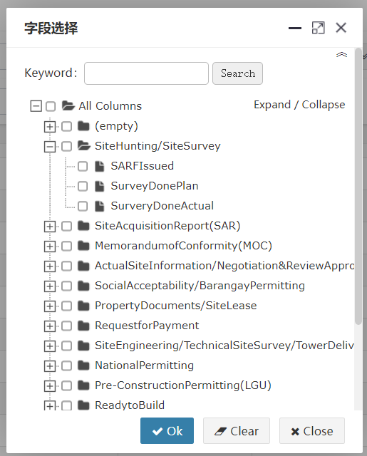

虽然列选择策略已经在列策略中可以自定义，但考虑到本系统基站字段特别多，且平常在工作中可能会经常频繁的想变更查看某些字段信息，所以可以随时筛选你想查下的字段，但不会保留记忆，如需记忆，在自定义中定义。

Although the column selection strategy can be customized in the column strategy, considering that there are many fields in the site of the system, and you may often want to change and view some field information in your work, you can filter the fields you want to check at any time, but the memory will not be retained. If you need to remember, define it in customization

1. “Export” 导出所有基站数据（Excel文档）到本地。根据页面所筛选的数据行和数据列，点导出时，系统会导出当前页面所有分页的基站数据，所见即所得。

"Export" exports all site data (excel document) to the local. According to the data rows and columns filtered on the page, when clicking export, the system will export the site data of all pages on the current page, What you see is what you get.

1. “Import” 导如基站数据（Excel文档）到平台。可选项：覆盖导入 和 追加导入。如果是覆盖导入，则根据Site ID匹配覆盖原有数据。此功能慎用！有可能会导致数据被误操作清除。导入时除非勾选了是否覆盖导入，否则都是追加导入数据。

"Import" imports the site data (Excel document) to the platform. Optional: overwrite import and append import. If it is an overwrite import, the original data will be overwritten according to the Site ID match. Use this function with caution! It may cause the data to be cleared by misoperation. During import, the imported data is appended unless overwrite import is checked.

**举例：**导入基站数据步骤

**Example**: importing site data

* **步骤一 Step 1**

导入基站前先下载EXCEL数据模板，点击按钮“Import”在弹出窗口中点击“Download template”：

Download the Excel data template before importing the Site, click "import" and click "download template" in the pop-up window:

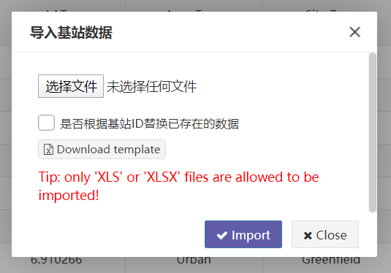

* **步骤二 Step 2**

在下载的模板文档中，拷贝700多个基站数据，并检查数据正确性：

检查这些字段不能为空：“Physical Plan Site ID”、“Province”、“SAQ Clustering”、“SAQ Vendor”、“TSS/DDD Vendor”、“CME Vendor”

In the downloaded template document, copy more than 700 site data and check the correctness of the data:

Check that these fields cannot be empty: “Physical Plan Site ID”、“Province”、“SAQ Clustering”、“SAQ Vendor”、“TSS/DDD Vendor”、“CME Vendor”

* **步骤三 Step 3**

点击选择文件，选择你要导入的excel文件。

Click Select File and select the excel file you want to import.

* **步骤四 Step 4**

选择是否勾选“是否根据基站ID替换已存在的数据”。如勾选则会覆盖相同Physical Plan Site ID的基站数据。如果不勾选，则当遇到相同ID时提示且全部数据导入失败。

注：导入时系统会验证每个字段是否正确，只要有一个验证不通过，则全部导入失败，待修改正确后重新导入。

Select whether to check "replace existing data according to site ID". If checked, the site data with the same physical plan site ID will be overwritten. If unchecked, a prompt will appear when the same ID is encountered and all data import fails.

Note: when importing, the system will verify whether each field is correct. As long as one of the fields fails to pass the verification, all the fields will fail to import. Import again after the modification is correct.

1. 编辑基站：点击编辑按钮，页面进入编辑模式，再次点击退出编辑模式：

Edit site: click the Edit button, the page will enter the edit mode, and click again to exit the edit mode:

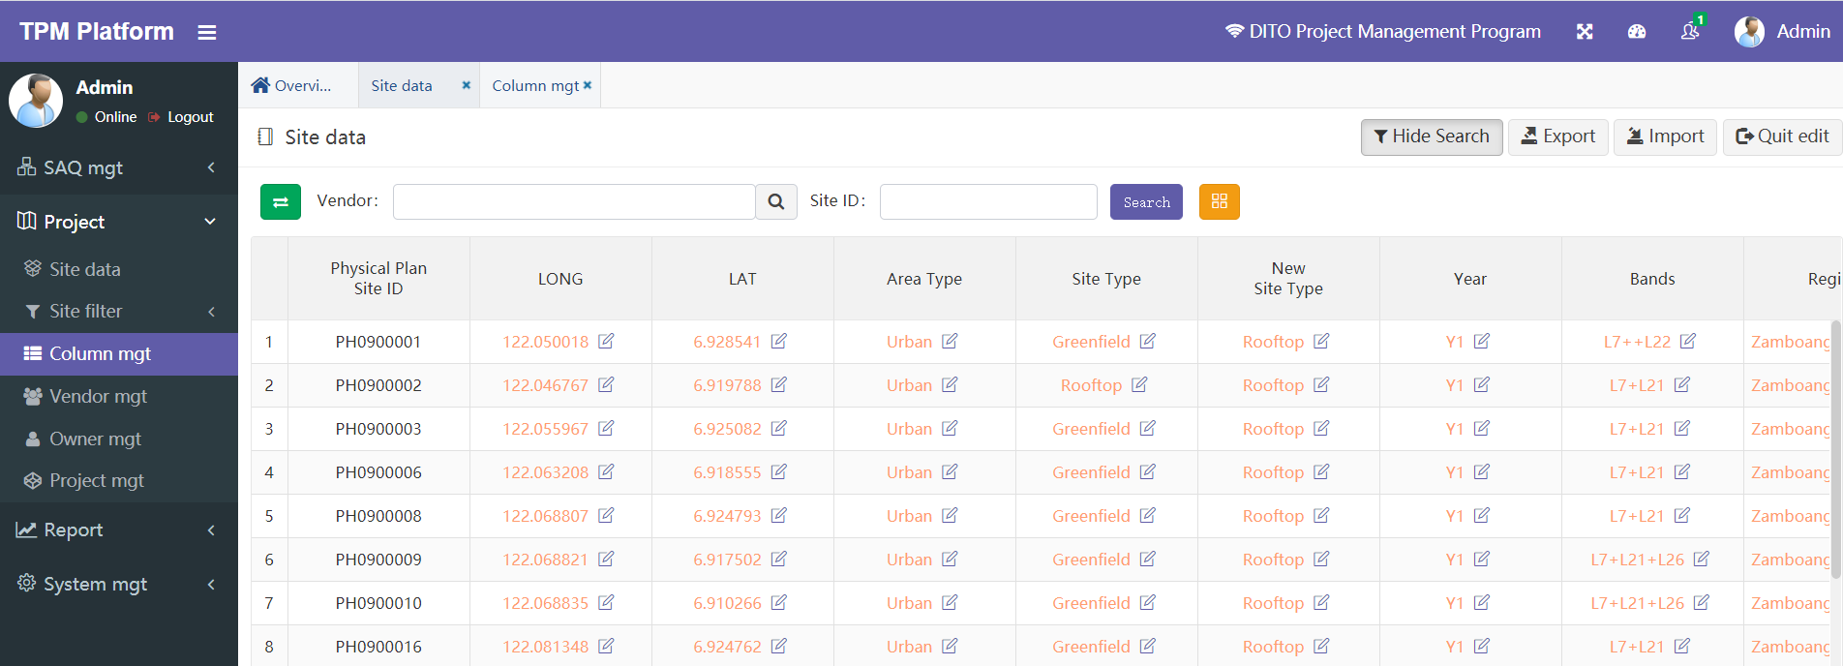

* 点击任何一个单元格，即可进入编辑该单元格的详情页，除“Physical Plan Site ID”、“Province”外其他字段均可编辑。

“Physical Plan Site ID”不能修改是因为它是唯一标识基站编号的数据。“Province”不能修改是因为“Province”与“SAQ Clustering”父子关系，当用户选择了“SAQ Clustering”，则“Province”已经唯一确定。

Click any cell to enter the details page of editing the cell. Other fields can be edited except "Physical Plan Site ID" and "Province".

"Physical Plan Site ID" cannot be modified because it is the data that uniquely identifies the site number. "Province" cannot be modified because of the parent-child relationship between "province" and "SAQ Clustering". When "SAQ Clustering" is selected, the "Province" has been uniquely determined.

* 当前权限只有管理员与项目组可以修改。

Current permissions can only be modified by administrators and project groups

* 不同单元格数据类型会有不同的展示，类型有：文本、整数、日期、小数。

Different cell data types have different displays, including text, integer, date and decimal

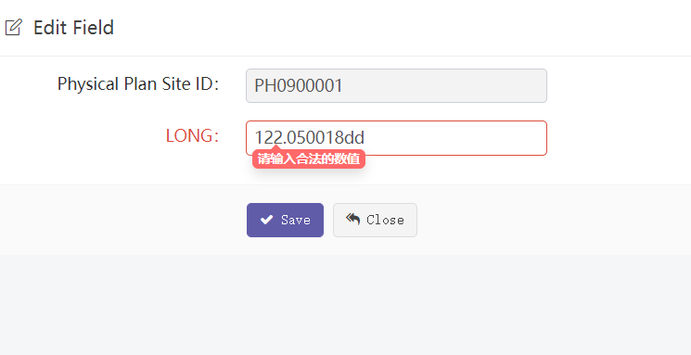

系统会对输入的数据类型做验证，整数字段输入框不能输入字母等。

The system will verify the input data type. Letters cannot be entered in the integer field input box.

* 有四个特殊类型的字段：“SAQ Clustering”、“SAQ Vendor”、“TSS/DDD Vendor”、“CME Vendor”这四个字段会弹出下拉框供选择输入：

There are four special types of fields: “SAQ Clustering”、“SAQ Vendor”、“TSS/DDD Vendor”、“CME Vendor”. Drop down boxes will pop up for selection and input:

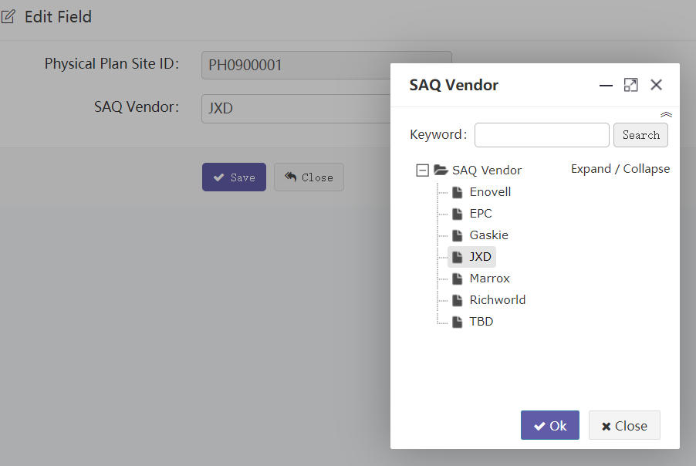

1. “Batch update” 更新指定基站配置参数数据（Excel文档）。如果需要对某些基站的某几个字段更新值，则可以选择此功能。

"Batch update" updates the specified site configuration parameter data (excel document). You can select this function if you need to update the values of some fields of some sites.

#### User column

对于Database中的基站参数数据，由于安全原因考虑，对不同的用户可以设置不同的可操作权限。

For Database parameter, for security reasons, different operational permissions can be set for different users.

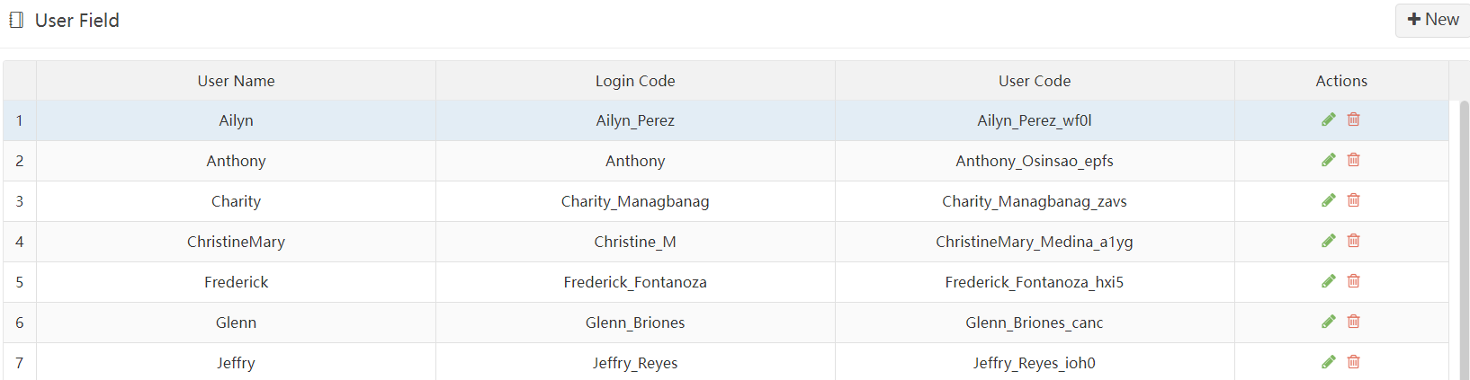

点按钮New可新增权限用户，赋予字段权限的页面如下：

Click the button New to add a user with permission. The page for granting field permission is as follows:

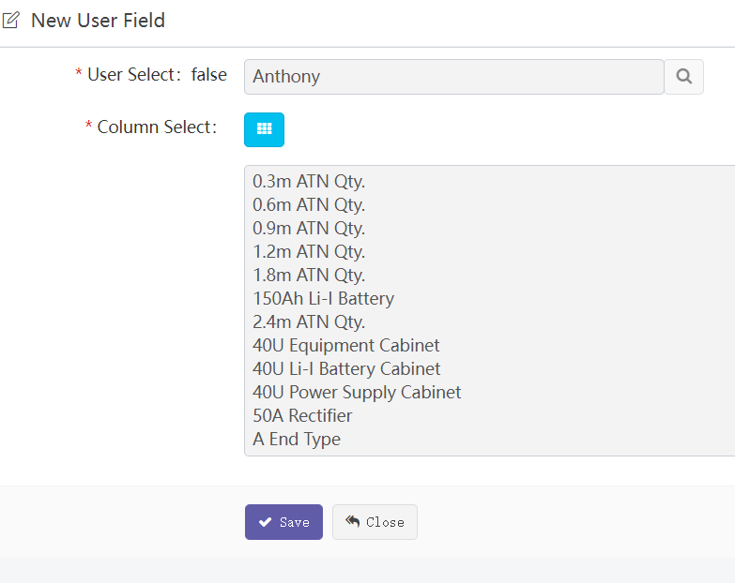

1. 选择要新增或编辑权限的用户名称。
2. 选择可操作的基站参数字段。

设置完成后，该用户进入Database，只能看到和操作权限赋予的字段。

1. Select the user name to be added or edited.
2. Select the Actionable Site Parameters field.

After the setting is completed, the user enters the Database and can only see and operate the fields granted by the permission.

#### Project Daily Report

为了让指定用户只能修改指定基站的部分配置参数。预先定义好基站筛选策略和字段筛选策略。

此菜单具有的操作功能基本同：“Wireless” -> ” Project” ->” Database”。是其功能子集。含：搜索、导出、单个修改字段、批量修改字段。

区别是用户只能看到如下筛选过的数据：

1. 基站筛选策略默认为：“Phase 2 FTK Special - 64 Sites”
2. 字段筛选策略默认为：“Project Daily Report”

In order to allow some users to only modify the specified configuration parameters of the specified site. Define the site filtering strategy and field filtering strategy in advance.

The operation functions of this menu are basically the same as: " Wireless " - > " Project " - > " Database ". Is a subset of its functions. Including: search, export, single modification field and batch modification field.

The difference is that users can only see the following filtered data:

1. The Site filtering policy defaults to "Phase 2 FTK Special - 64 Sites "
2. The default field filtering policy is "Project Daily Report "

#### Progress

##### Summary(All)

为了让部分用户只能修改指定基站的指定配置参数。预先定义好基站筛选策略和字段筛选策略。

此菜单具有的操作功能基本同：“Wireless” -> ” Project” ->” Database”。是其功能子集。含：搜索、导出、单个修改字段。

区别是用户只能看到如下筛选过的数据：

1. 基站筛选策略默认为：“759 站点”
2. 字段筛选策略默认为：“Summary(All)”

In order to allow some users to only modify the specified configuration parameters of the specified site. Define the site filtering strategy and field filtering strategy in advance.

The operation functions of this menu are basically the same as: “Wireless” -> ” Project” ->” Database”. Is a subset of its functions. Including: search, export and single modification fields.

The difference is that users can only see the following filtered data:

1. The Site filtering policy defaults to "759 sites"
2. The default field filtering policy is "Summary(All)"

##### Summary(Milestone)

为了让部分用户只能修改指定基站的指定配置参数。预先定义好基站筛选策略和字段筛选策略。

此菜单具有的操作功能基本同：“Wireless” -> ” Project” ->” Database”。是其功能子集。含：搜索、导出、单个修改字段。

区别是用户只能看到如下筛选过的数据：

1. 基站筛选策略默认为：“759 站点”
2. 字段筛选策略默认为：“Summary(Milestone)”

In order to allow some users to only modify the specified configuration parameters of the specified site. Define the site filtering strategy and field filtering strategy in advance.

The operation functions of this menu are basically the same as: “Wireless” -> ” Project” ->” Database”. Is a subset of its functions. Including: search, export and single modification fields.

The difference is that users can only see the following filtered data:

1. The Site filtering policy defaults to "759 sites"
2. The default field filtering policy is " Summary(Milestone)"

##### MetroDavao

为了让部分用户只能修改指定基站的指定配置参数。预先定义好基站筛选策略和字段筛选策略。

此菜单具有的操作功能基本同：“Wireless” -> ” Project” ->” Database”。是其功能子集。含：搜索、导出、单个修改字段。

区别是用户只能看到如下筛选过的数据：

1. 基站筛选策略默认为：“Metro Davao”
2. 字段筛选策略默认为：“Summary(All)”

In order to allow some users to only modify the specified configuration parameters of the specified site. Define the site filtering strategy and field filtering strategy in advance.

The operation functions of this menu are basically the same as: "wireless" - > "project" - > "database". Is a subset of its functions. Including: search, export and single modification fields.

The difference is that users can only see the following filtered data:

1. The Site filtering policy defaults to "Metro Davao"
2. The default field filtering policy is " Summary(All)"

##### DITO Commercial Areas

为了让部分用户只能修改指定基站的指定配置参数。预先定义好基站筛选策略和字段筛选策略。

此菜单具有的操作功能基本同：“Wireless” -> ” Project” ->” Database”。是其功能子集。含：搜索、导出、单个修改字段。

区别是用户只能看到如下筛选过的数据：

1. 基站筛选策略默认为：“759 站点”
2. 字段筛选策略默认为：“DITO Daily Report”

In order to allow some users to only modify the specified configuration parameters of the specified site. Define the site filtering strategy and field filtering strategy in advance.

The operation functions of this menu are basically the same as: “Wireless” -> ” Project” ->” Database”. Is a subset of its functions. Including: search, export and single modification fields.

The difference is that users can only see the following filtered data:

1. The Site filtering policy defaults to "759 sites"
2. The default field filtering policy is: "DITO Daily Report "

### Acceptance

Acceptance是验收模块。主要给用户拿手机去基站建设现场拍照上传到我们平台，可以实时拍照上传，也允许离线拍照后，到有网络的地方在上传。然后后台用户审核这些照片是否通过。如不通过可继续上传。

使用场景大致步骤如下：

步骤一、后台” Site Dir”中建好各级目录，图片文件上传到这些对应的目录中。

步骤二、后台” User authorization”中设置每个用户对应的基站/目录的权限。手机端上传用户和后台审核用户均在这里设置。

步骤三、后台” Template”和” Template setting”中设置好不同基站类型的模板。每个模板可设置不同的上传文件格式和数量等，供手机端上传时参考。

步骤四、手机端APP上传照片。

步骤五、后台” Upload”中审核用户手机APP上传的图片。

Acceptance is the acceptance module. It mainly takes users' mobile phones to take photos at the site construction site and upload them to our platform, which can take photos and upload them in real time, or upload them to places with networks after taking offline photos. Then the background user reviews whether these photos pass. If not, you can continue to upload.

The general steps of the usage scenario are as follows:

Step 1. Create directories at all levels in the background " Site Dir ", and upload image files to these corresponding directories.

Step 2. Set the permissions of the site / directory corresponding to each user in the background " User authorization ". Both mobile upload users and background audit users are set here.

Step 3. Set templates of different Site types in " Template " and " Template setting" in the background. Each template can set different upload file formats and quantities for reference when uploading on the mobile terminal.

Step 4. Upload photos on the mobile app.

Step 5. Review the pictures uploaded by the user's mobile APP in the background "Upload".

#### Upload

Upload是验收工作主页面。

Upload is the main page of acceptance work.

这里可以看到所有手机端上传的图片，并审核。

Here you can see all the pictures uploaded on the mobile terminal and review them.

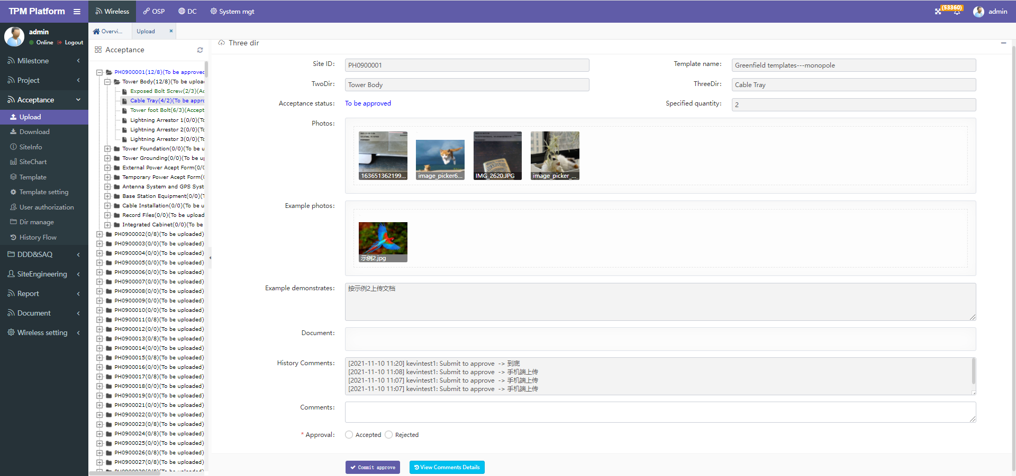

说明：Explain

1. 左边是所有基站+目录树图。点击节点右边显示该节点目录对应的上传图片等信息。

On the left is all sites + directory tree. Click the right side of the node to display the uploaded pictures and other information corresponding to the node directory.

1. 右边是目录对应上传图片详细信息。

On the right is the detailed information of the uploaded pictures corresponding to the directory.

* ” Acceptance status”：验收状态。分四种状态，分别是：

Acceptance status. There are four states:

"To be uploaded"-待上传

"To be approved"-待审核

"Accepted"-审核通过

"Rejected"-审核不通过

* “Specified quantity”：上传的图片数量。该数量供手机端上传参考，但没有做控制，手机端可上传任何数量图片。Number of uploaded pictures. This number is for the reference of uploading on the mobile terminal, but it is not controlled. Any number of pictures can be uploaded on the mobile terminal
* “Photos”：此处是手机端所有上传的图片缩略图。点击后可查看大图。Here are thumbnails of all uploaded pictures on the mobile terminal. Click to view the large picture
* “Example photos”：该基站类型对应的模板样例图片。Sample image of the template corresponding to the site type
* “Example demonstrates”： 该基站类型对应的模板样例文档。Sample image of the template corresponding to the site type
* “Document”： 该目录已上传的文档。Uploaded documents in this directory
* “History Comments”： 该目录历史操作记录一览。List of historical operation records of this directory
* “Comments”：审核时添加的注释。Comments added during audit
* “Approval”：审核。如果是审核操作，必须选通过或者不通过。to examine. For approval, you must select pass or fail
* “View Comments details”：点击后可查看详细历史注释信息。Click to view the detailed historical notes

#### Download

此处提供下载所有已上传文档清单。可单个下载，也可批量下载。

A list of all uploaded documents can be downloaded here. It can be downloaded individually or in batches.

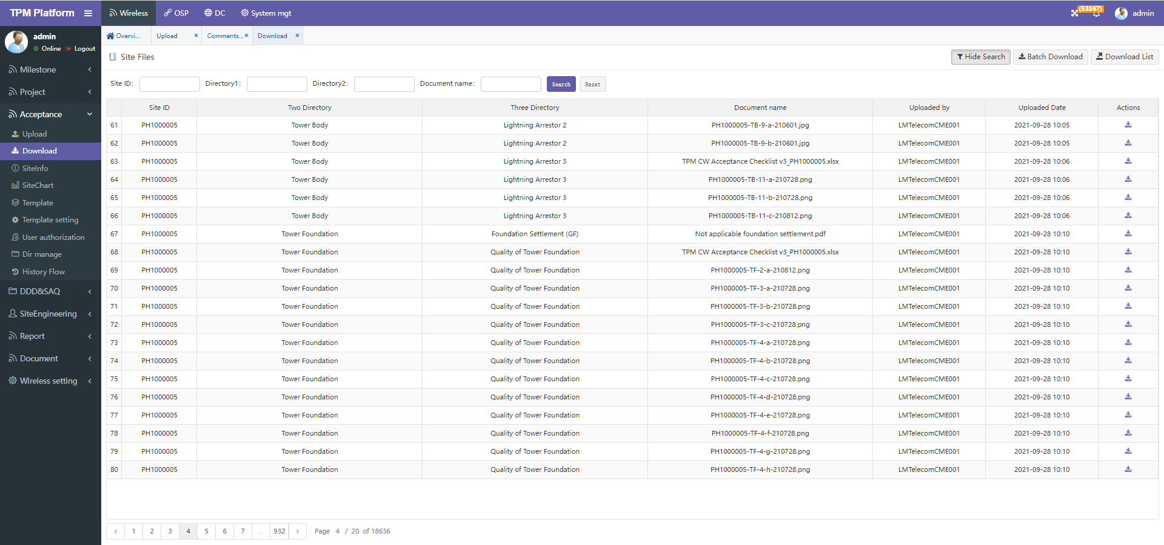

说明：Explain

1. 照片文件清单列出了所有的上传照片。

The photo file list lists all uploaded photos.

1. 通过上方搜索选项可以筛选上传照片。

Upload photos can be filtered through the search option above

1. “Batch download”：点击后下载所有当前筛选后的压缩文档，如果没有筛选会下载所有的文档，需慎用！如果文档过大，会造成系统拥塞出错！

"Batch download": Click to download all currently filtered compressed documents. If there is no filtering, all documents will be downloaded. Use with caution! If the document is too large, it will cause system congestion and error!

1. “Download list”：下载Excel文档清单。

"Download list": download the excel document list.

1. 点击每一行后面的下载图标，可单个下载照片文件。建议下载时多使用此功能。

Click the download icon behind each line to download a single photo file. It is recommended to use this function when downloading.

#### SiteInfo

此处可查看每个基站整体上传情况。

左边树图只能展示到二级目录。

点击二级目录后，在右边显示该二级目录下所有的三级目录上传照片一览。

Here you can view the overall upload status of each Site.

The tree on the left can only be displayed to the secondary directory.

After clicking the secondary directory, the list of uploaded photos of all the tertiary directories under the secondary directory will be displayed on the right.

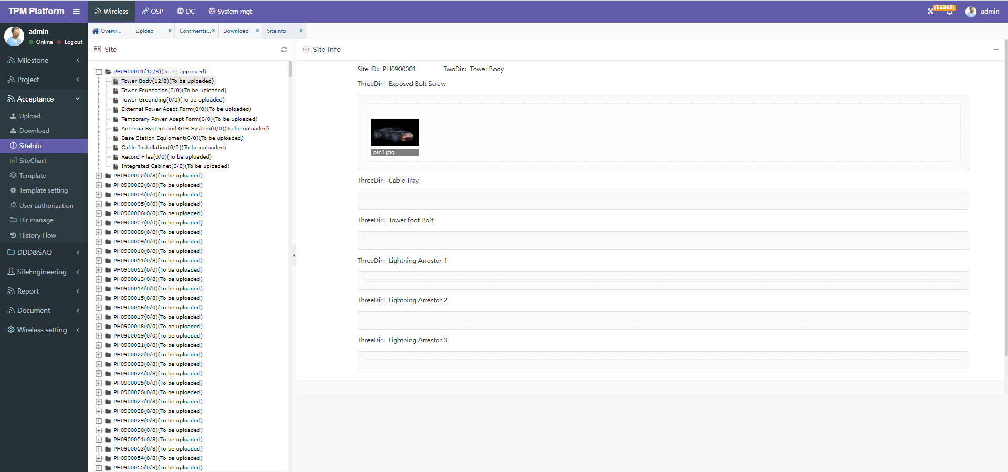

#### SiteChart

此处使用报表-柱状图方式查看每个基站整体上传情况。

左边树图只显示基站。

点击基站后，在右边显示该基站下所有的二级目录整体上传照片柱状图一览。

Here, you can use the report histogram method to view the overall upload of each Site.

The tree on the left shows only the sites.

After clicking the site, the histogram list of the overall uploaded photos of all secondary directories under the site is displayed on the right.

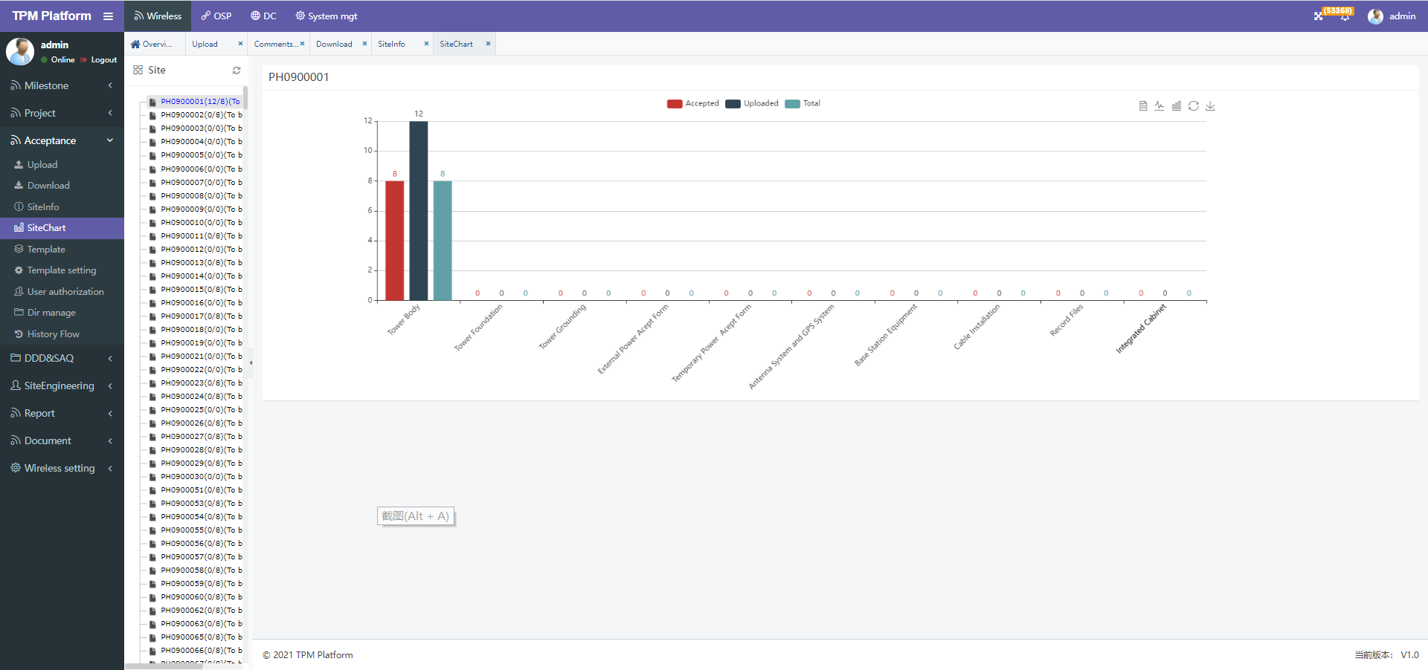

#### Template

此处可以增删改模板定义，仅定义模板基础属性。

包括：模板名称、对应的基站类型、对应的基站类型字段。

不定义详细的模板内容。模板内容在 “Template setting”中定义

You can add, delete or modify template definitions here. Only the basic attributes of the template are defined.

Including: template name, corresponding Site type and corresponding Site type fields.

Detailed template content is not defined. Template content is defined in "template setting"

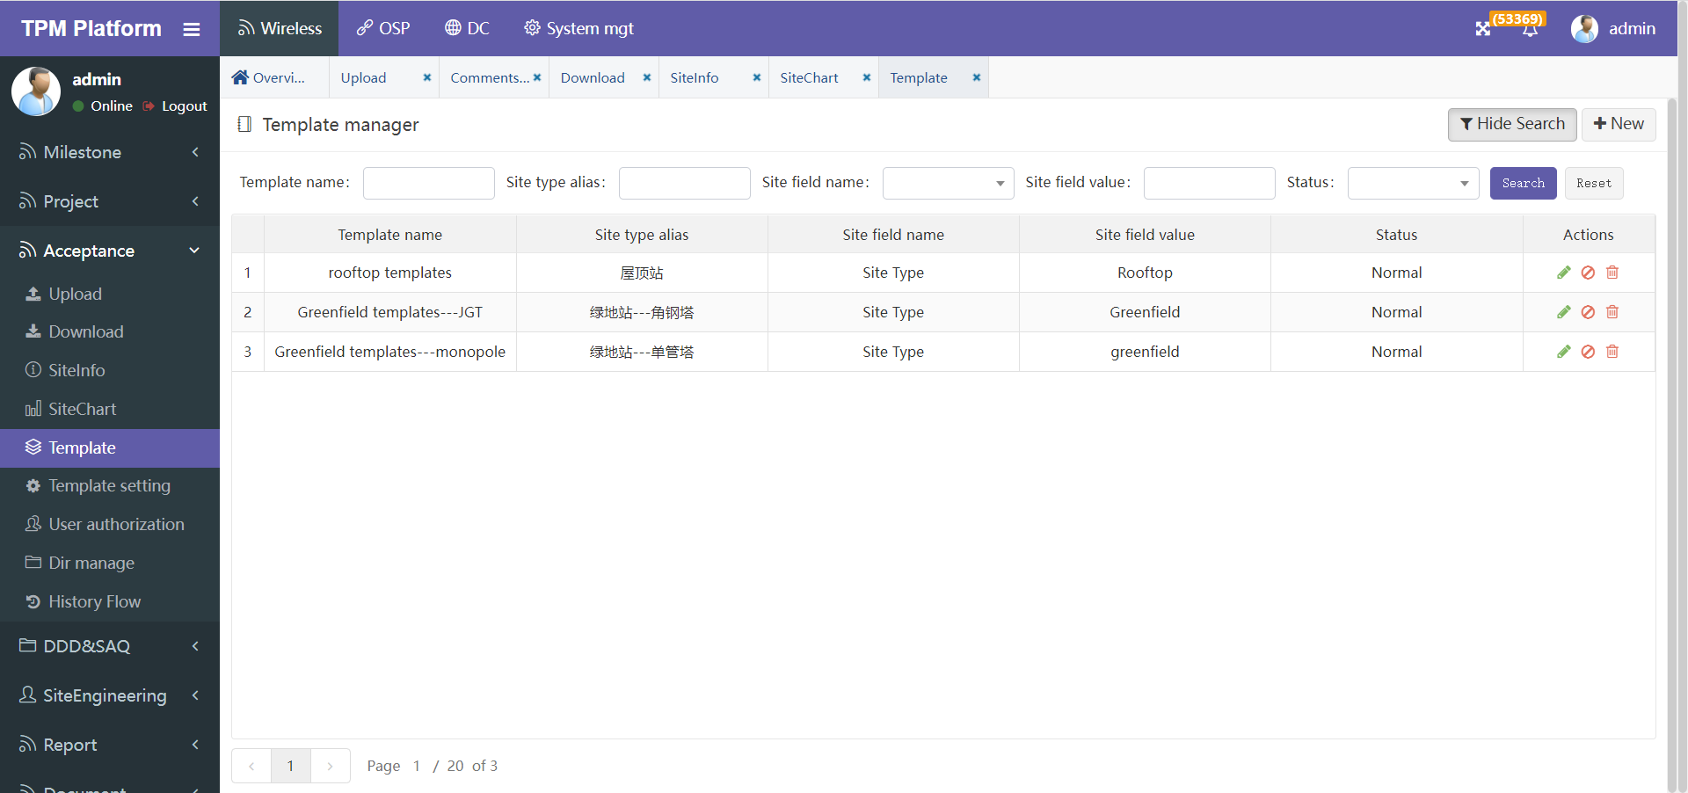

#### Template setting

此处定义模板详细内容。

Template details are defined here.

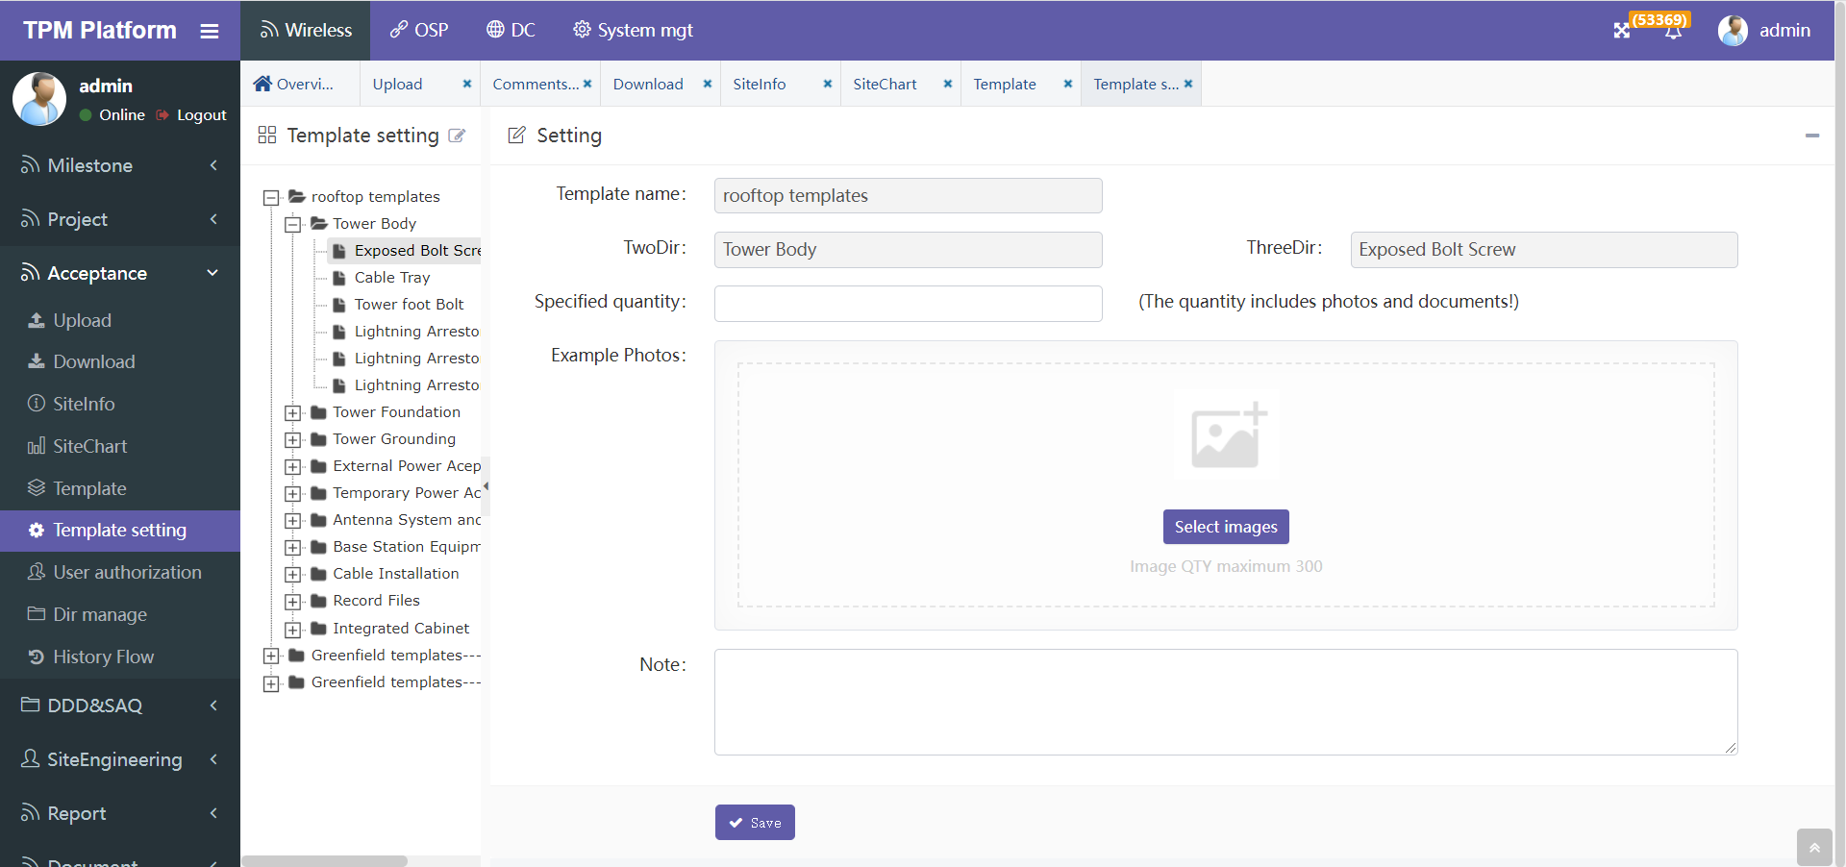

说明：Explain

1. 左边树图是预先定义好的模板名称。每个模板自动对应二级三级目录，这些目录在目录菜单中已定义。

The tree on the left is the predefined template name. Each template automatically corresponds to level 2 and level 3 directories, which have been defined in the directory menu

1. 点击对应的目录节点后，右边显示模板详细内容。

After clicking the corresponding directory node, the template details will be displayed on the right.

* “Specified quantity”：上传的图片数量。该数量供手机端上传参考，但没有做控制，手机端可上传任何数量图片。

"Specified quantity": the number of uploaded pictures. This number is for the reference of uploading on the mobile terminal, but it is not controlled. Any number of pictures can be uploaded on the mobile terminal.

* “Example photos”：该基站类型对应的模板样例图片。

"Example photos": the template sample picture corresponding to the site type.

* “Note”： 备注信息。

"Note": note information.

#### User authorization

用户授权功能是验收模块控制用户上传和审核权限定义的子模块。

The user authorization function is a sub module of the acceptance module, which controls the definition of user upload and approval permissions.

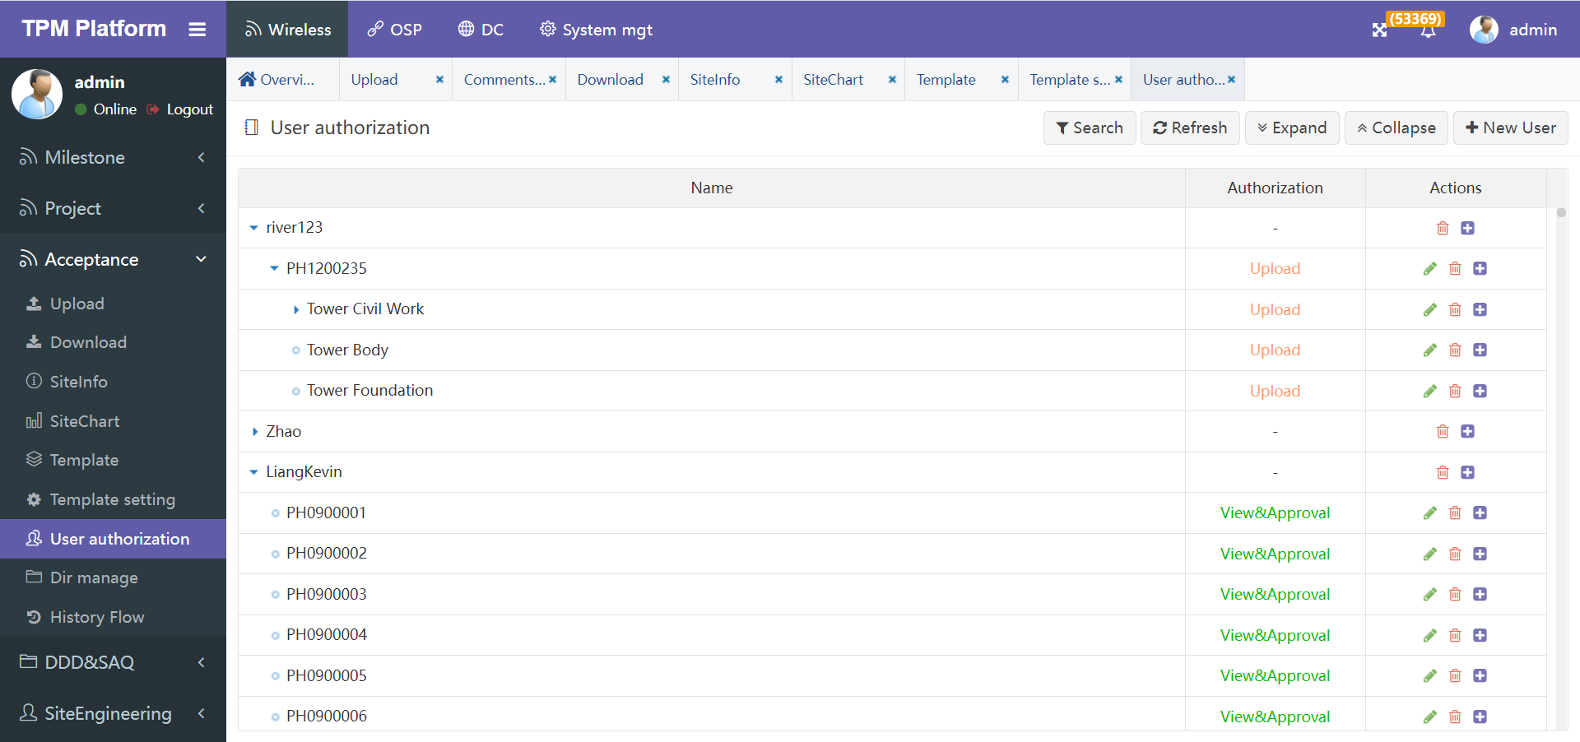

说明：Explain

1. 初始时无任何权限定义。

Initially, there is no permission definition

1. 权限定义围绕用户发起。点击”New User”可新增一个权限用户：

此用户必须是系统中存在的，新增时可选，已定义过的用户不能再定义，也就是说一个用户只能定义一次。

Permission definitions are initiated around users. Click "new user" to add a user with permission: This user must exist in the system. It is optional when adding. Defined users cannot be defined again, that is, a user can only be defined once.

1. 用户定义完成后，在此用户节点后点击”+”，可依次新增：基站、二级目录、三级目录。每个节点均可定义权限类型。权限类型分：

View&Approval：表示查看和审核权限。分配给审核人员。

Upload：表示上传权限。分配给APP端上传用户。

After user definition, click "+" after this user node to add site, secondary directory and tertiary directory in turn. Each node can define permission types. Permission types:

View & Approval: indicates the view and approval permission. Assigned to reviewers.

Upload: indicates the upload permission. Assigned to app upload user.

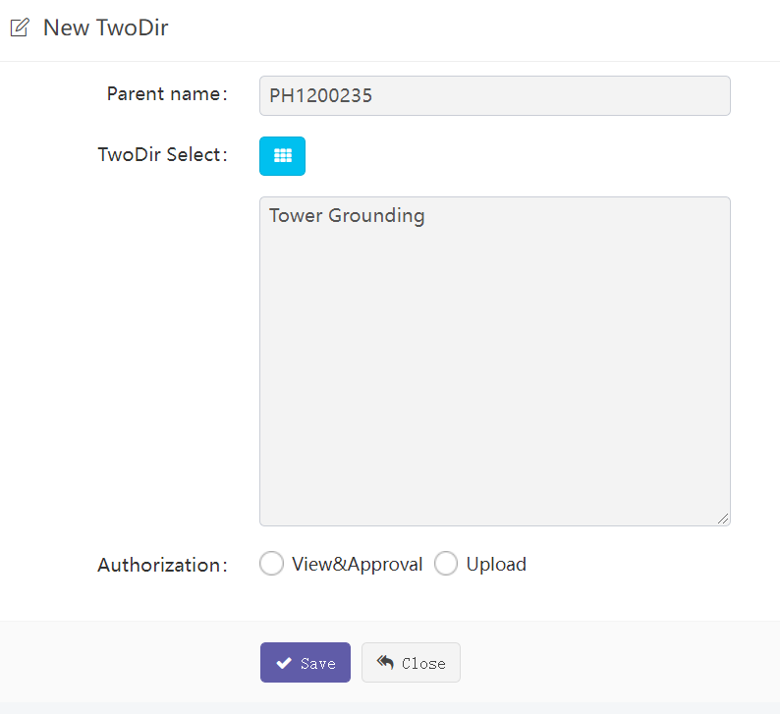

#### Dir manager

目录管理功能。

Directory management function.

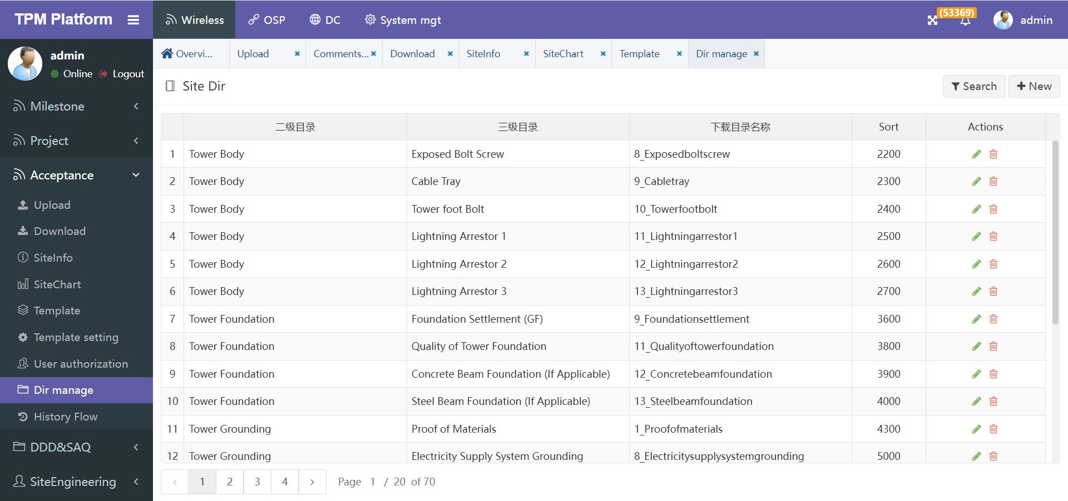

说明：Explain

1. 初始目录系统均已设置完成。考虑到目录的变动会引起操作系统对应的目录和已上传文档的变动，所以慎修改，变动时可通知开发人员，评估变动带来的影响。否则可能容易丢失数据。

The initial directory system has been set up. Considering that the change of the directory will cause the change of the directory corresponding to the operating system and the uploaded documents, it should be modified carefully. When the change is made, the developer can be notified to evaluate the impact of the change. Otherwise, it may be easy to lose data

1. “下载目录名称”：是对应操作系统的目录名称，必须是操作系统允许的字符，否则不能建目录。

"Download directory name": it is the directory name of the corresponding operating system. It must be the characters allowed by the operating system, otherwise the directory cannot be created

1. “序号”：是目录排序号码，由小到大排序。

"Sort": it is the directory sorting number, which is sorted from small to large

#### History Flow

此处可查看所有历史操作记录。

Here you can view all historical operation records.

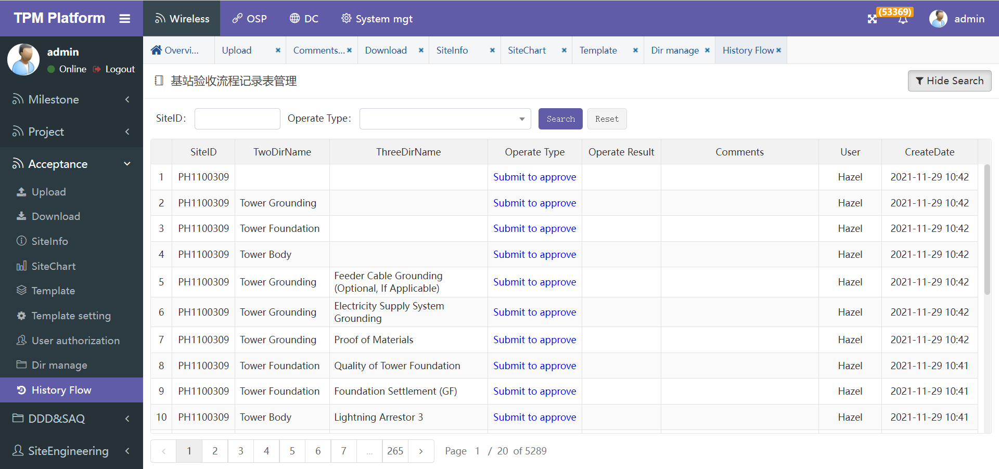

说明：Explain

1. 历史操作记录数量较多，可通过搜索选项筛选过滤。如想看某一基站的操作记录，可在搜索框”SiteID”中输入对应的基站ID，点搜索。

There are many historical operation records, which can be filtered through search options. If you want to see the operation records of a site, enter the corresponding site ID in the search box " SiteID " and click search.

### Acceptance(New)

因业务需求变更，原先的Acceptance验收模块已不能满足日常工作需求。经讨论重新开发一个全新的验收模块。旧验收模块依旧保留。

新验收模块功能上主要区别是分4级目录管理照片及文档，原先是3级目录；审核流程变为多级审核，原先是一级审核。

业务逻辑与之前类似：主要给用户拿手机去基站建设现场拍照上传到我们平台，可以实时拍照上传，也允许离线拍照后，到有网络的地方在上传。然后后台用户审核这些照片是否通过。如不通过可继续上传。

使用场景大致步骤如下：

步骤一、后台”Dir Manager”中建好各级目录，图片文件上传到这些对应的目录中。同时可以设置各目录审核权限。

步骤二、后台” User authorization”中设置手机端用户对应的基站/目录的上传权限。

步骤三、后台” Template”中设置好不同基站类型对应的模板。每个模板可设置不同的上传文件格式和数量等，供手机端上传时参考。

步骤四、手机端APP上传照片。

步骤五、后台” Upload”也可上传图片和文档。

步骤六、后台” Approve”给审核人员审核。

Due to changes in business requirements, the original acceptance module can no longer meet the daily work needs. After discussion, a new acceptance module is developed. The old acceptance module remains.

The main difference in the function of the new acceptance module is that the photos and documents are managed by four levels of directory, which was originally a three-level directory; The approval process has changed to multi-level approval, which was originally level-1 approval.

The business logic is similar to that before: it mainly takes users' mobile phones to take photos at the site construction site and uploads them to our platform. It can take photos and upload them in real time. It also allows offline photos to be uploaded to places with networks. Then the background user reviews whether these photos pass. If not, you can continue to upload.

The general steps of the usage scenario are as follows:

Step 1. Create directories at all levels in the background "Dir Manager ", and upload image files to these corresponding directories. At the same time, you can set the approval permission of each directory

Step 2. Set the upload permission of the site / directory corresponding to the mobile user in the background "user authorization" .

Step 3. Set templates of different Site types in the background. Each template can set different upload file formats and quantities for reference when uploading on the mobile terminal.

Step 4. Upload photos on the mobile app.

Step 5. The background "Upload" can also upload pictures and documents.

Step 6: the background "Approve" is submitted to the reviewer for approval.

#### Upload

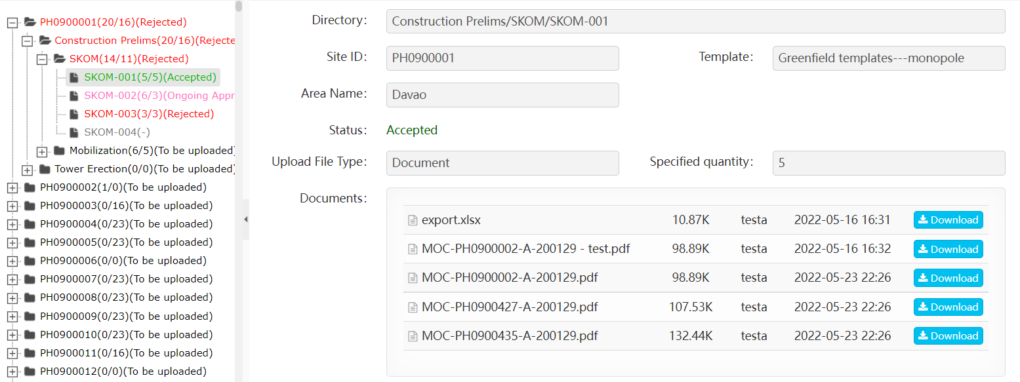

Upload菜单页面分两块：

1. 左边是目录机构树图，分4级目录，第1级基站，后面的对应业务逻辑的3级目录。
2. 右边是上传/审核页面，点击左边最后一级目录，在右边显示该目录对应的文档信息。上传用户可在此上传对应的照片和文档；其他用户可查看照片和文档信息。
3. 左边树图节点用不同颜色表示目录的当前状态：To be uploaded、To be approved、Ongoing Approval、Accepted、Rejected。，对于最后一级目录根据实际情况显示当前状态。对于父级目录的状态是根据所有其下子目录来判断显示，显示逻辑是不同的，比如：

Accepted：所有子目录均为Accepted

Rejected：只要有一个子目录是Rejected

To be uploaded：只要有一个子目录是To be uploaded

To be approved：所有子目录没有一个是To be uploaded，且至少有一个是To be approved

Ongoing Approval：所有子目录没有一个是To be uploaded和To be approved，，且至少有一个是Ongoing Approval

1. 右边上传界面项目简介（Approve菜单类似，不再赘述）

The Upload menu page is divided into two parts:

1、On the left is the directory structure tree, which is divided into four levels of directories, the first level of sites, and the following three levels of directories corresponding to the business logic.

2、On the right is the upload / review page. Click the last level directory on the left to display the document information corresponding to the directory on the right. Uploading users can upload corresponding photos and documents here; Other users can view photo and document information.

3、The tree graph node on the left shows the current status of the directory in different colors: to be uploaded, to be approved, ongoing approval, accepted, and rejected. For the last level directory, the current status is displayed according to the actual situation. The parent directory status is displayed based on all its subdirectories. The display logic is different, for example:

**Accepted:** all subdirectories are accepted

**Rejected:** as long as one subdirectory is rejected

**To be uploaded:** as long as one subdirectory is to be uploaded

**To be approved:** none of all subdirectories is to be uploaded, and at least one is to be approved

**Ongoing approval:** none of all subdirectories are to be uploaded and to be approved, and at least one is ongoing approval

4、Upload the project introduction of the interface on the right (the approve menu is similar and will not be repeated)

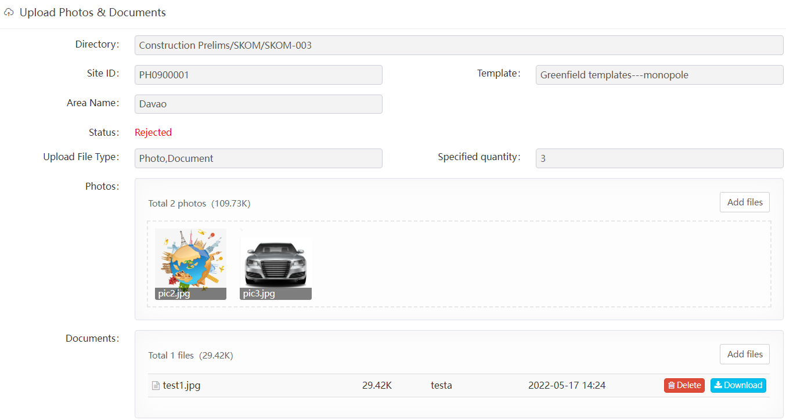

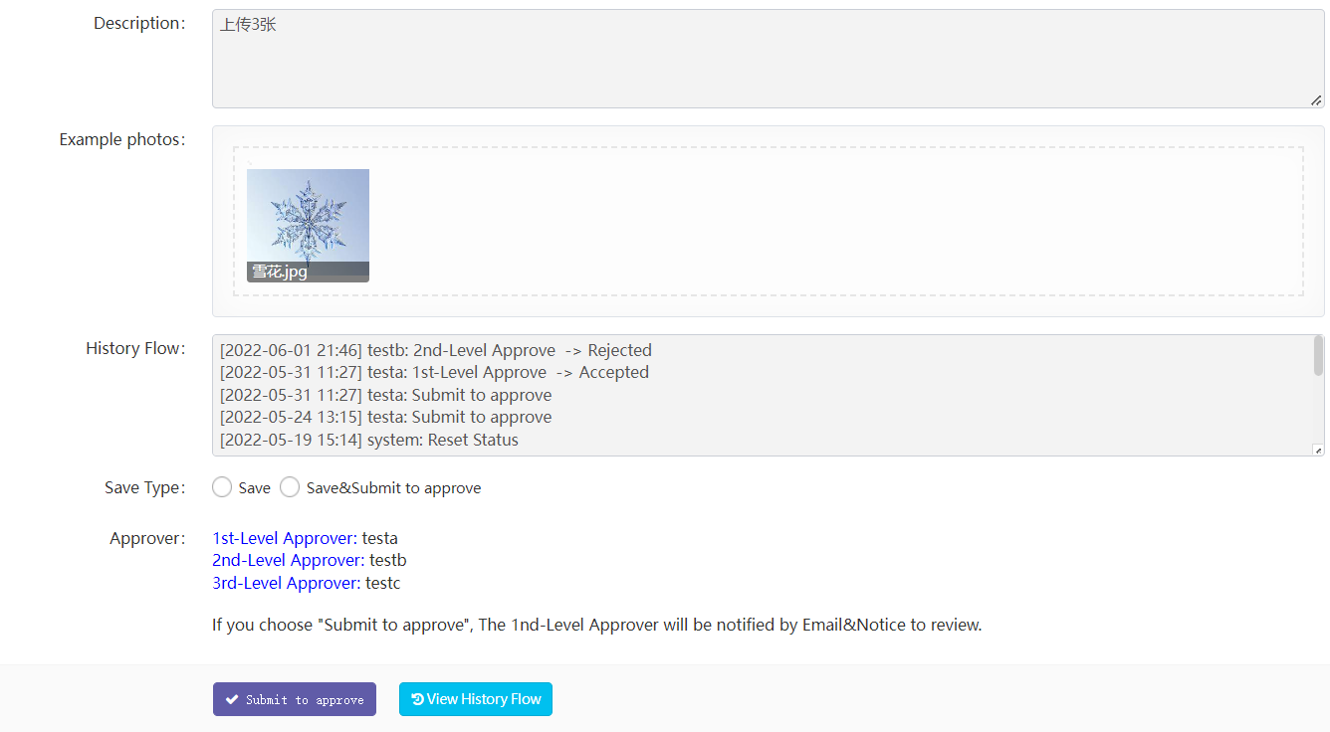

Directory：对应的目录结构

Site ID：基站ID

Template：该基站类型对应的模板。上传的照片和文档根据该模板来规范定义。

Area Name：该基站归属地区。审核用户根据该地区来划分。

Status：当前最后一级目录的状态。在

Upload File Type：允许上传的文件类型，分：Photos/Documents/Photos&Documents

Specified quantity：模板中规定需要上传的文件数量。包括Photos/Documents。

Photos：上传照片(如果有)

Documents：上传文档(如果有)

Description：模板中定义的描述内容，指导用户正确上传照片。

Example photos：模板中定义的样例照片，，指导用户正确上传照片。

History Flow：当前目录操作历史记录，包括上传记录和审核记录等。

Save Type：保存类型。

”Save”：表示保存当前照片等，但递交审核；

”Save& Submit to approve”： 表示保存当前照片并递交审核。

可以输入备注信息。递交后就不能再修改照片。

同时递交后将邮件通知第一级审核人员。

Approver：当前目录分级审核用户清单。

按钮”Submit to approve”：递交审核.

按钮”View History Flow”：跳转到该目录操作历史记录详细页面：

>>>>>>>>>>>>>>>>>>>>>>>>>>>>

Directory: corresponding directory structure

Site ID: site ID

Template: the template corresponding to the site type.

The uploaded photos and documents are defined according to the template.

Area name: the area to which the BTS belongs. Audit users are divided according to the region.

Status: the current status of the last level directory. stay

Upload file type: the file type allowed to upload,

divided into: photos/documents/photos&amp;documents

Specified quantity: the template specifies the number of files to be uploaded.

Includes photos/documents.

Photos: upload photos (if any)

Documents: upload documents (if any)

Description: the description content defined in the template to guide users to

upload photos correctly.

Example photos: sample photos defined in the template, which guide users to

upload photos correctly.

History flow: current directory operation history, including upload records and audit records.

Save type: two options:

"Save": means to save the current photo, etc., but submit it for approval;

"Save&Submit to approve": save the current photo and submit it for approval.

You can also enter notes.You can't modify the photos after submission

At the same time, the first level auditor shall be notified by email

after submission.

Approver: current directory hierarchical audit user list.

Button "submit to approve": submit for approval

Button "view history flow": jump to the directory operation history details page:

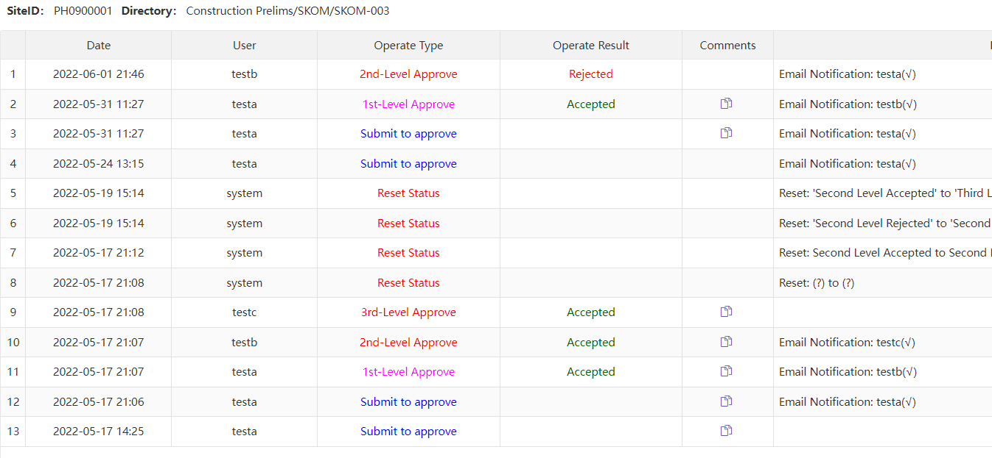

#### Approve

###### Approve User

Approve菜单页面与Upload页面界面项类似，这里不再赘述，详见Upload。

上传用户上传照片和文档后。由审核用户在Approve界面来审核是否通过或不通过。

The approve menu page is similar to the interface items of the upload menu. It will not be repeated here. See upload for details.

after users upload photos and documents. The approval user can approve whether to pass or not in the approve interface.

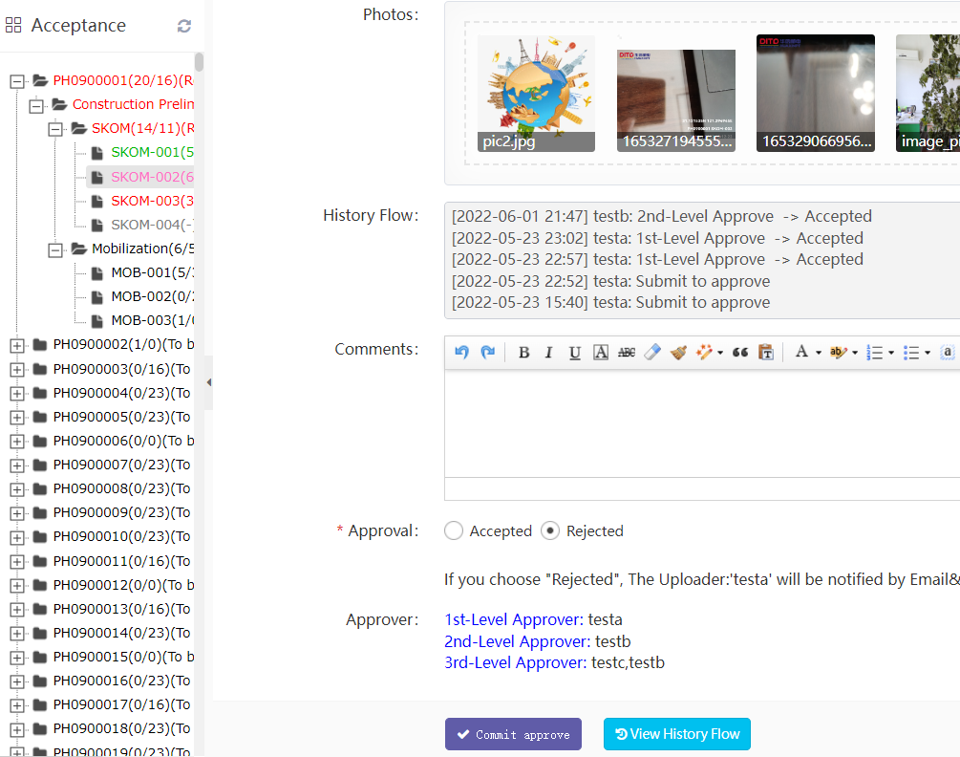

Approval：表示审核通过或不通过。如果审核通过并且还有下一级审核，则邮件通知下一级审核人员。如果审核不通过，则直接邮件通知上传的人员。

Approval: means whether the approval is passed or not. If the Approval is passed and there is a next level Approval, the next level Approver will be notified by email. If the approval fails, the uploading user will be notified by email.

###### Admin User

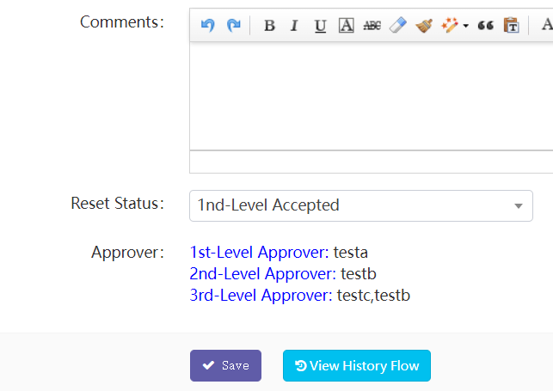

在审核页面，对于Admin管理员角色，允许改变当前目录到任何一个状态。

如上图，在下拉框选择即可。这种临时强行改变不会邮件通知任何人。

On the approve page, for the admin role, he can change the current directory to any state.

As shown in the above figure, select from the drop-down box.

This temporary forced change will not be notified to anyone by email.

#### Download

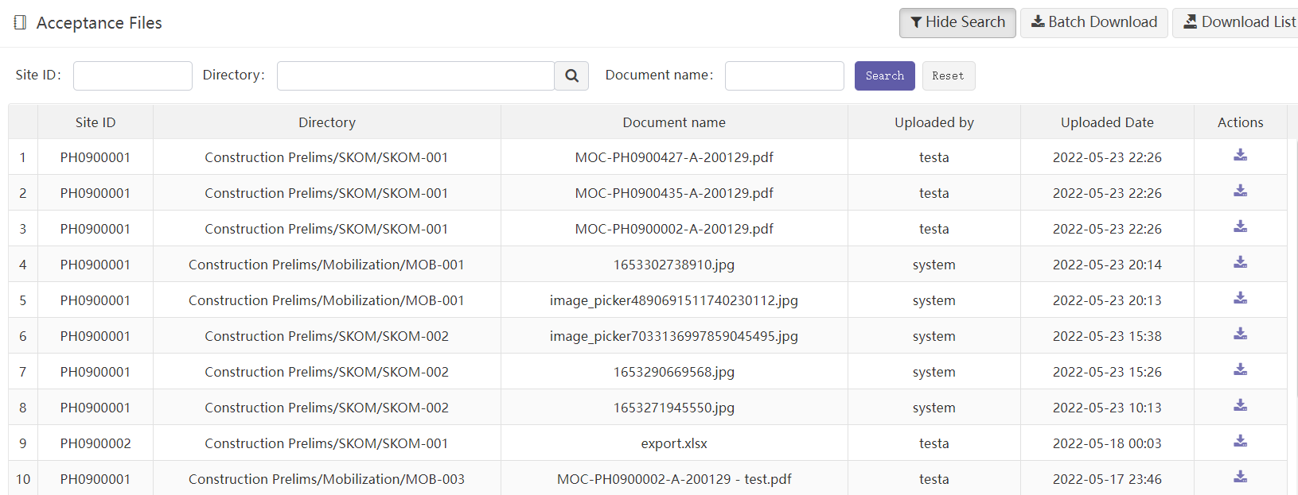

下载页面方便用户查询及下载单个照片或文档，也可以批量打包下载。

1. 通过“site id”、“Directory”、“document name”筛选，可精确查询到相应的文件。
2. 点击文档后面的下载图标，可直接将对应文件下载到本地。

The download page is convenient for users to query and download individual photos or documents, or batch package and download.

1、Through "site ID", "directory" and "document name" filtering, the corresponding files can be accurately queried.

2、Click the download icon at the back of the document to directly download the corresponding file to the local.

* **按钮“Batch Download”：批量打包下载**

**Button” Batch Download”:**

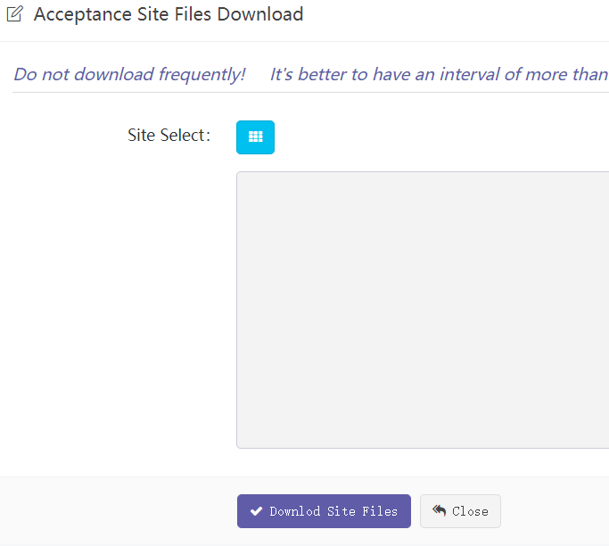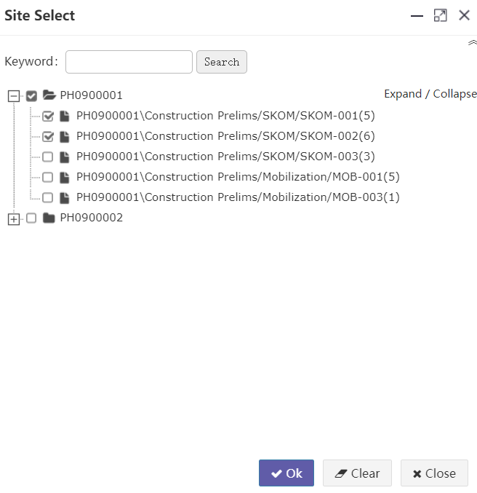

根据用户所选基站/目录，将其对应的所有照片和文档压缩后打包下载到本地。文档按目录结构打包。

注意：1、该操作不宜选择太多基站及目录。2、不宜频繁下载。否则容易造成系统拥堵及崩溃。

According to the site / directory selected by the user, all photos and documents corresponding to them are compressed, packaged and download to local. Documents are packaged in a directory structure.

Note:

1. Too many sites and directories should not be selected for this operation.

2. Do not download frequently. Otherwise, it is easy to cause system congestion and collapse.

#### RevisedList

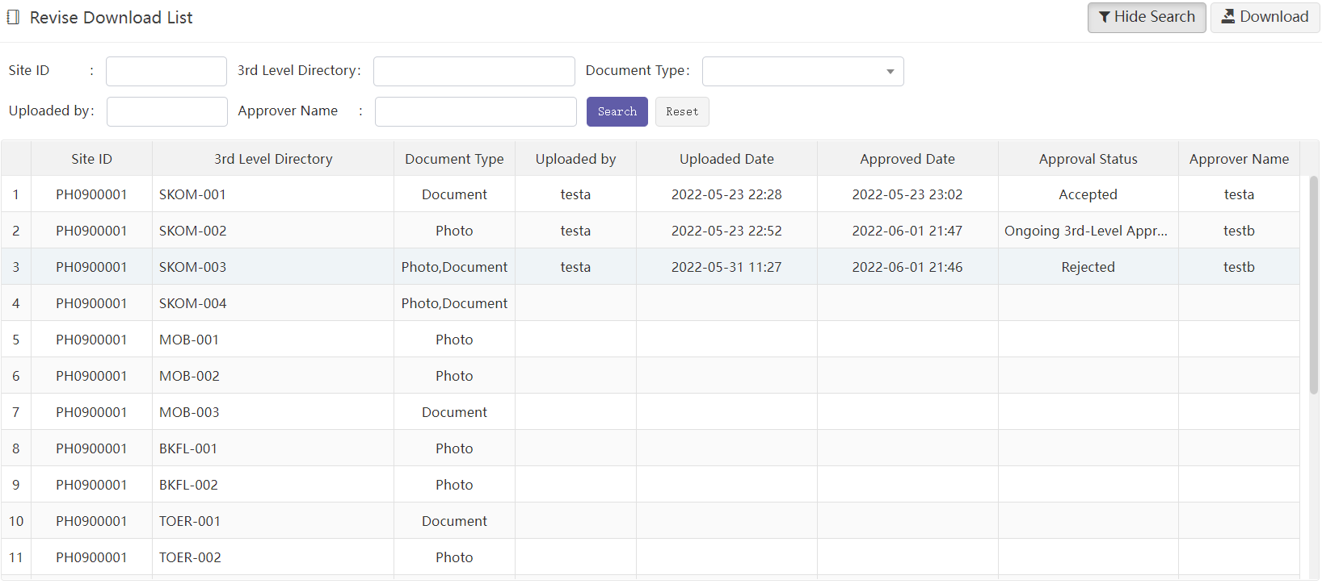

RevisedList是一个独立的功能菜单。

罗列出所有基站及其下所有目录当前的审核明细清单。

通过搜索项可过滤条件。

按钮Download：将当前搜索结果清单以EXCEL格式下载到本地。

Revisedlist is a separate function menu.

List the current approve details of all sites and their directories.

Search options allow you to filter criteria.

Button Download: download the current search result list to the local in Excel format.

#### Dir manager&Approval authorize

目录管理功能。

Directory management function.

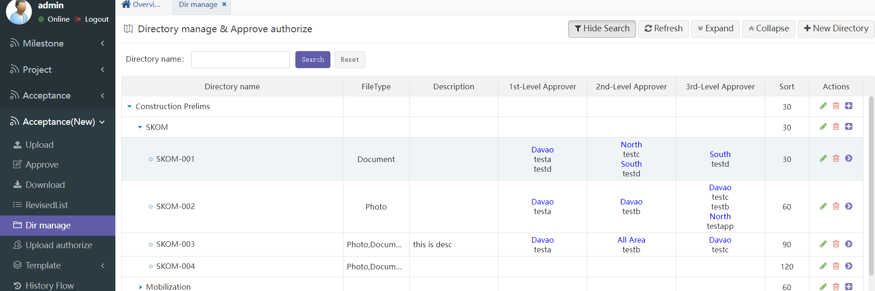

说明：Explain

1. 目录分三级结构。可以自由设置，但尽量少变动，因为每个目录对应操作系统上的实际目录结构。这里删除后，操作系统目录也会被删除。

The directory has a three-level structure. You can set it freely, but change it as little as possible, because each directory corresponds to the actual directory structure on the operating system. After deletion, the operating system directory will also be deleted

1. 一级和二级目录不上传照片/文档，只有三级目录需要上传。

Level 1 and level 2 directories do not upload photos / documents, only level 3 directories need to be uploaded.

1. 点击右上角按钮”New Directory”可进入新建目录页面：

Click "New directory" in the upper right corner to enter the new directory page

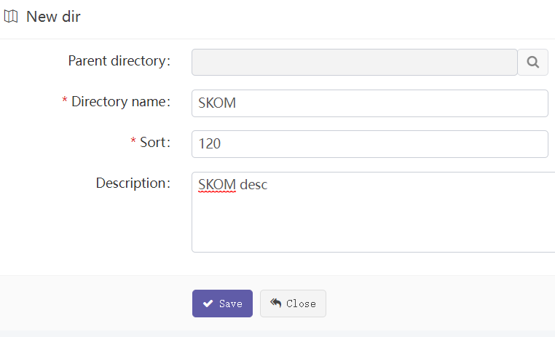

Parent directory: 父目录

Directory name: 目录名称。对应操作系统目录名称，必须是操作系统允许的字符，

否则不能建目录。

Sort: 目录排序号码，由小到大排序。

Description: 目录描述。

Parent directory: parent directory

Directory name: The corresponding operating system directory name must be the characters

allowed by the operating system,Otherwise, you cannot create a directory.

Sort: it is the directory sorting number, which is sorted from small to large.

Description: directory description.

1. 点击行尾图标”Edit” 或者 ”+” 分别可进入编辑目录页面和新增子目录页面：页面项同上。

Click "Edit" or "+" at the end of the line to enter the edit directory page and the new sub directory page respectively: the page items are the same as above

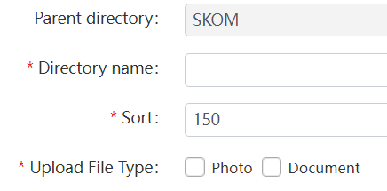

* 对于第三级目录，与前二级都不一样，多一项：“Upload File Type”选项，表示该第三级目录需要上传照片、文档、还是两者都可以。根据实际情况填写。  
  For the third level directory, it is different from the first two levels. There is one more option: " Upload File Type ", which means that the third level directory needs to upload photos or documents or both. Fill in according to the actual situation.

1. 点击行尾图标”>”，弹出三个菜单，分别对应三级审核授权页面。注意：审核最多三级，但也可以只设置一级审核。

Click the ">" icon at the end of the line to pop up three menus corresponding to the three-level approval authorization page. Note: there are three levels of approval at most, but one level of approval can also be set.

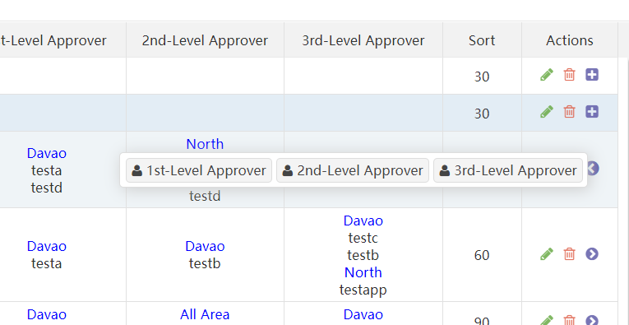

1. 审核页面 Approval page：

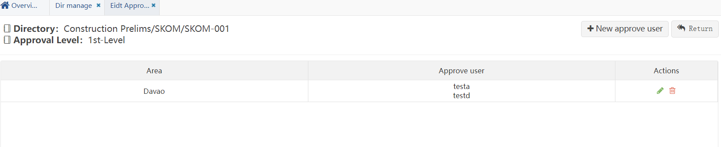

点击右上角：“New Approve user”可新增审核用户。页面如下：

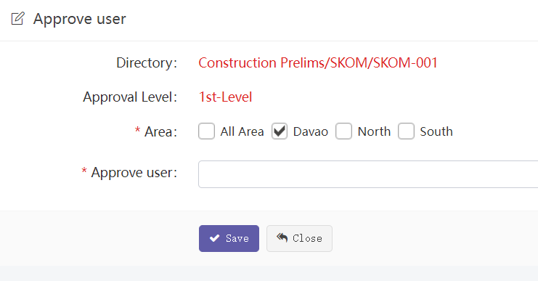

1. Directiory: 第三级目录就是当前目录，表示用户对当前目录有审核权限。
2. Approval Level: 表示当前是第几级审核。
3. Area: 表示基站归属区域。审核权限按第三级目录和基站归属区域来划分。

如上图表示：该用户对“Davao”区域的所有基站下的当前第三级目录

有审核权限。

1. Directory: the third level directory is the current directory, indicating that the user has audit permission on the current directory.
2. Approval level: indicates the current approval level.
3. Area: indicates the BTS home area. The audit authority is divided according to the third

level directory and the BTS belonging area.

As shown in the figure above, the current level 3 directory of all BTSs in the

"Davao" area Have audit authority.

#### Upload authorize

上传用户授权是验收模块控制用户上传权限定义的子模块。

The user upload authorization function is a sub module of the acceptance module, which controls the definition of user upload permissions.

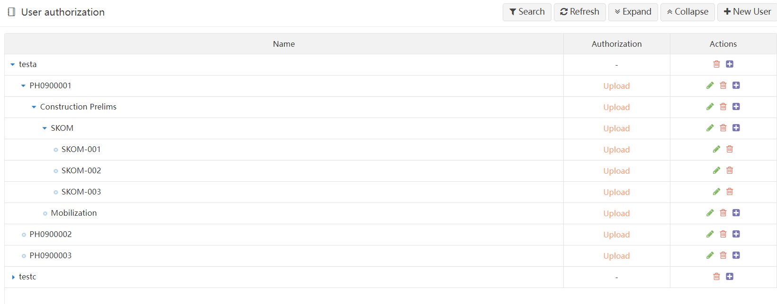

说明：Explain

1. 初始时无任何权限定义。

Initially, there is no permission definition

1. 权限定义围绕用户发起。点击”New User”可新增一个权限用户：

此用户必须是系统中存在的，新增时可选，已定义过的用户不能再定义，也就是说一个用户只能定义一次。

Permission definitions are initiated around users. Click "new user" to add a user with permission: This user must exist in the system. It is optional when adding. Defined users cannot be defined again, that is, a user can only be defined once.

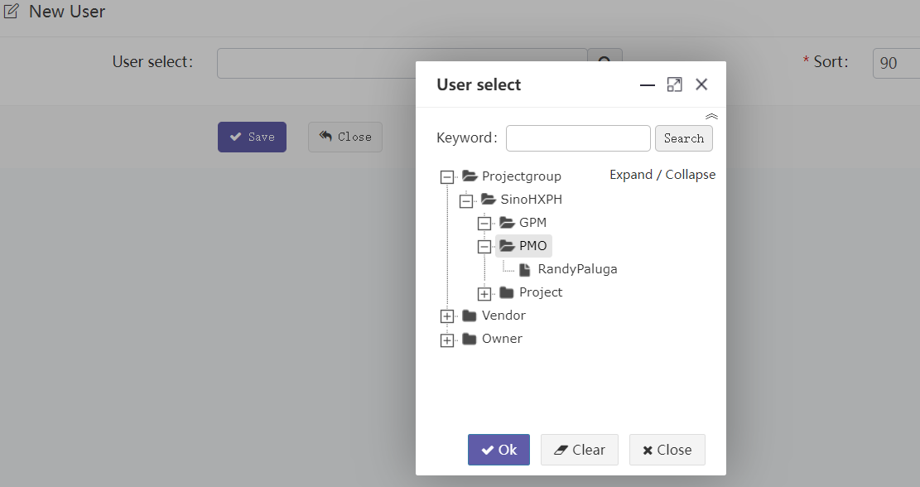

1. 用户定义完成后，在此用户节点后点击”+”，可依次新增：基站、二级目录、三级目录、四级目录。每个节点目录均可定义权限类型。

After user definition is completed, click "+" after this user node to add Site, level 2 directory, level 3 directory and level 4 directory in sequence. Each node directory can define permission types.

[New Site]:

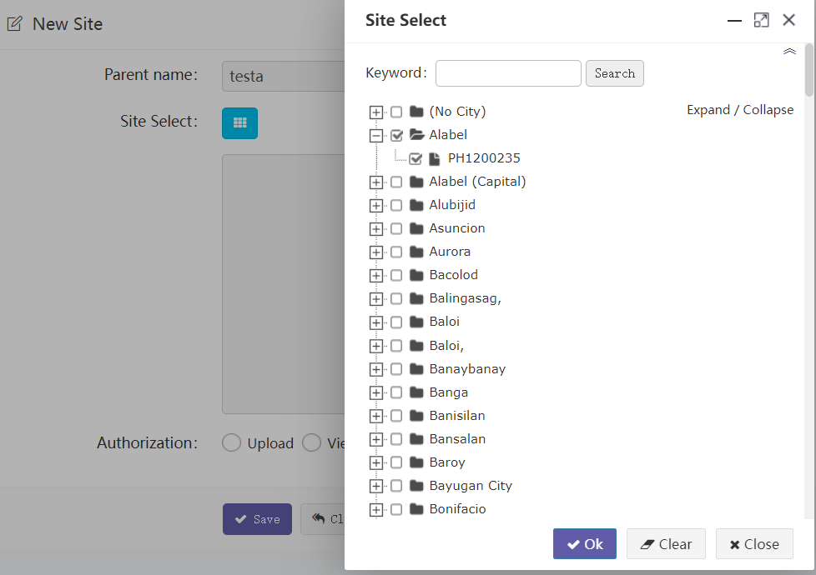

[New level 2/3 directory]:

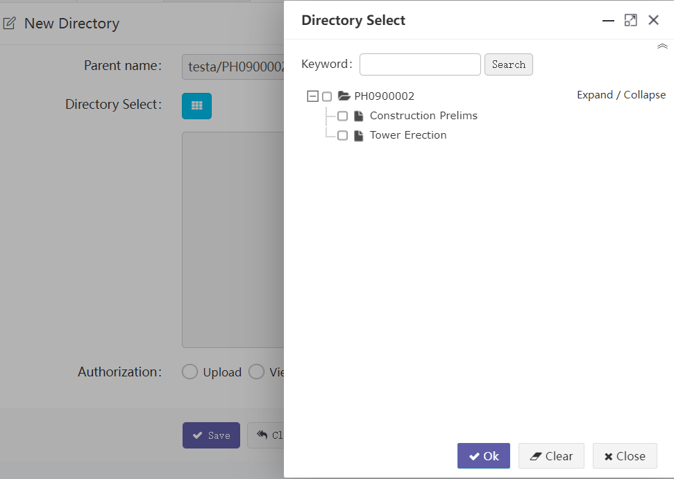

[New level 4 directory]:

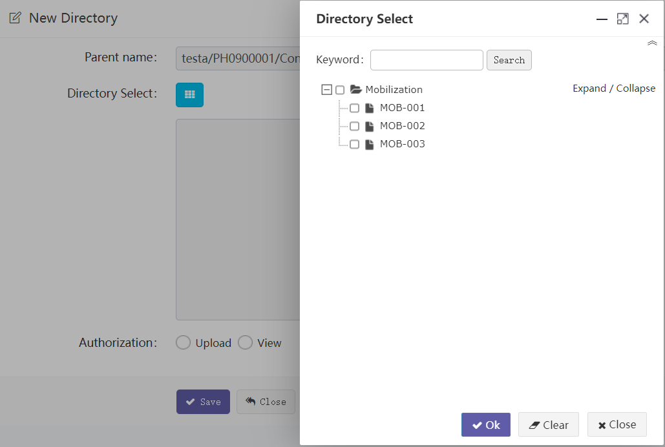

四级目录多一个权限选项：Upload 、 View

Upload：表示允许上传权限。分配给APP端和PC端上传用户。

View ：表示只能查看权限。仅PC端用户。

Level 4 directory has one more permission option: upload and view

Upload: indicates permission to upload. Assigned to app and PC upload users.

View: indicates that you can only view permissions. Only PC users.

* **关于权限的补充说明：**

权限具有继承关系，如果设置了父节点没有设置子节点，则所有子节点都继承父节点的权限。比如你设置了基站节点的权限，但基站下面不设置任何目录，则该用户对该基站下所有目录均拥有与基站一致的权限。

Permissions are inherited. If the parent node is set but no child node is set, all child nodes inherit the permissions of the parent node. For example, if you set the permissions of the Site node, but no directory is set under the Site, the user has the same permissions as the Site for all directories under the Site.

#### Tempate

模板的功能是按照基站不同分类，分别定义各上传目录规定要上传的照片/文档的数量、格式等信息。不同的基站分类，这些信息会不一样。

The function of the template is to define the number and format of photos / documents to be uploaded in each upload directory according to different classifications of site. Different site have different information.

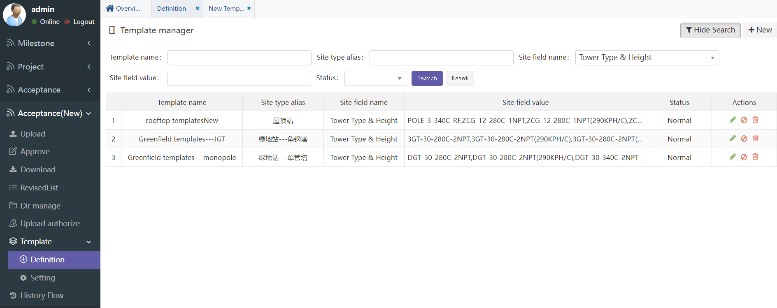

##### Definition

模板定义分两步：第一步先定义一个空模板。第二步对空模板各目录分别定义内容。

There are two steps to define a template.：

Step 1： is to define an empty template.

Step 2 ：define the contents of each directory of the empty template.

Step 1： define an empty template

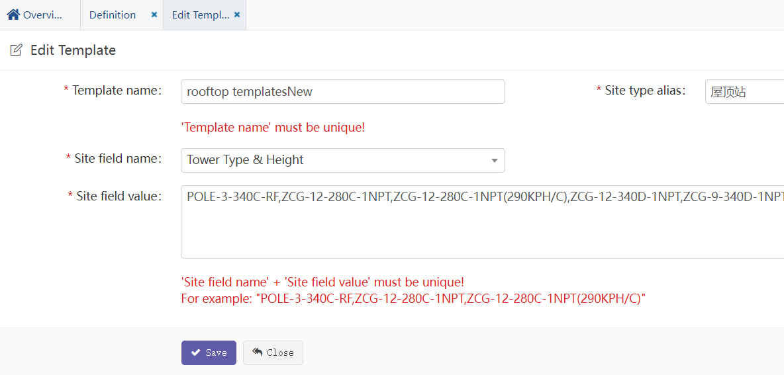

说明Explain：

1. “Site type alias”: 基站分类别名。可任意取。
2. “Site field name”: 基站类型字段。根据这个字段来区分基站分类。
3. “Site field value”: 基站类型值。表示这个模板所包含的基站类型种类。如果有多个则使用“，”隔开。
4. "Site type alias": Site classification alias. It can be taken at will.
5. "Site field name": Site type field. This field is used to distinguish the Site classification.
6. "Site field value": Site type value. Indicates the type of site included in this template. If there are more than one, Use "," to separate。

##### Setting

Step 2 ：define the contents of each directory of the empty template.

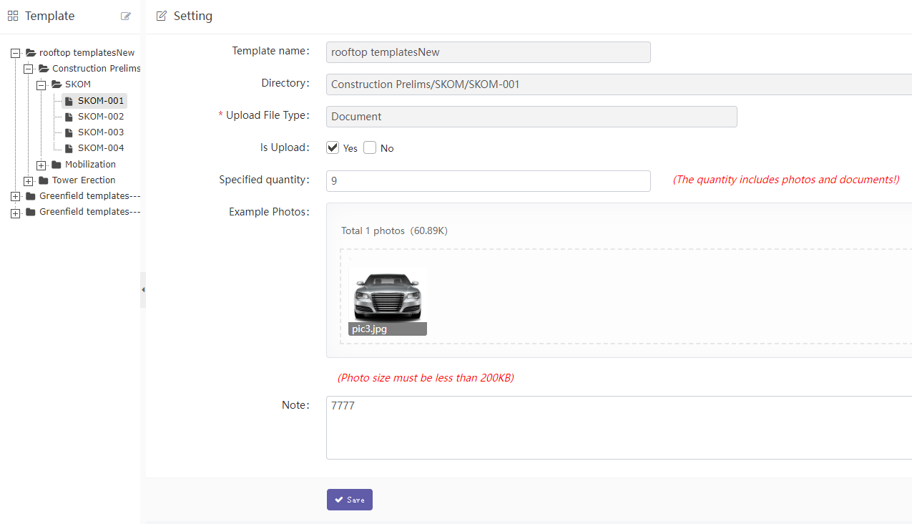

1. 左边树图是预先定义好的模板名称。每个模板自动对应二级三级四级目录，这些目录在目录菜单中已定义。

The tree on the left is the predefined template name. Each template automatically corresponds to level 2 and level 3 and level 4 directories, which have been defined in the directory menu

1. 点击对应的目录节点后，右边显示模板详细内容。

After clicking the corresponding directory node, the template details will be displayed on the right.

* “Is Upload”：是否需要上传图片和文档。有的基站类型目录不需要上传。

"Is Upload": Whether to upload pictures and documents. Some Site type directories do not need to be uploaded.

* “Specified quantity”：上传的图片数量。包括照片和文档总和，该数量供手机端上传参考，但没有做控制，手机端可上传任何数量图片。

"Specified quantity": the number of uploaded pictures. Including the sum of photos and documents, This number is for the reference of uploading on the mobile terminal, but it is not controlled. Any number of pictures can be uploaded on the mobile terminal.

* “Example photos”：该基站类型对应的模板样例图片。

"Example photos": the template sample picture corresponding to the site type.

* “Note”： 备注信息。

"Note": note information.

#### History Flow

此处可查看所有历史操作记录。

Here you can view all historical operation records.

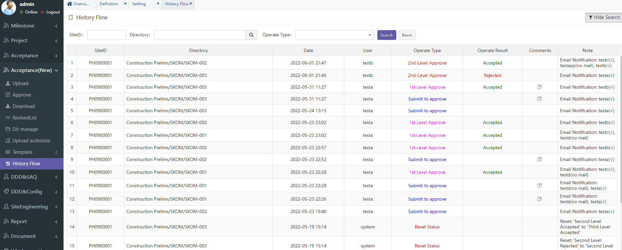

说明：Explain

1. 历史操作记录数量较多，可通过搜索选项筛选过滤。过滤项有：基站、目录名、操作类型。如想看某一基站的操作记录，可在搜索框”SiteID”中输入对应的基站ID，点搜索。

There are many historical operation records, which can be filtered through search options. You can filter through search options. Filter items include: Site id, directory name, and operation type. If you want to see the operation records of a site, enter the corresponding site ID in the search box " SiteID " and click search.

1. “Comments”列如有图标表示有备注信息，点击可查看详细信息：

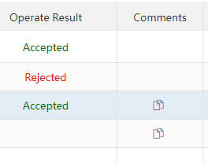

### DDD&SAQ

此功能是给DDD流程使用。用户先定义目录和流程，正式使用时先上传文档，按定义的流程一步步执行，子流程可以审核通过/不通过，可以添加备注、添加额外图片和文档，也可以邮件通知指定的人员。执行到最后整个流程完成。

This function is used for DDD process. The user defines the directory and process first, uploads the document before formal use, and executes it step by step according to the defined process. The sub process can pass / fail approval, add notes, add additional pictures and documents, or notify the designated personnel by e-mail. Finally, the whole process is completed.

#### Engineering Documents

流程流转主界面。

左边树图：显示在目录管理中定义的目录树图。点击某一个节点，在右边视图显示该节点下所有流程一览表。

右边列表：显示当前流程一览，包括基站名、初始文档、流程状态等信息。

Process flow main interface.

Tree on the left: displays the directory tree defined in directory management. Click a node to display a list of all processes under the node in the right view.

List on the right: displays the current process list, including site name, initial document, process status, etc.

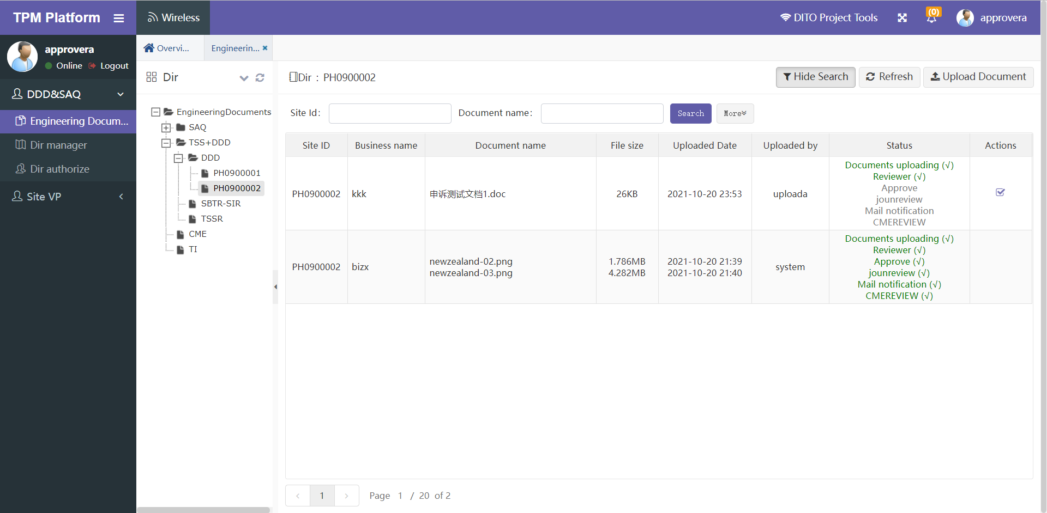

说明：Explain

1. 根据目录和流程的定义，具有权限的用户可点击上方”Upload Document”启动流程。点击后跳转到启动流程-上传文档界面：

According to the definition of directory and process, users with permission can click "upload document" above to start the process. Click to jump to the start process - upload document interface:

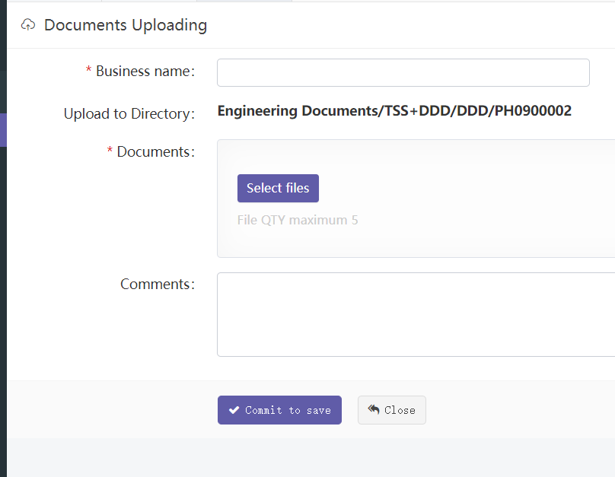

1. 正常启动流程后，会在上面的主界面新增一条流程记录。在状态栏可以看到绿色打勾的状态信息。

After the process is started normally, a process record will be added in the main interface above. You can see the status information with green tick in the status bar

1. 状态栏说明：

Status bar description

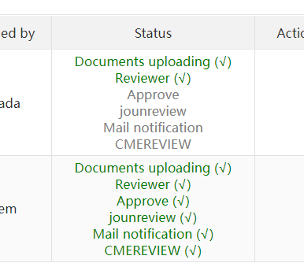

状态栏会把所有的子流程全部显示出来，绿色表示已完成，红色表示审核不通过，灰色表示还未开始。

括号中(√)表示已完成或审核通过，

括号中( x )表示审核不通过，

括号中( - )表示正在执行中还未结束。

All sub processes will be displayed in the status bar. Green means completed, red means failed, and gray means not started.

(√) in brackets indicates that it has been completed or approved,

( x ) in brackets indicates that the audit is not passed,

( - ) in parentheses indicates that it is being executed but not finished.

1. 流程执行到某一步骤具有操作权限的用户会看到下图Actions中的小图标，点击后可进入操作界面。

When the process is executed to a step, users with operation permission will see the small icon in Actions in the figure below. Click to enter the operation interface

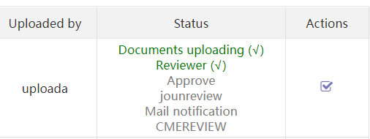

1. 流程操作界面：

Process operation interface

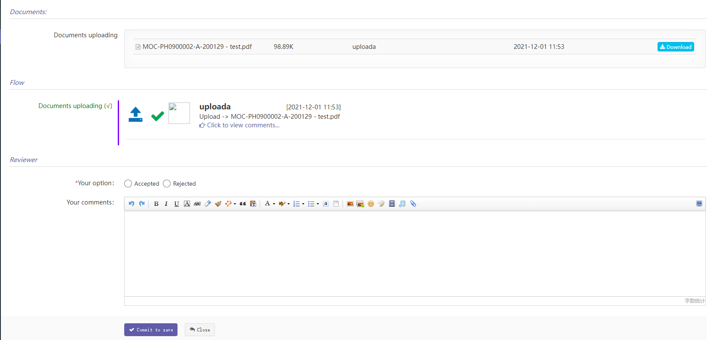

说明：Explain

1. “Documents”：展示所有本流程中使用到的文档。包括启动上传文档和中间的审核上传文档等，不包括富文本中的文件。

“Documents”：Show all documents used in this process. Including startup upload documents and intermediate audit upload documents, excluding files in rich text

1. “Flow”：展示所有已经操作过的历史记录信息。

“Flow”： Display all history information that has been operated

1. “Reviewer”：是当前需要操作的流程。

“Reviewer”： This is the current process to be operated

1. 如果是审核流程，需要选择审核通过或不通过，备注信息可选，备注是富文本输入，可添加图片等信息。

If it is an approval process, you need to select whether to approve or not. The remarks are optional. The remarks are rich text input, and pictures and other information can be added

1. 如果是顺序流程，只需确认下即可流转到下一流程。

If it is a sequential process, it can be transferred to the next process only after confirmation

1. 在主界面中点击状态列，会跳转到下图的流程详细页，此页面只能看不能操作。此页面会罗列出所有已执行的子流程历史信息和还未执行到的剩余子流程信息。

Click the status column in the main interface to jump to the process details page in the figure below. This page can only be viewed but not operated. This page will list the history information of all sub processes that have been executed and the remaining sub processes that have not been executed

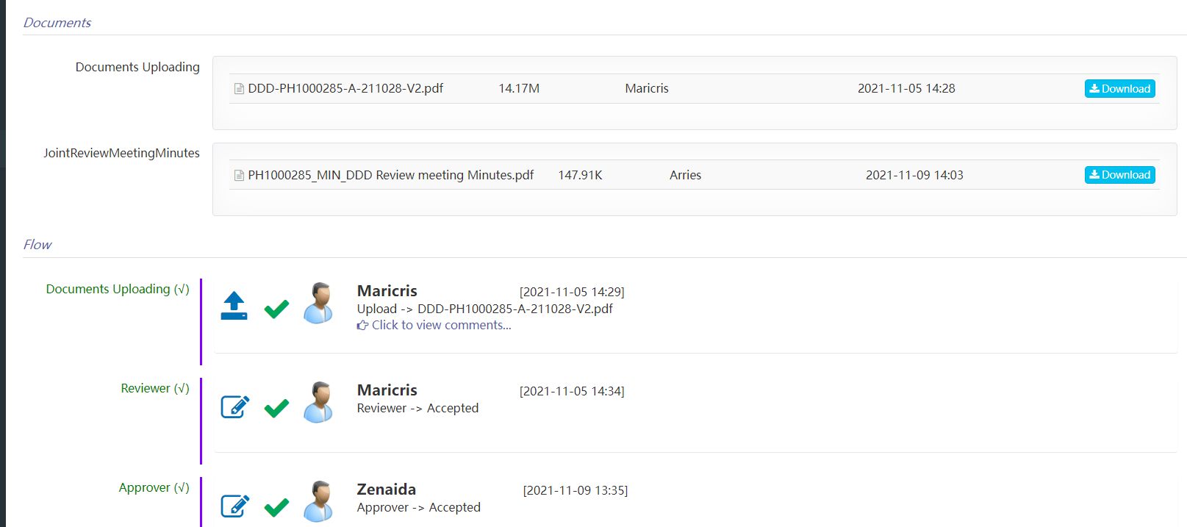

#### Dir manage

所有上传的文档均按定义好的目录格式存放。目录修改要慎重！

All uploaded documents are stored in a defined directory format. Be careful when modifying the directory!

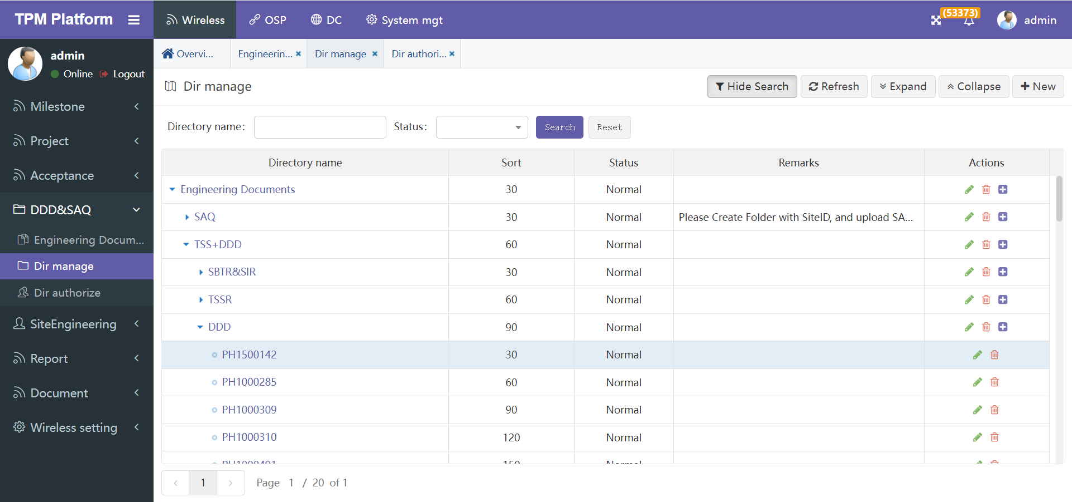

说明：

1. 为方便管理文档，根目录建议只需一个，系统默认已建好：Engineering Documents。
2. 二级目录和三级目录可以任意建，但命名要符合操作系统目录命名规范。
3. 四级目录必须是基站目录，系统会验证，如不是则不能建。

Description:

1. To facilitate document management, only one root directory is recommended. By default, the system has been established: engineering documents.
2. Secondary directory and tertiary directory can be built arbitrarily, but the naming shall comply with the naming specification of operating system directory.
3. The level 4 directory must be a site directory, which will be verified by the system. If not, it cannot be created.

#### Dir authorization

用户操作权限是按照目录来赋权。用户目录新建以后，除第四级基站目录外，这里会自动同步第一到第三级目录数据。

权限实际上只针对第三级目录赋值，如下图的”DDD”目录，该目录下所有定义的基站权限均与”DDD”目录权限一致。

User operation permissions are authorized according to the directory. After the user directory is created, in addition to the level 4 site directory, the level 1 to level 3 directory data will be automatically synchronized here.

In fact, permissions are only assigned to the third level directory, as shown in the "DDD" directory in the figure below. All the defined Site permissions in this directory are consistent with the "DDD" directory permissions.

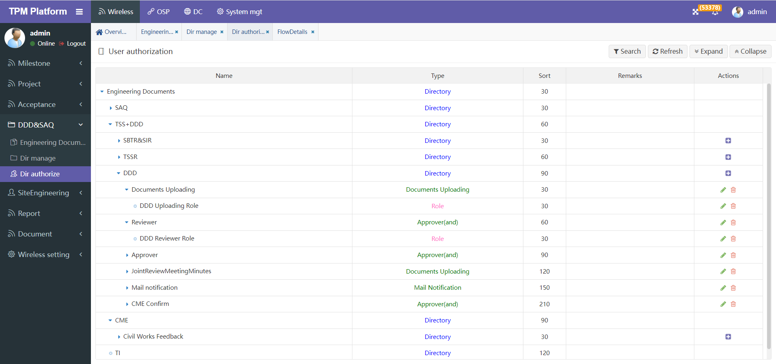

仅可以在第三级目录下定义流程与用户权限。

Process and user permissions can only be defined under the third level directory.

且第一个启动子流程必须要选择上传文档。

And the first startup sub process must choose to upload documents.

流程定义说明：

Process definition Description:

1. 点击三级目录后的”+”按钮，可新增一个子流程：

Click the "+" button behind the three-level directory to add a sub process

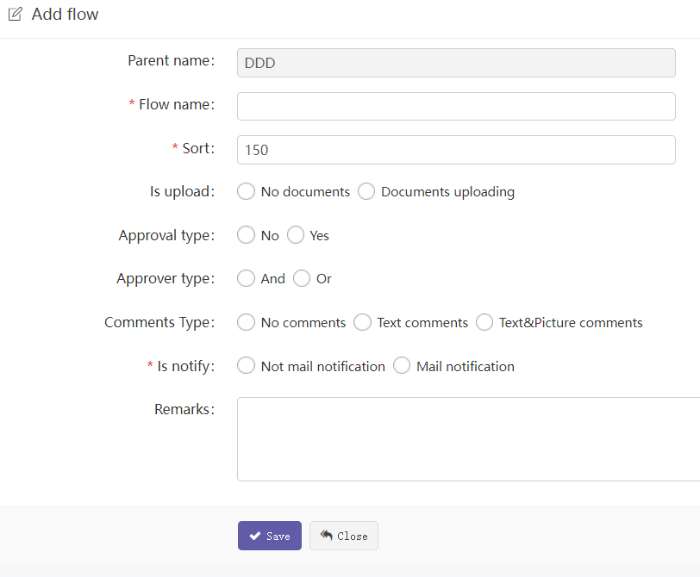

“Flow name”：子流程名称。

Sub process name

“Sort”：此子流程在整个流程中的位置。流程严格按此顺序流转。

The position of this sub process in the whole process. The process flows strictly in this order

“Is upload”：是否上传文档。第一个启动子流程必须选可上传。

Whether to upload the document. The first startup sub process must be uploaded

“Approval type”：是否审核类子流程。

Approve sub process

“Approver type”：审核类型，审核人之间的审核关系。

Approval type, approval relationship between approvers.

And表示同时审核通过才算审核通过，

Or表示只要一个用户审核通过就算通过。

And indicates that the approval is passed only when it is approved at the same time,

Or means that as long as a user passes the audit, it will be passed.

“Comments type”：备注类型。无备注/简单文本备注/富文本备注

Note type. No comments / simple text comments / rich text comments

“Is notify”：本子流程是否邮件通知类子流程。

Is this sub process a mail notification sub process

“Remarks”：备注。Remarks

1. 点击每个子流程后的”+”按钮，可新增一个且只能一个用户角色，表示该流程的权限用户：

Click the "+" button after each sub process to add one and only one user role, indicating the authorized user of the process

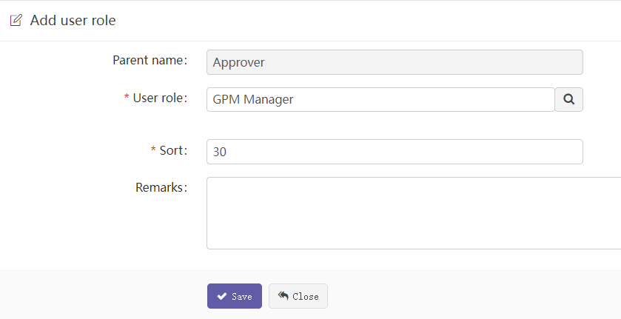

角色可通过弹出框选择。对于邮件通知类，会自动通知该角色下用户。

The role can be selected through the pop-up box. For the mail notification class, users in this role will be automatically notified.

### DDD&Config

DDD配置参数管理模块。

DDD Configuration parameter management module.

#### Database

本菜单给管理员管理所有DDD配置参数。是参数的全集。

下面的菜单: Database V1…等 则是给非管理员管理部分配置参数，是个子集。

This menu allows the administrator to manage all configuration parameters. Is the complete set of parameters.

The following menu: Database V1... Is a subset of configuration parameters for non administrator management.

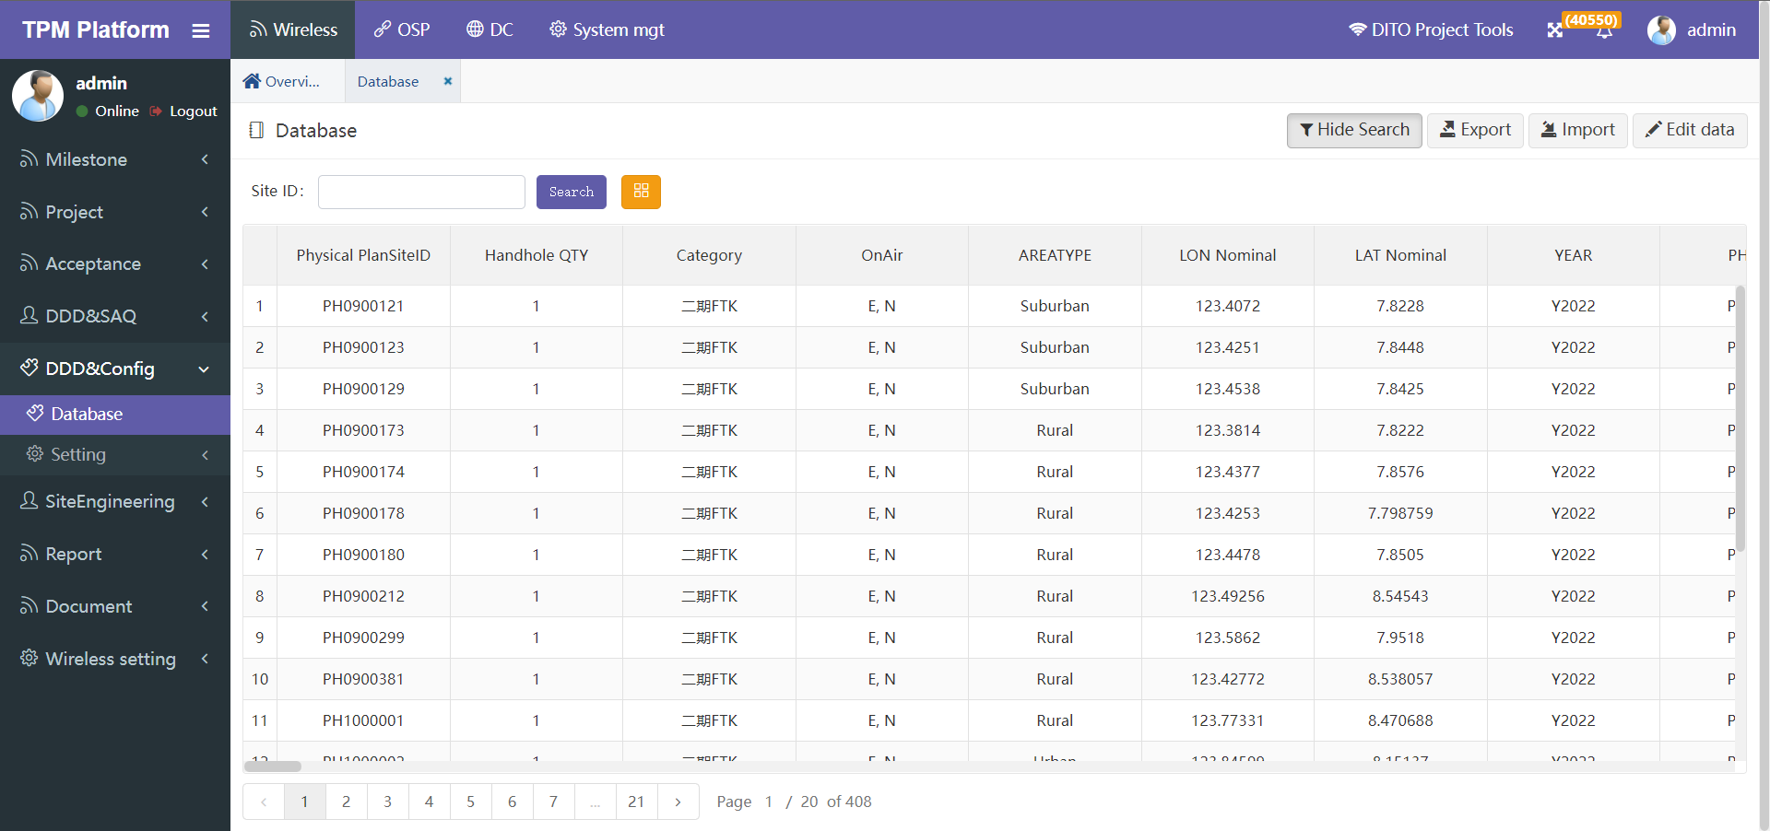

* **功能说明： Function description**

1. 本功能主要为项目组管理员维护管理配置参数使用。

This function is mainly used by manager of the project team to maintain and manage configuration parameters

1. 基站查询“Search”功能可通过SiteId搜索模糊查询

The "search" function of site query can search fuzzy query through siteid

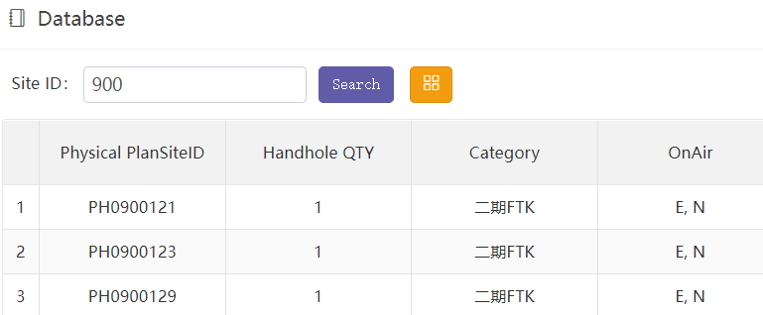

1. 黄色按钮”Column select”是选择本页面需要显示哪些字段，因为字段数量较多可选择少量显示，便于操作。

The yellow button " Column select" is used to select which fields need to be displayed on this page. Because there are a large number of fields, you can select a small number to display for easy operation.

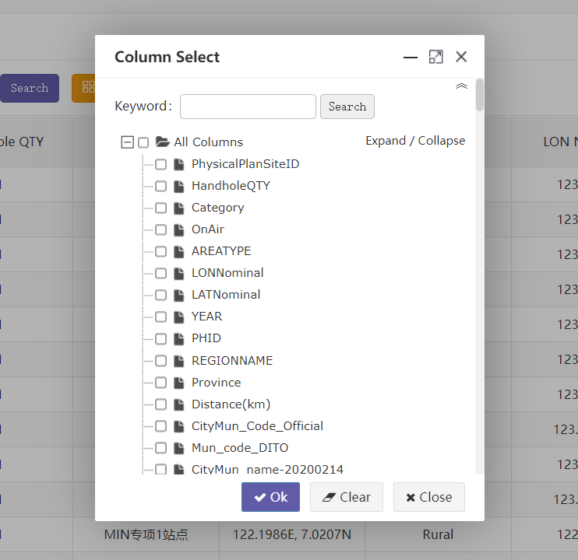

1. “Export” 导出所有基站数据（Excel文档）到本地。根据页面所筛选的数据行和数据列，点导出时，系统会导出当前页面所有分页的基站数据，所见即所得。

"Export" exports all site data (excel document) to the local. According to the data rows and columns filtered on the page, when clicking export, the system will export the site data of all pages on the current page, What you see is what you get.

1. “Import” 导如基站数据（Excel文档）到平台。

可选项：覆盖导入 和 追加导入。

如果是覆盖导入，则根据Site ID匹配覆盖原有数据。此功能慎用！有可能会导致数据被误操作清除。导入时除非勾选了是否覆盖导入，否则都是追加导入数据。

"Import" imports the site data (Excel document) to the platform. Optional: overwrite import and append import. If it is an overwrite import, the original data will be overwritten according to the Site ID match. Use this function with caution! It may cause the data to be cleared by misoperation. During import, the imported data is appended unless overwrite import is checked.

* **举例：导入基站数据步骤 Example**: importing site data

**说明：**基站导入务必使用平台下载EXCEL模板、严格按照如下步骤导入！

因为各人的EXCEL文件格式千变万化，会出现各种意想不到的情况。

* **步骤一 Step 1**

导入基站前先下载EXCEL数据模板。

点击按钮“Import”在弹出窗口中点击“Download template”。

说明：模板各列字段名称和排序根据系统中最新设置会变化，建议每次导入前都下载最新模板。

Download the Excel data template before importing the Site, click "import" and click "download template" in the pop-up window:

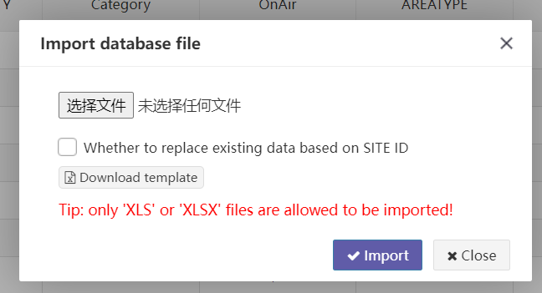

* **步骤二 Step 2**

先比对你本地的EXCEL参数文档各列与模板文档各列名称与顺序一致，

再将你本地的EXCEL参数文档数据拷贝到TXT文本，

*类似如下图：（从EXCEL粘贴出来的文本各列自动tab空格符间隔）*

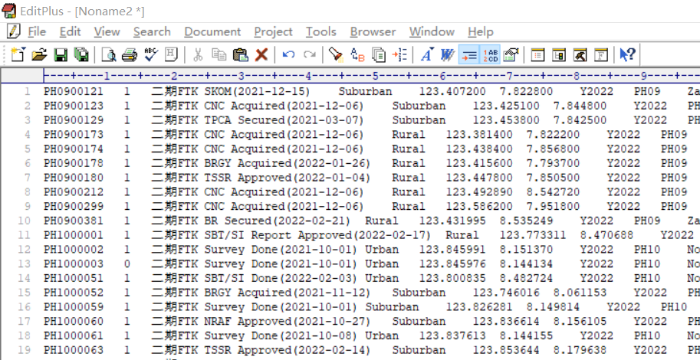

再将上面的TXT文本粘贴拷贝到EXCEL模板文件中。

*类似如下图：（导入系统的EXCEL数据必须是模板文档）*

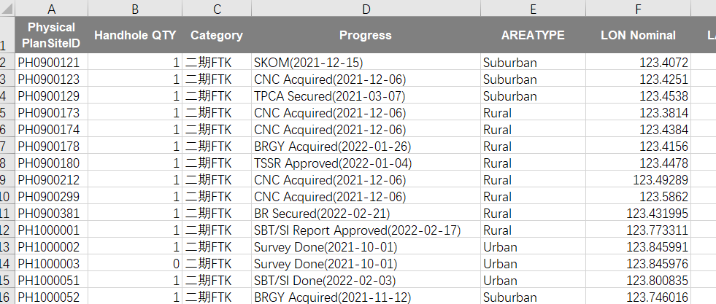

注：上述这样做的目的就是排除本地EXCEL中各种公式各种不可见字符等导致导入异常。

* **步骤三 Step 3**

点击选择文件，选择你要导入的excel文件。

Click Select File and select the excel file you want to import.

* **步骤四 Step 4**

选择是否勾选“是否根据基站ID替换已存在的数据”。如勾选则会覆盖相同Physical Plan Site ID的基站数据。如果不勾选，则当遇到相同ID时提示且全部数据导入失败。

注：导入时系统会验证每个字段是否正确，只要有一个验证不通过，则全部导入失败，待修改正确后重新导入。

Select whether to check "replace existing data according to site ID". If checked, the site data with the same physical plan site ID will be overwritten. If unchecked, a prompt will appear when the same ID is encountered and all data import fails.

Note: when importing, the system will verify whether each field is correct. As long as one of the fields fails to pass the verification, all the fields will fail to import. Import again after the modification is correct.

* 导入时常见错误：*（导入时系统再页面顶部显著颜色提示具体错误信息）*

1. 数据格式不对。

如：数字格式不对。如：使用文本导入 或者 数字型使用了特殊字符 ‘-‘ 等

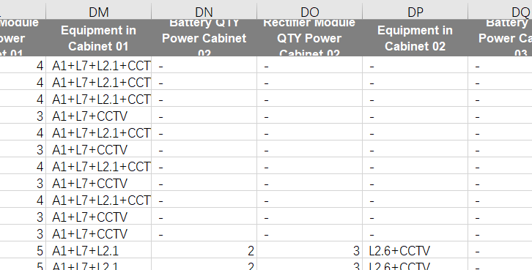

如：日期格式不对。正确格式：“yyyy-MM-dd”或“yyyy/MM/dd”

错误格式：“1900/1/1”或“01/02/2022”等。

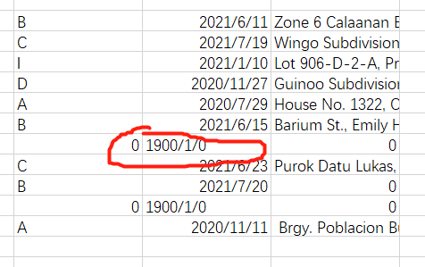

1. 列标题名称不匹配。

有空格、回车、不可见字符等都会导致标题无法匹配，所以务必使用模板文档。

1. 编辑参数：点击编辑按钮，页面进入编辑模式，再次点击退出编辑模式：

Edit site: click the Edit button, the page will enter the edit mode, and click again to exit the edit mode:

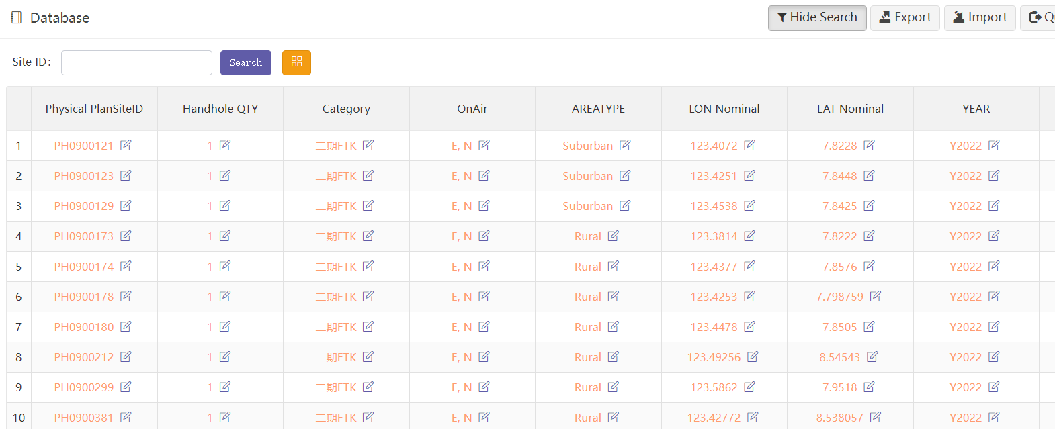

* 点击任何一个单元格，即可进入编辑该单元格的详情页

Click any cell to enter the details page of editing the cell. Other fields can be edited当前权限只有管理员与项目组可以修改。

Current permissions can only be modified by administrators and project groups

* 不同单元格数据类型会有不同的展示，类型有：文本、整数、日期、小数。

Different cell data types have different displays, including text, integer, date and decimal



系统会对输入的数据类型做验证，整数字段输入框不能输入字母等。

The system will verify the input data type. Letters cannot be entered in the integer field input box.

#### Database V1

为了管理方便，及分用户权限去管理不同的配置参数，将全集参数分成多份，分别授权不同用户使用不同的菜单进入管理。具体如何分配参数:

详见菜单：“Setting”-“Database column”

子集参数的功能完全同上面的菜单《Database》

In order to facilitate management and manage different configuration parameters according to user permissions, the full set of parameters is divided into multiple parts, and different users are authorized to use different menus to enter management. How to allocate parameters:

See the menu "setting" - "database column" for details.

The functions of subset parameters are exactly the same as those of the above menu database.

#### Database V2

同上 the same as above

#### Database V3

同上 the same as above

#### Ver Compare

**比较同一个参数集合，在不同日期（天）的差异。**

**Compare the differences of the same parameter set on different dates (days)**

如下图As shown below：

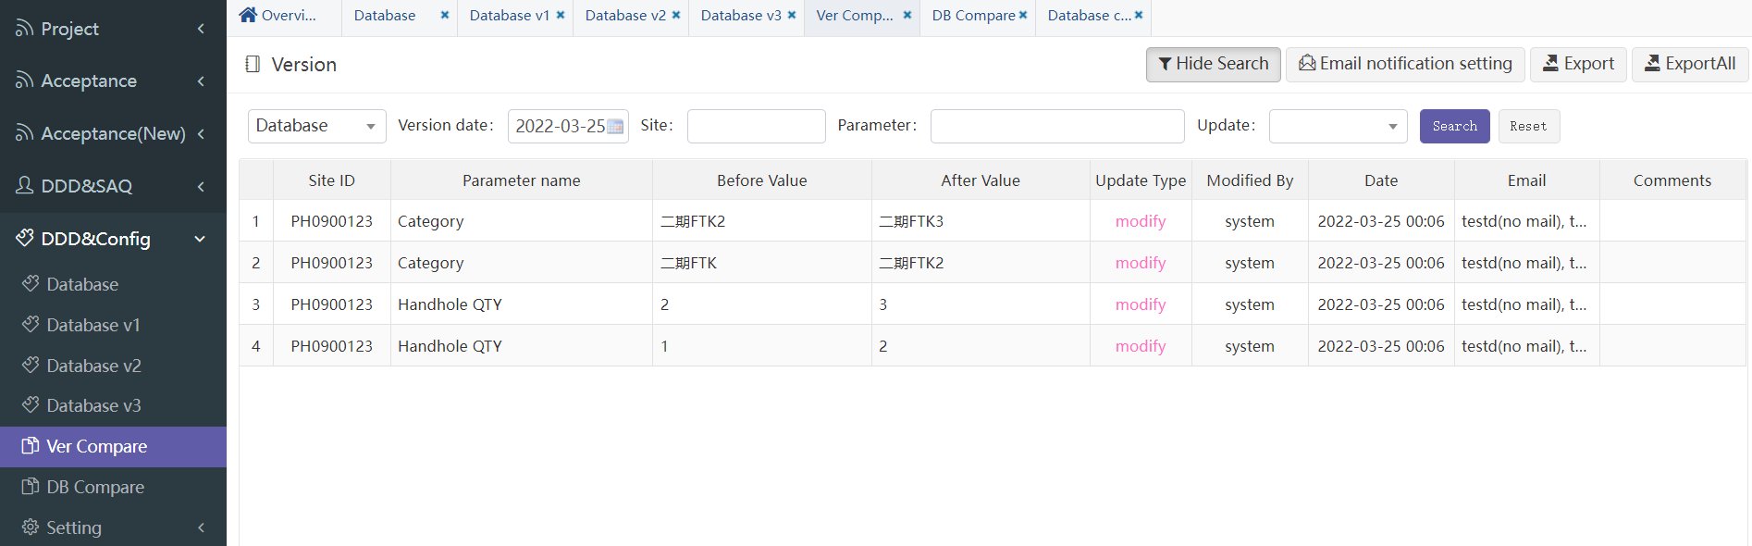

过滤项：

Database ： 需要比较的参数集合。

Version date： 需要查询的日期，表示该天哪些参数数值有变化。单位(天)。

Site：需要查询具体基站ID。

Parameter： 需要查询的具体参数名称。

Upate：可选两种：import/modify。前者表示批量导入是比较的差异值，

后者表示手工在页面修改的单个参数值。

Filter items：

Database ： select the database to compare。

Version date： The date to query indicates which parameter values have

changed on that day. Unit (day)。

Site：Site id。

Parameter： Parameter name。

Upate：two options：import/modify。

import indicates that the batch import is the difference value for comparison

modify indicates Represents a single parameter value manually modified

on the page。

###### Email notification

跳转到jump to： Setting -> Email user

###### Export

导出差异值清单。根据当前搜索条件过滤导出，所见即所得。

Export variance value list. Filter the export according to the current search criteria, what you see is what you get .

#### DB Compare

**比较当前时间点，全集参数与各子集参数之间的差异。**

**Compare the differences between the full set parameters and the subset parameters at the current time point..**

如下图As shown below：

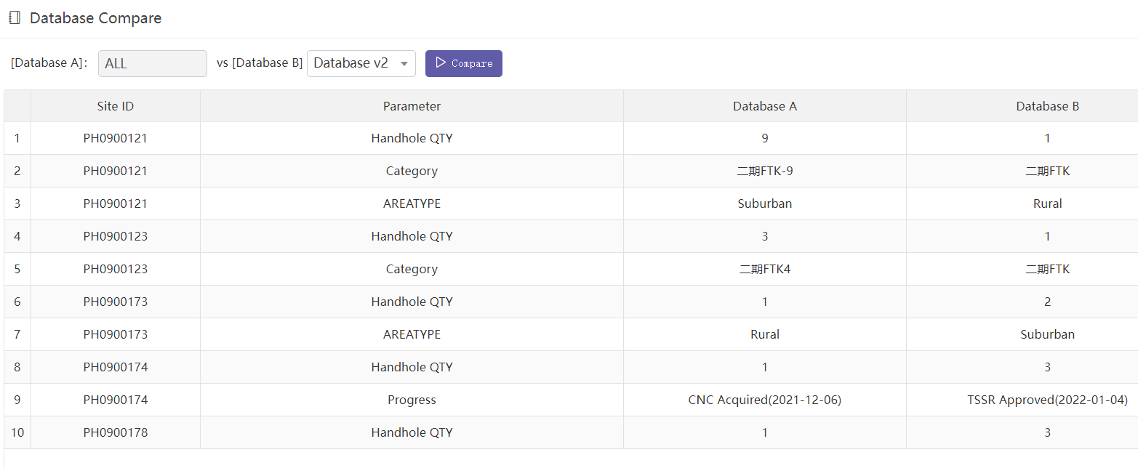

[Database A]： ALL -> 全集参数

[Database B]： Databse V2 -> V2子集参数

搜索结果就是以上两个参数集合的差异。

[Database A]： ALL -> Full set parameters

[Database B]： Databse V2 -> V2 set parameters

搜索结果就是以上两个参数集合的差异。

The search result is the difference between the above two parameter sets.

#### Setting

##### Column mgt

全集各参数字段维护。

Full set of parameter field maintenance.

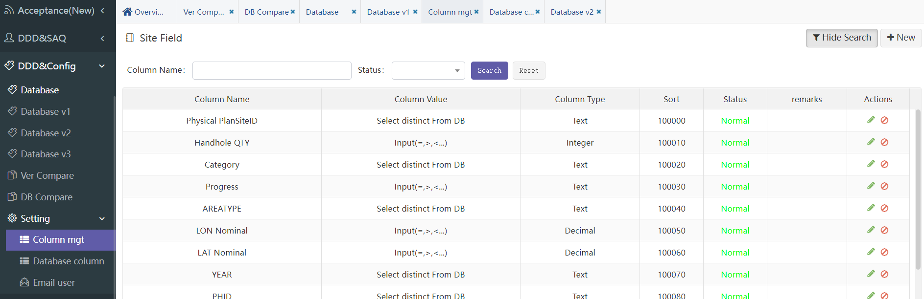

以上字段维护基本同：project -> database

The maintenance of the above fields is basically the same as: Project - > Database

##### Database column

各子集各参数字段维护。

Maintain the parameter fields of each subset.

以上字段维护基本同上

The maintenance of the above fields is the same as above.

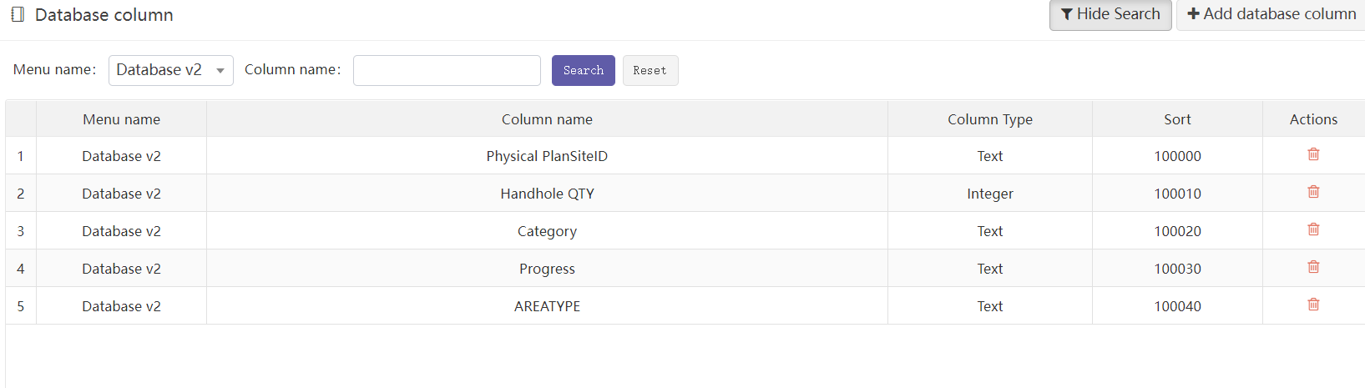

##### Email user

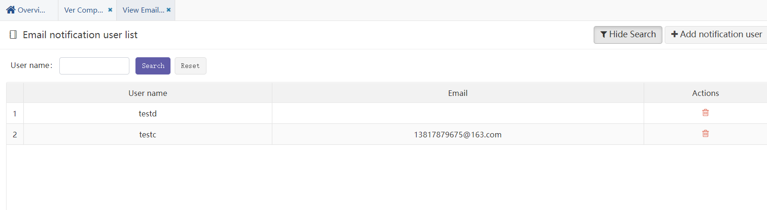

邮件通知功能：配置参数一旦有变化，需要通知用户设置。

如果手工修改单个参数，则邮件通知一封；

如果批量导入有多个参数修改，则将所有修改缩略后也只发送一封通知邮件。

Email notification function: once the configuration parameters are changed, the user needs to be notified of the settings.

If a single parameter is modified manually, an email notification will be sent;

If multiple parameters are modified in batch import, only one notification email will be sent after all modifications are abbreviated.

### SiteEngineering

工程文档管理流程。

功能同”DDD&SAQ”类似，但这里对流程定义做了较大改动。前者是顺序流程，审核不通过则返回前一个流程。而这里对流程的流转可以任意跳转。还有一个大的改动，就是将通知类流程结合到子流程中，在定义时可选。

Engineering document management process.

The function is similar to "DDD &amp; SAQ", but the process definition has been greatly changed here. The former is a sequential process. If it fails to pass the approval, it will return to the previous process. Here, the flow of the process can jump arbitrarily. Another big change is to combine the notification process into the sub process, which is optional when defined.

#### Process

流程流转主界面。

左边树图：显示在目录管理中定义的目录树图。点击某一个节点，在右边视图显示该节点下所有流程一览表。

右边列表：显示当前流程一览，包括基站名、初始文档、流程状态等信息。

Process flow main interface.

Tree on the left: displays the directory tree defined in directory management. Click a node to display a list of all processes under the node in the right view.

List on the right: displays the current process list, including site name, initial document, process status, etc.

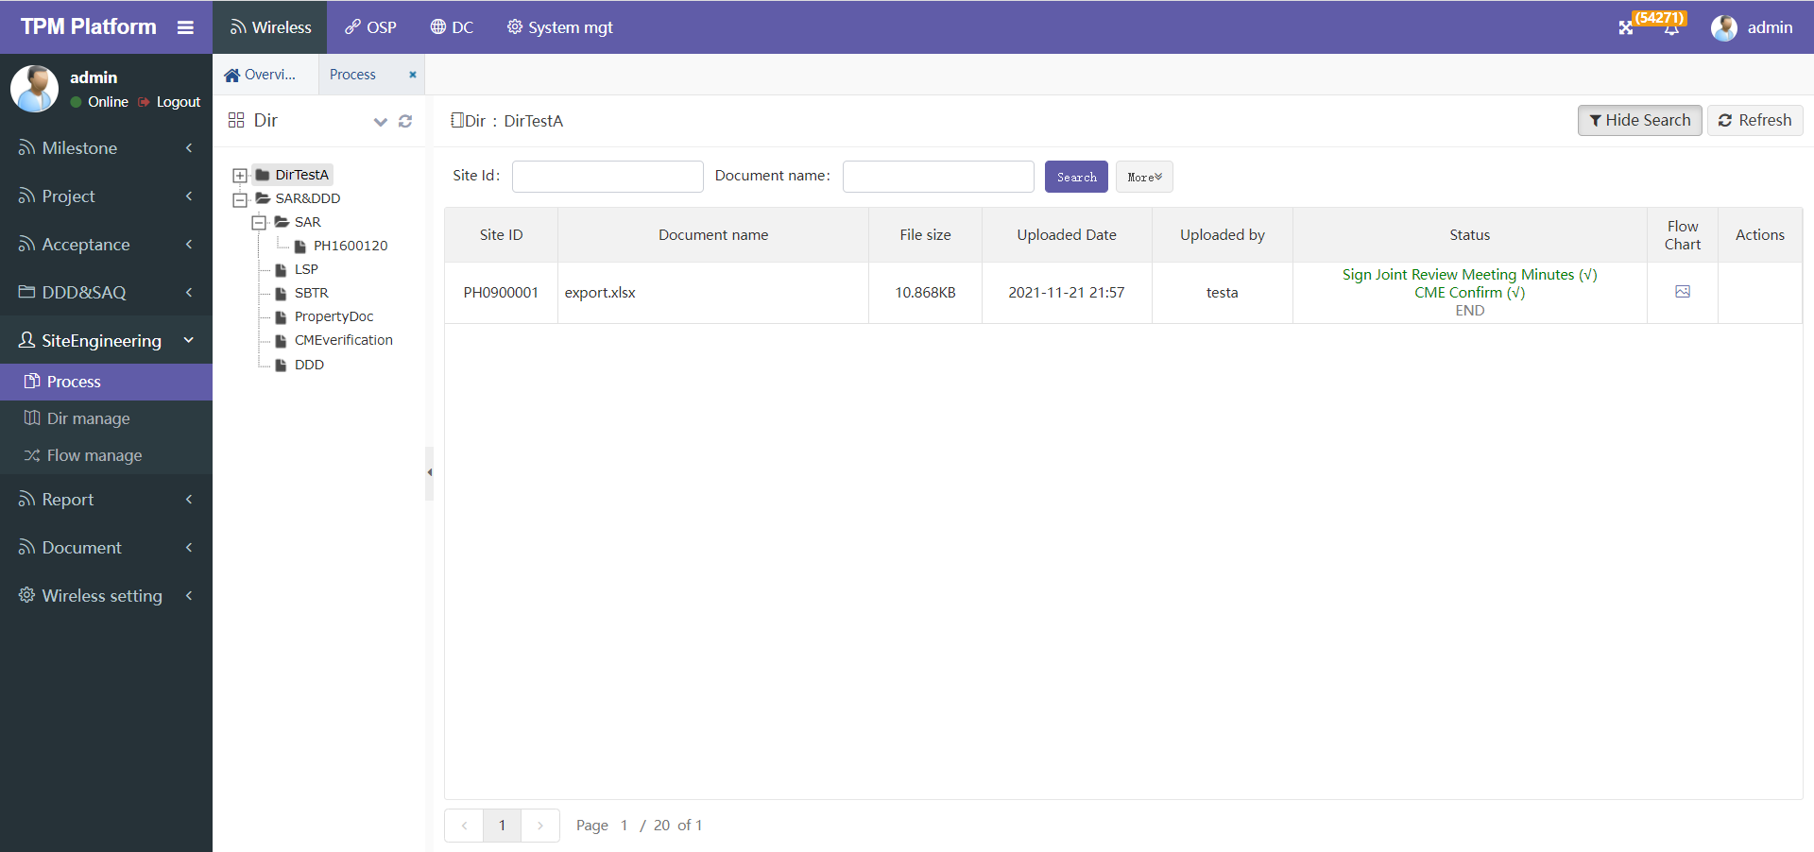

说明：Explain

1. 根据目录和流程的定义，具有权限的用户可点击上方”Start a New Flow”启动流程。点击后跳转到启动流程界面：

According to the definition of directory and process, users with permission can click "start a new flow" above to start the process. Click to jump to the start process interface:

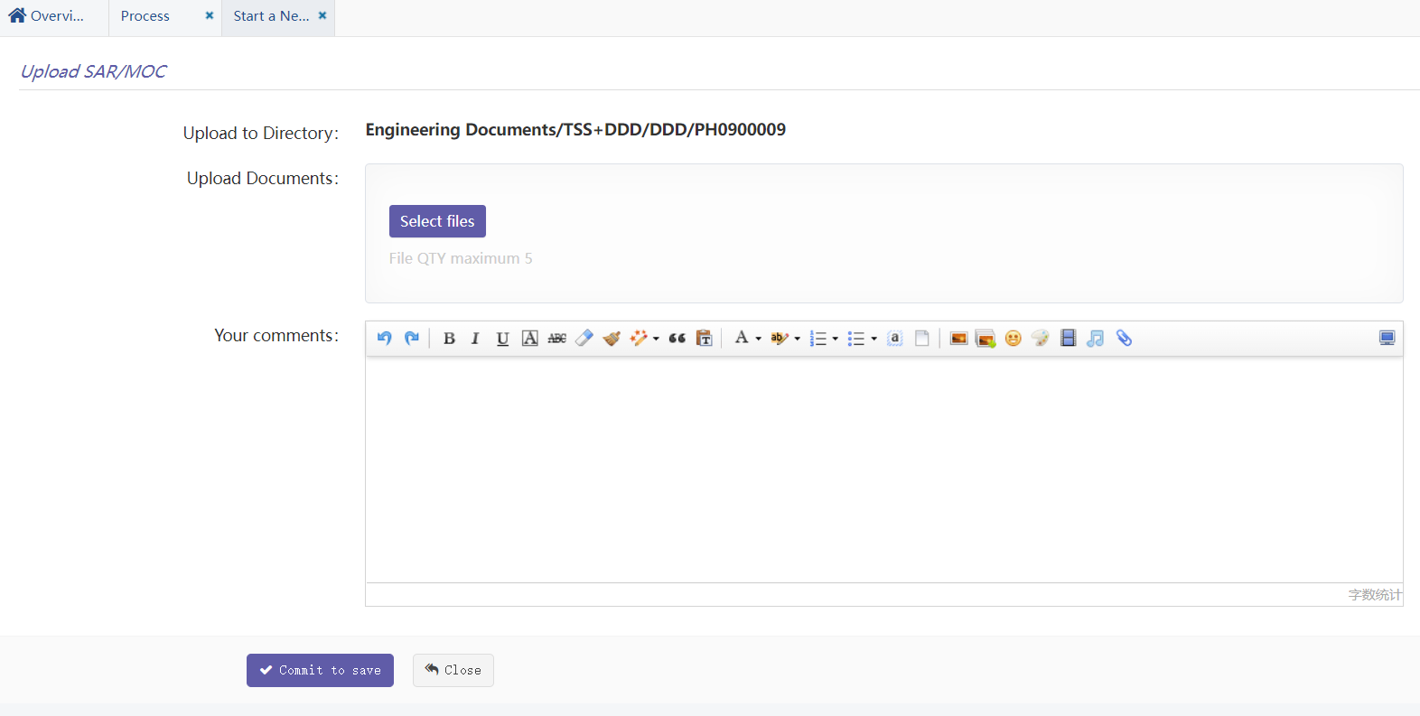

每个子流程界面项都是由流程定义的。详见”Flow manage”

Each sub process interface item is defined by the process. See " Flow management" for details

界面包括：上传文档、审核、备注。

The interface includes: upload document, review and remarks.

1. 正常启动流程后，会在上面的主界面新增一条流程记录。在状态栏可以看到绿色打勾的状态信息。

After the process is started normally, a process record will be added in the main interface above. You can see the status information with green tick in the status bar

1. 状态栏说明：

Status bar description

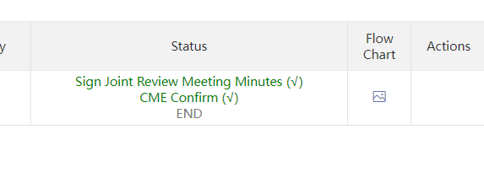

与DDD不同的是，这里的状态栏仅显示三个子流程：当前流程/前一个流程/后一个流程，绿色表示已完成，红色表示审核不通过，灰色表示还未开始。

括号中(√)表示已完成或审核通过，

括号中( x )表示审核不通过，

括号中( - )表示正在执行中还未结束。

Different from DDD, the status bar here only displays three sub processes: current process / previous process / next process. Green indicates completed, red indicates failed approval, and gray indicates not started.

(√) in brackets indicates that it has been completed or approved,

( x ) in brackets indicates that the audit is not passed,

( - ) in parentheses indicates that it is being executed but not finished.

1. 流程执行到某一步骤具有操作权限的用户会看到下图Actions中的小图标，点击后可进入操作界面。

When the process is executed to a step, users with operation permission will see the small icon in actions in the figure below. Click to enter the operation interface

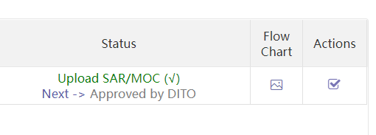

1. 流程操作界面：

Process operation interface

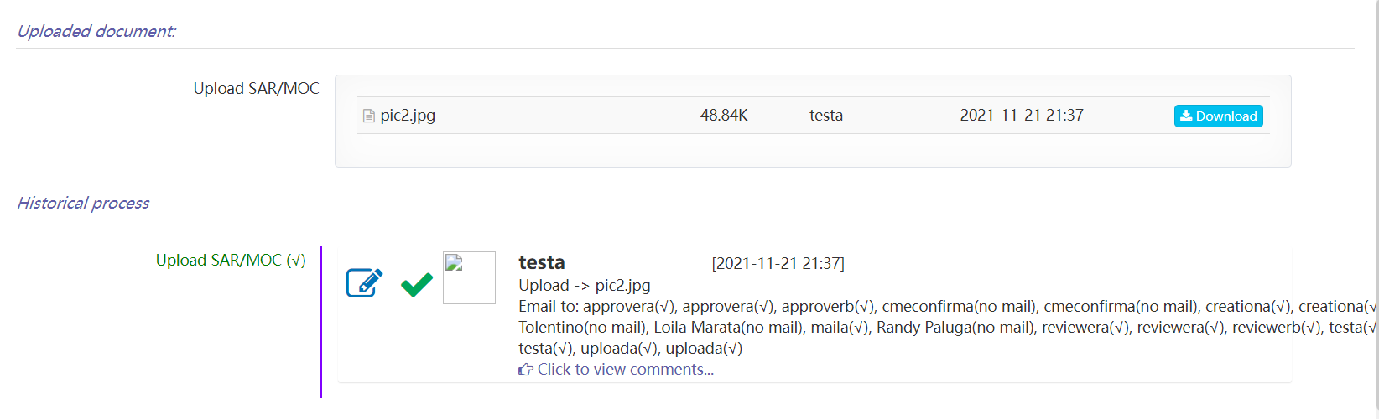

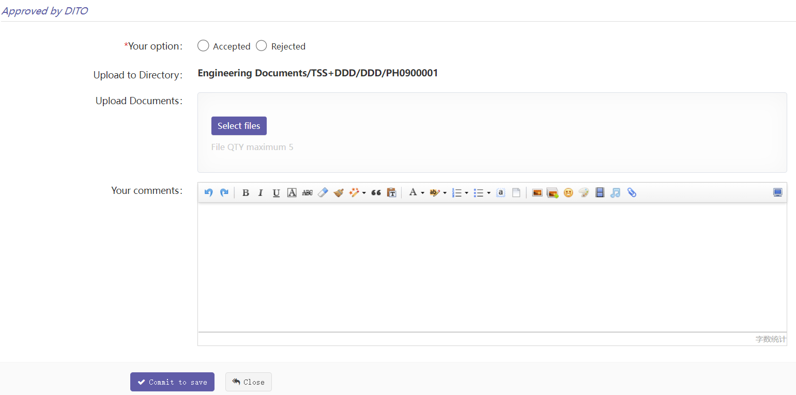

说明：Explain

1. “Uploaded document”：展示所有本流程中使用到的文档。包括启动上传文档和中间的审核上传文档等，不包括富文本中的文件。

Show all documents used in this process. Including startup upload documents and intermediate audit upload documents, excluding files in rich text

1. “History process”：展示所有已经操作过的历史记录信息。

Display all history information that has been operated

1. “Approved by DITO”：是当前需要操作的流程。

This is the current process to be operated

1. 如果是审核流程，需要选择审核通过或不通过，备注信息可选，备注是富文本输入，可添加图片等信息。

If it is an approval process, you need to select whether to approve or not. The remarks are optional. The remarks are rich text input, and pictures and other information can be added

1. 如果是顺序流程，只需确认下即可流转到下一流程。

If it is a sequential process, it can be transferred to the next process only after confirmation

1. 如果本流程需要上传文档，则选择文档上传。

If this process needs to upload documents, select document upload

1. 流程图 Flow chart

考虑这里的流程比较复杂。如要查看全局完整流程图可点击”Flow Chart”查看：

Consider the complexity of the process here. To view the global complete flow chart, click "flow chart" to view:

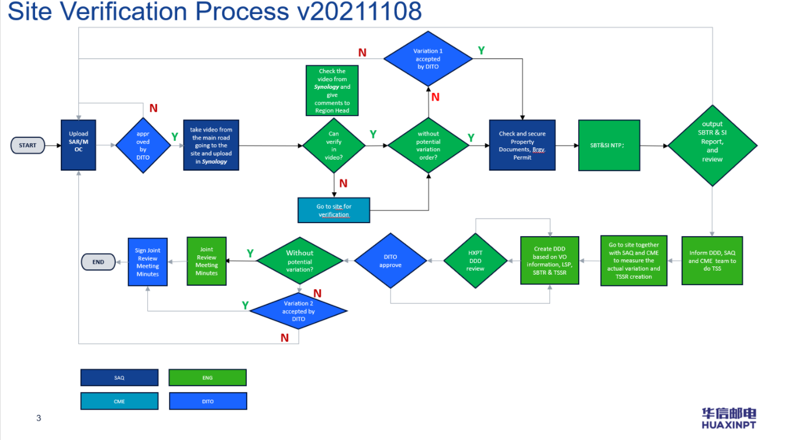

1. 在主界面中点击状态列，会跳转到下图的流程详细页，此页面只能看不能操作。此页面会罗列出所有已执行的子流程历史信息和还未执行到的剩余子流程信息。

Click the status column in the main interface to jump to the process details page in the figure below. This page can only be viewed but not operated. This page will list the history information of all sub processes that have been executed and the remaining sub processes that have not been executed.

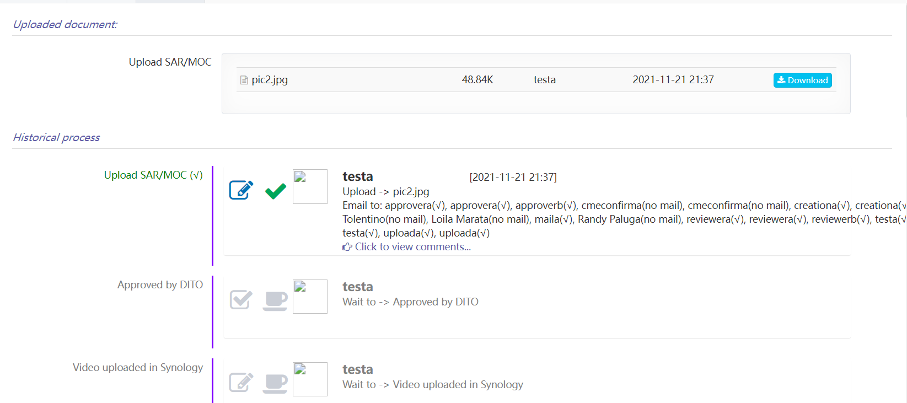

#### Dir manage

所有上传的文档均按定义好的目录格式存放。目录修改要慎重！

All uploaded documents are stored in a defined directory format. Be careful when modifying the directory!

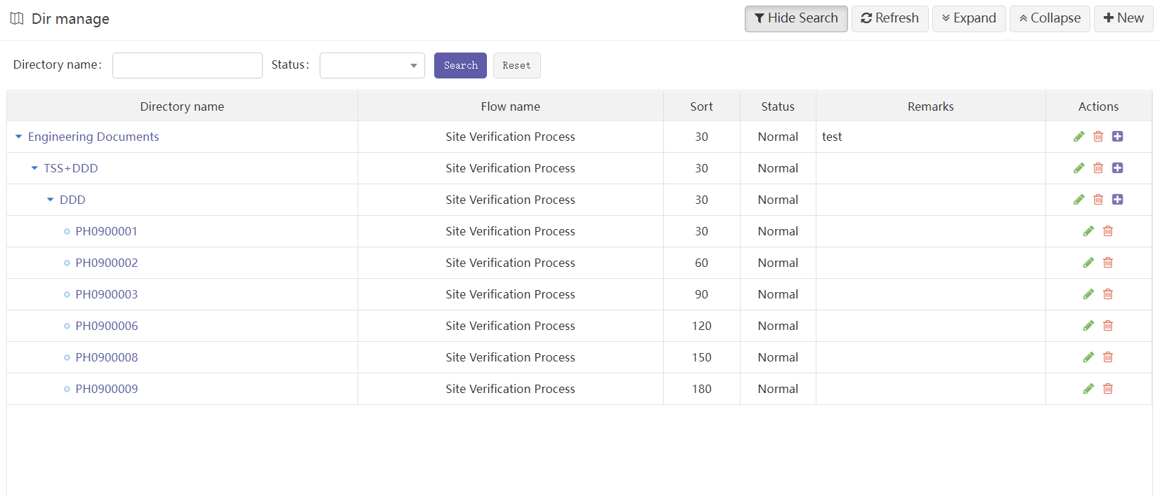

说明：

1. 为方便管理文档，根目录建议只需一个，系统默认已建好：Engineering Documents。
2. 二级目录和三级目录可以任意建，但命名要符合操作系统目录命名规范。
3. 四级目录必须是基站目录，系统会验证，如不是则不能建。
4. 目录定义的时候需要指定流程。也就是说以后该目录下所有的流程流转均这里指定流程去流转。

注意：流程一旦开始流转，已存在历史数据，此时如再去修改，会发生意想不到的情况！

Explain:

1. To facilitate document management, only one root directory is recommended. By default, the system has been established: engineering documents.
2. Secondary directory and tertiary directory can be built arbitrarily, but the naming shall comply with the naming specification of operating system directory.
3. The level 4 directory must be a site directory, which will be verified by the system. If not, it cannot be created.
4. The process needs to be specified when defining the directory. That is to say, in the future, all process flows under this directory are designated here.
5. Note: once the process starts to flow, historical data already exists. At this time, if you modify it again, unexpected situations will occur!

#### Flow manage

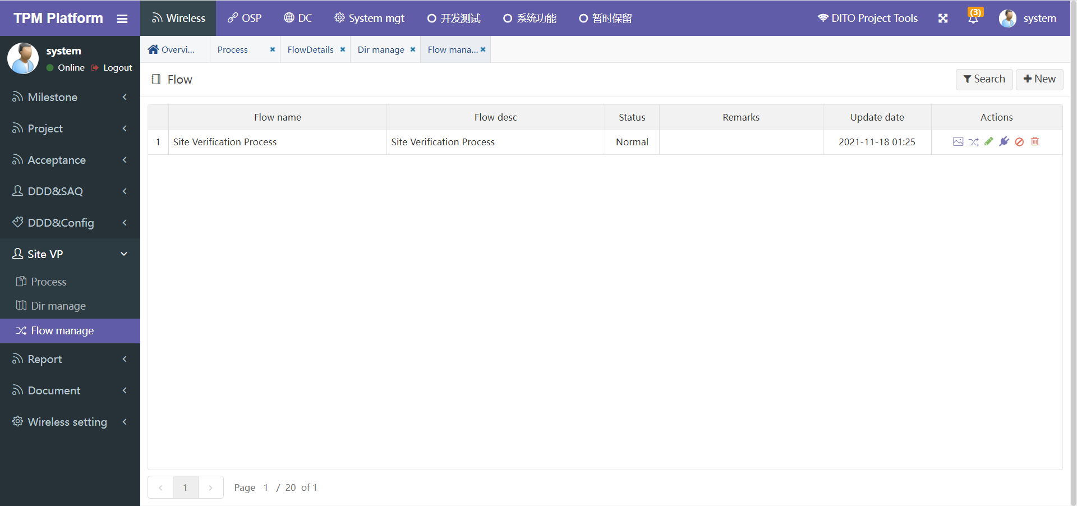

对于本功能模块，流程是在有限范围内自定义的。用户可以定义一个或多个流程，然后再目录管理中应用指定的流程。

For this function module, the process is customized in a limited range. Users can define one or more processes, and then apply the specified processes in directory management.

流程定义分两步：1、先定义整个父流程名称等信息。2、再定义各个子流程。

Process definition is divided into two steps: 1. First define the name of the whole parent process and other information. 2. Then define each sub process.

* **父流程定义：Parent process definition**

1. 点击”New”跳转到新建父流程界面：

Click "new" to jump to the new parent process interface

1. 只需定义流程简称和描述即可。

Just define the process abbreviation and description

* **子流程定义：Sub process definition**

1. 点击如下图标，可进入子流程定义界面：

Click the following icon to enter the sub process definition interface

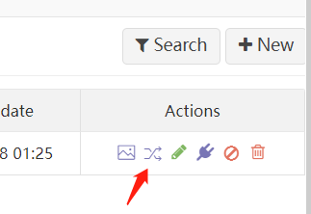

1. 子流程定义界面：

Sub process definition interface

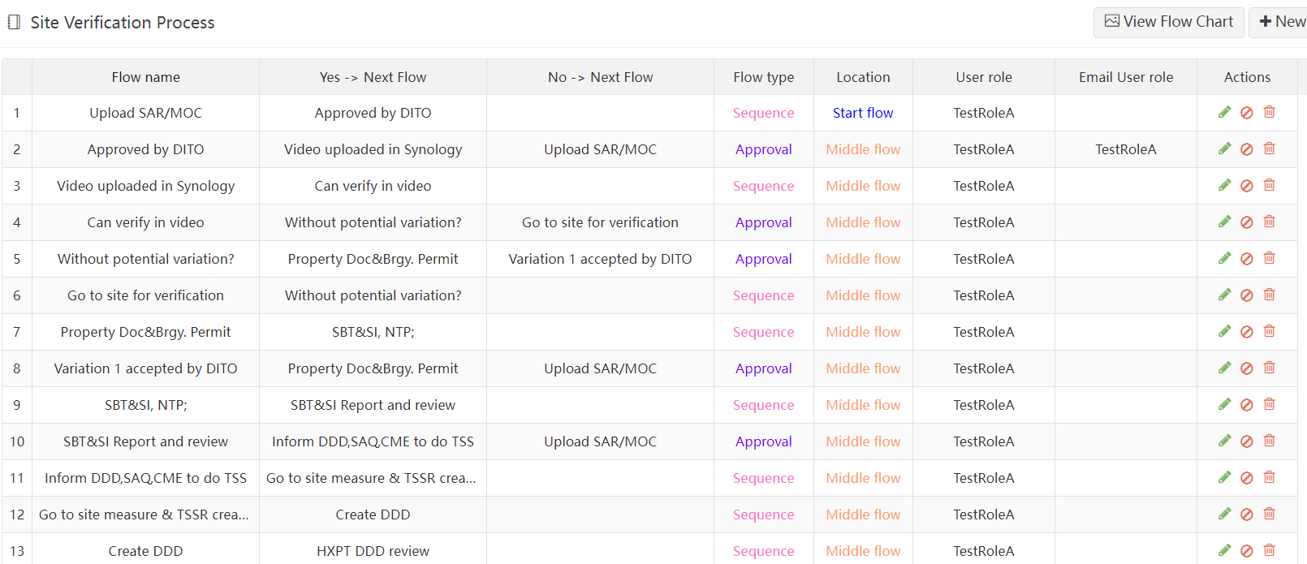

1. 点击”View Flow Chart”查看完整流程图。

Click " View Flow Chart " to view the complete flow chart

1. 点击”New”可新建一个流程，同样点击每行行尾的编辑图标可进入编辑页面：

Click "New" to create a new process. Similarly, click the edit icon at the end of each line to enter the edit page

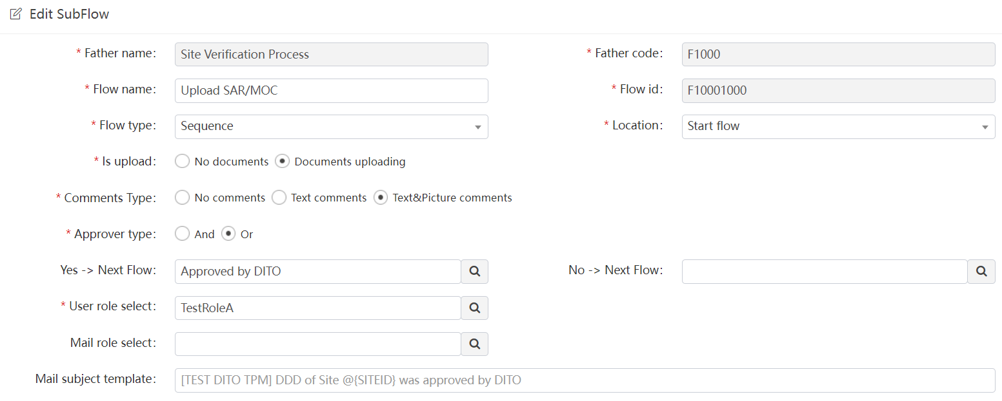

“Flow name”：子流程名称。

Sub process name

“Flow type”：子流程类型。分2种：顺序流程/审核流程。前者执行完成后就跳转到

下一个；后者审核通过跳转到下一个，不通过则跳转到指定的其他子流

程。

Sub process type. There are two types: sequential process / approval process. After the former is executed, it jumps to the next one; If the latter is approved, it will jump to the next one; if not, it will jump to other specified sub processes.

“Location”：位置。分3种：Start flow/ Middle flow/End flow。其中起始流程只能有

一个；结束流程可有多个。

Location. There are three types: start flow / middle flow / end flow. There can only be one starting process; There can be more than one end process.

“Is upload”：是否上传文档。Upload document

“Comments type”：备注类型。无备注/简单文本备注/富文本备注

Note type. No comments / simple text comments / rich text comments

“Approver type”：审核类型，审核人之间的审核关系。

Approval type, approval relationship between approvers.

And表示同时审核通过才算审核通过，

Or表示只要一个用户审核通过就算通过。

And indicates that the approval is passed only when it is approved at the same time,

Or means that as long as a user passes the audit, it will be passed.

“Is notify”：本子流程是否邮件通知类子流程。

Is this sub process a mail notification sub process

* 流程测试：Process test

子流程在新建的时候不会去验证是否合法。但一旦整个流程新建完成，父流程需要测试验证通过后才能正常使用。点击父流程行尾按钮可测试。测试是否合法的内容有：

When a sub process is created, it will not verify whether it is legal. However, once the whole process is created, the parent process needs to be tested and verified before it can be used normally. Click the end of the parent process line button to test. The contents to test whether it is legal include:

1. 有且只能有一个"发起流程"
2. 至少要有一个"结束流程"
3. 非结束流程：

顺序流程：后一个流程不能为空，前一个流程必须为空

审核流程：后一个流程不能为空，前一个流程不能为空

1. 角色不能为空
2. 色核查类型不能为空
3. 结束流程：下一个流程/前一个流程均为空
4. 前一个及后一个流程编号如果不为空，则不能等于自己
5. 上传文档和注释必须选一个
6. 如果选了邮件通知，则邮件标题和内容模板必须要选
7. There can be only one "initiation process"
8. There must be at least one "end process"
9. Non closing process:

Sequential process: the latter process cannot be empty, and the previous process must be empty

Approval process: the latter process cannot be blank and the previous process cannot be blank

1. Role cannot be empty
2. Color check type cannot be empty
3. End process: the next process / previous process is empty
4. If the previous and subsequent process numbers are not empty, they cannot be equal to their own
5. You must select one to upload documents and comments
6. If mail notification is selected, the mail title and content template must be selected

### Report

#### Daily rpt

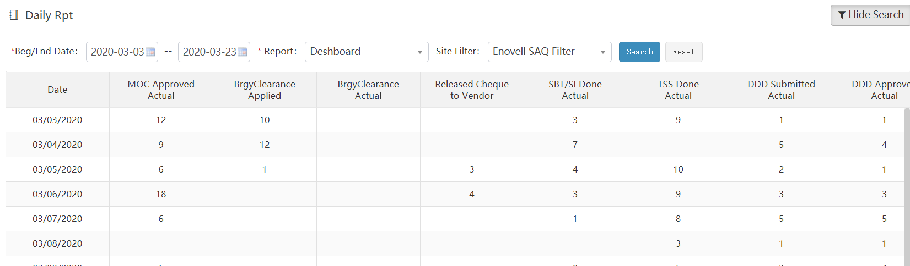

1. 条件选项：

开始日：报表统计的开始时间

结束日：报表统计的结束时间

自定义的报表：预先已经自定义的报表，这里必须要选一个。

基站筛选策略：要统计哪些基站数据，根据所选筛选策略统计，可以不选，不选即统计全部基站。

1. 报表内容数据：

第一列：前面选择的日期天，从开始日到结束日的每一天数据，一天一行。

其他列：自定义报表中每一列所对应的统计信息数据。

**注：**目前系统统计的时间范围是从2019年10月1日到2020年12月31日

1. Condition options:

Start date: the start time of report statistics

End date: the end time of report statistics

Custom report: a report that has been customized in advance. You must select one here.

Site filtering strategy: the site data to be counted can be counted according to the selected filtering strategy. If it is not selected, all sites will be counted.

1. Report content data:

The first column: the previously selected date, each day from the start date to the end date, one row per day.

Other columns: customize the statistics data corresponding to each column in the report.

Note: at present, the time range of system statistics is from October 1, 2019 to December 31, 2020

#### Weekly rpt

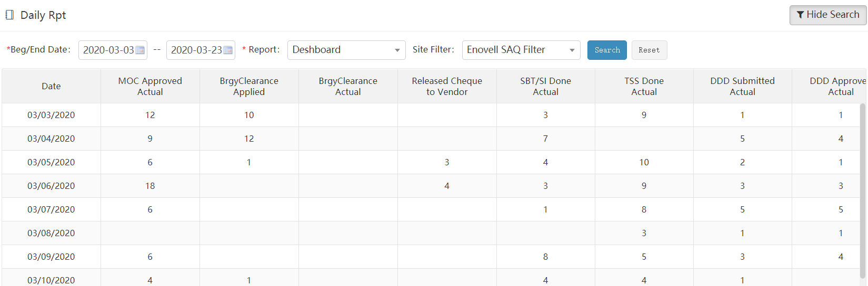

1. 条件选项：

开始周：报表统计开始周

结束周：报表统计结束周

自定义的报表：预先已经自定义的报表，这里必须要选一个。

基站筛选策略：要统计哪些基站数据，根据所选筛选策略统计，可以不选，不选即统计全部基站。

1. 报表内容数据：

第一列：前面选择的日期周，从开始周到结束周的每一周数据，一周一行。

其他列：自定义报表中每一列所对应的统计信息数据。

**注：**目前系统统计的时间范围是从Week-40(Mon-09/30/2019)到Week-53(Mon-12/28/2020)

周的计算是按每周一到周日算一周，跨年的周会少几天。

1. Condition options:

Start week: report statistics start week

End week: the end week of report statistics

Custom report: a report that has been customized in advance. You must select one here.

Site filtering strategy: the site data to be counted can be counted according to the selected filtering strategy. If it is not selected, all sites will be counted.

1. Report content data:

The first column: the date week selected earlier, the data of each week from the start week to the end week, and one week row.

Other columns: customize the statistics data corresponding to each column in the report.

Note: at present, the time range of system statistics is from week-40 (mon-09 / 30 / 2019) to week-53 (mon-12 / 28 / 2020),The week is calculated from Monday to Sunday, and the week in the new year will be a few days less.

#### Monthly rpt

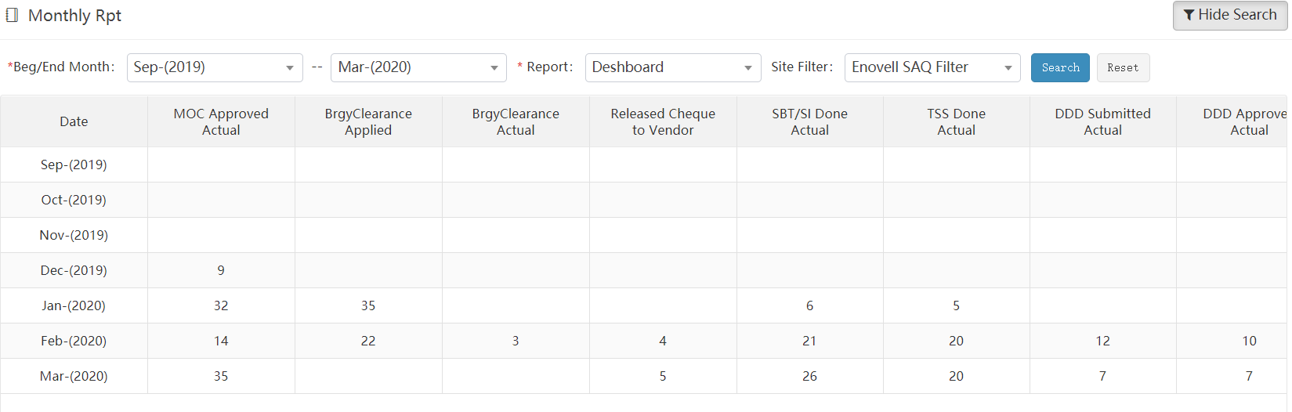

1. 条件选项：

开始月：报表统计开始月

结束月：报表统计结束月

自定义的报表：预先已经自定义的报表，这里必须要选一个。

基站筛选策略：要统计哪些基站数据，根据所选筛选策略统计，可以不选，不选即统计全部基站。

1. 报表内容数据：

第一列：前面选择的日期月，从开始月到结束月的每一月数据，一月一行。

其他列：自定义报表中每一列所对应的统计信息数据。

**注：**目前系统统计的时间范围是从Oct-(2019)到Dec-(2020)

1. Condition options:

Start month: the start month of report statistics

End month: end month of report statistics

Custom report: a report that has been customized in advance. You must select one here.

Site filtering strategy: the site data to be counted can be counted according to the selected filtering strategy. If it is not selected, all sites will be counted.

1. Report content data:

First column: the date and month selected earlier, the data of each month from the start month to the end month, with one row for each month.

Other columns: customize the statistics data corresponding to each column in the report.

Note: at present, the time range of system statistics is from Oct - (2019) to Dec - (2020)

#### Report design

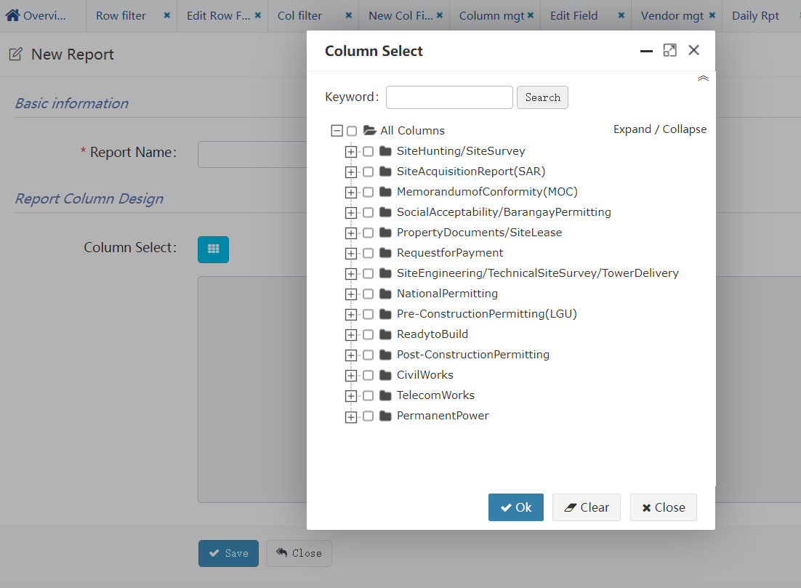

报表的已定义，只定义报表显示的字段，至于统计的时间跨度、基站范围，均在各个日报、周报、月报中来灵活筛选。

* 新建自定义报表步骤：

1. 定义报表名称。
2. 选择需要统计的字段列表。

目前可供统计的字段列表均为日期型字段。

统计逻辑：该字段日期为具体哪一天的，即统计该天计数1。

The report has been defined. Only the fields displayed in the report are defined. The statistical time span and site range are flexibly filtered in each daily, weekly and monthly report.

* To create a new custom report:

1. Define the report name.
2. Select the field list to be counted.

At present, the fields available for statistics are all date fields.

Statistical logic: the date of this field is the specific day, that is, the count of this day is 1.

#### DailyReportMailUser

每日产生的Excel报表需要每天发送邮件给指定用户。发送用户可以在这里设置。

每日下午6点发送，每人收到邮件的具体时间会不同。

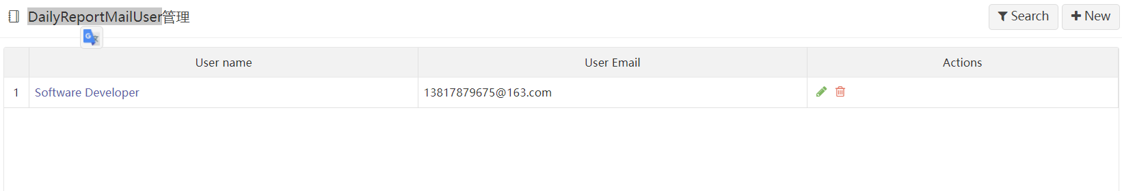

The daily generated excel report needs to send mail to the specified user every day. The sending user can set it here.

It will be sent at 6:00 p.m. every day, and the specific time when each person receives the mail will be different.

### Document

#### Download

此处统一维护OSP基站Milestone上传的相关文档。

Relevant documents uploaded by milestone of OSP Sites are maintained here.

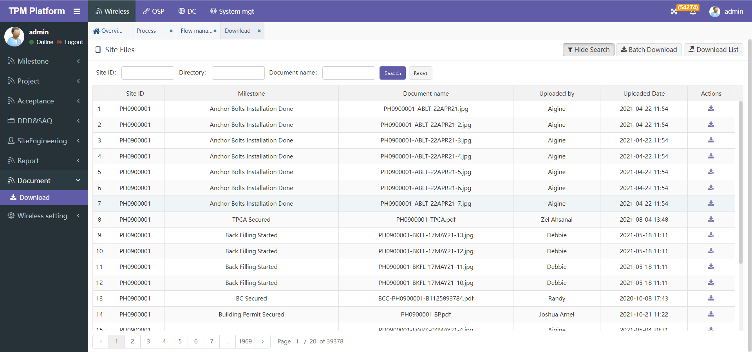

* Search

通过”Site ID”可搜索出所有该基站下的文档列表。

Use "site ID" to search the list of all documents under the site.

通过” Directory”可搜索所有对应的Milestone下的文档列表。

Use "directory" to search the document list under all corresponding milestone.

通过” Document name”可通过名称模糊搜索文档。

"Document name" allows you to search for documents by name blur.

* Batch download

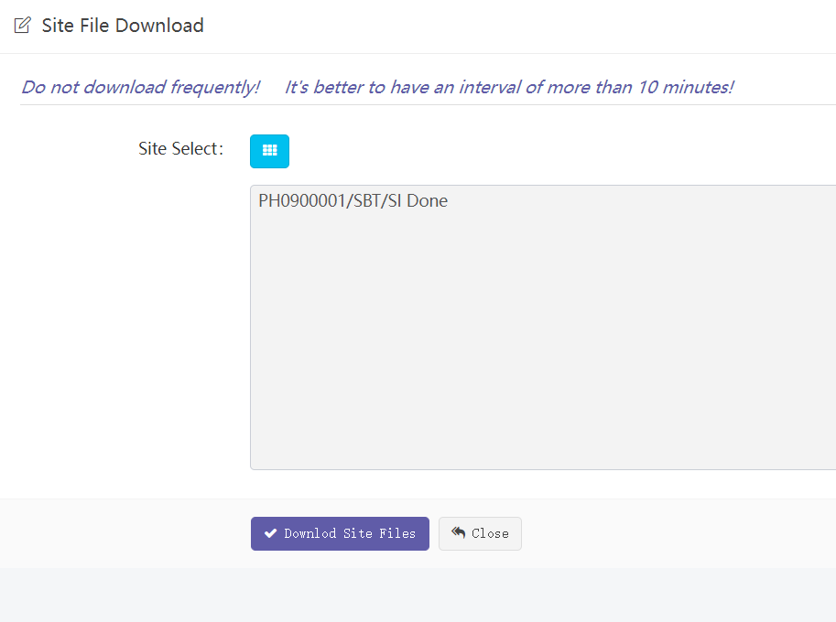

可选择指定基站的指定Milestone下载相应的文档。文档将被压缩打包后下载到本地。

You can select the specified milestone of the specified site to download the corresponding document. The document will be compressed, packaged and downloaded locally.

* Download list

下载所有文档EXCEL清单。

Download excel list of all documents

### Wireless setting

#### Filter

##### Row filter

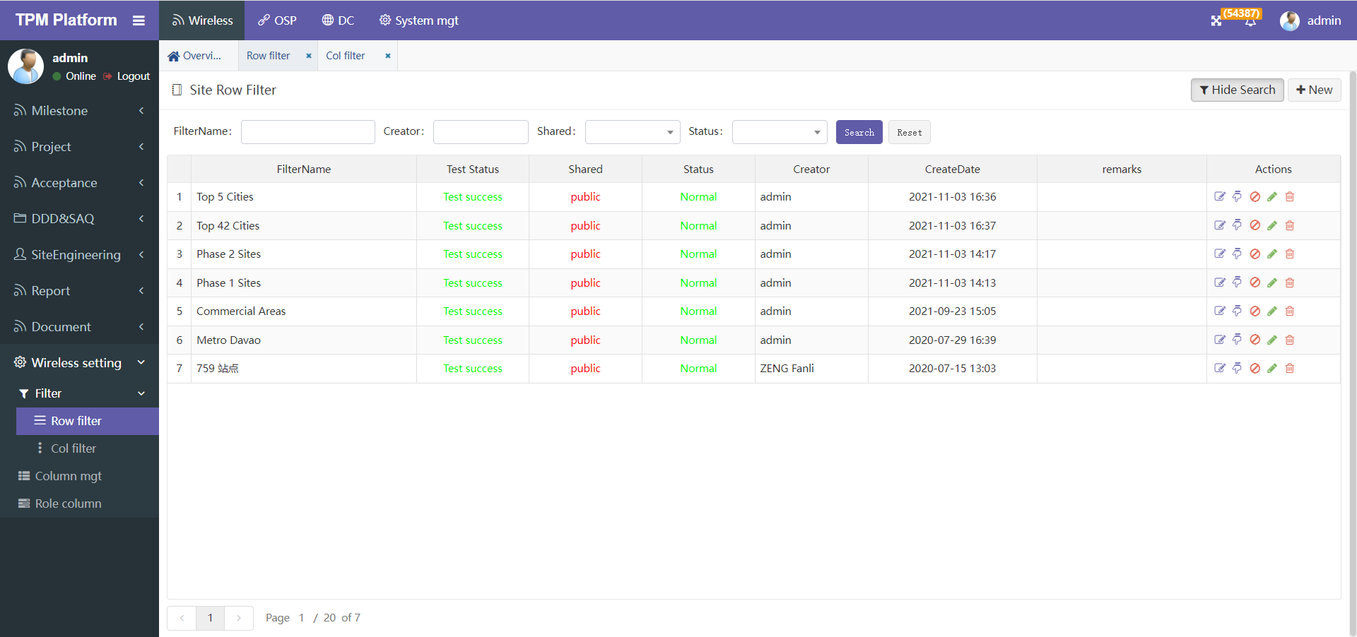

Row Filter是根据基站已有字段过滤基站数据。

简单的说就是从600多个基站中，筛选出一部分我想看的基站子集。将这个筛选规则事先定义保存好，下次在功能菜单中可选择这个策略来筛选基站。

Row filter is used to filter the site data according to the existing fields of the site.

To put it simply, select a subset of the sites I want to see from more than 600 sites. Save the filter rule defined in advance. Next time, you can select this policy in the function menu to filter the site.

**举例：如果想要查看SAQ Vendor是**[**Enovell**](http://www.sinohxph.com/a/yc/subcontr/form?id=10300)**分包商的基站，**

**且MileStone “SARF Issued”已经完成的基站数据。按如下步骤：**

**步骤一、**点“New”新建一个策略，此处只需输入一个策略名称“**SAQVendor**[**Enovell**](http://www.sinohxph.com/a/yc/subcontr/form?id=10300)”，保存。

**步骤二、**回到主页后，点该策略行后面的第一个操作编辑按钮，即进入编辑具体的策略页面。

For example：if you want to check that SAQ Vendor is the site of Enovel vendor,

And MileStone “SARF Issued” has completed the site data. Follow the steps below:

Step 1. Click "new" to create a new policy. Here, just enter a policy name "SAQVendor[Enovell](http://www.sinohxph.com/a/yc/subcontr/form?id=10300)"

and save it.

Step 2. After returning to the home page, click the first operation Edit button behind the policy

line to enter the edit specific policy page.

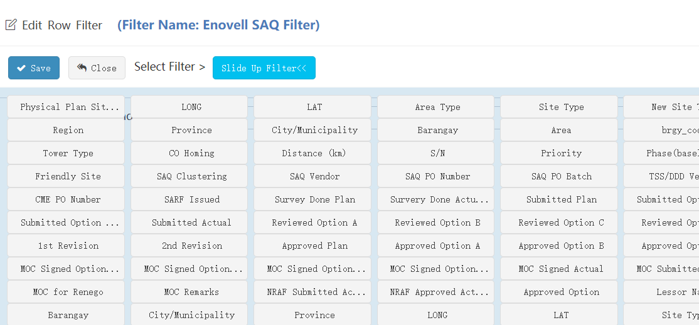

在策略筛选定义中理论上可定义每个基站字段，根据不同的基站字段筛选基站数据。

点击“Slide Up Filter”可选择可供筛选的所有字段。不同的字段数据会不一样，有“日期”型、“文本”型等，系统会自动根据不同类型，提供不同的筛选条件选项。

In the policy filtering definition, each site field can be defined theoretically to filter the site data according to different site fields.

Click "slide up filter" to select all fields available for filtering. Different field data will be different, including date type and text type. The system will automatically provide different filter criteria options according to different types.

* 日期型：按起始日期筛选，可以自选一个日期。

Date type: filter by start date; you can select a date.

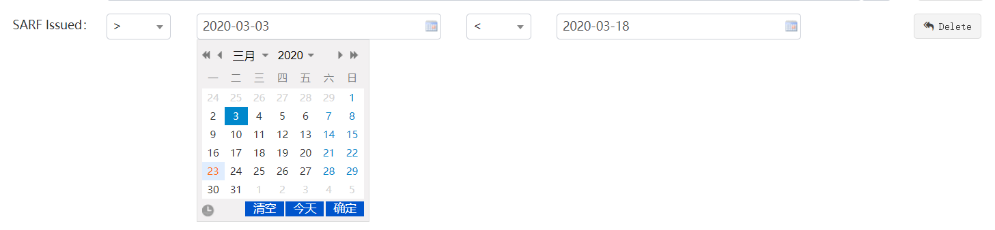

* 文本型：将系统中所有的数据罗列出来，可多选。下图是系统查询到Area Type有三个值，然后列出供选择。

Text type: lists all the data in the system. Multiple choices are allowed. The following figure shows that the system finds that there are three values of area type, and then lists them for selection



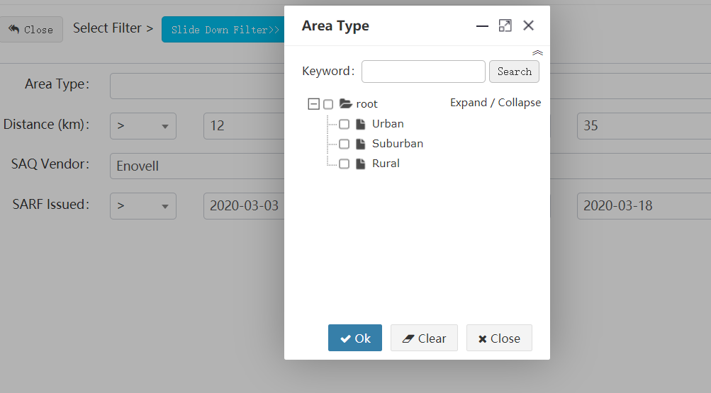

* 数字型：手工输入数字筛选。

Numeric type: enter numeric filter manually.



* 对于例子中筛选，我们选择字段：**SAQ Vendor 和 SARF Issued**

For the filtering in the example, we select the fields: **SAQ Vendor 和 SARF Issued**

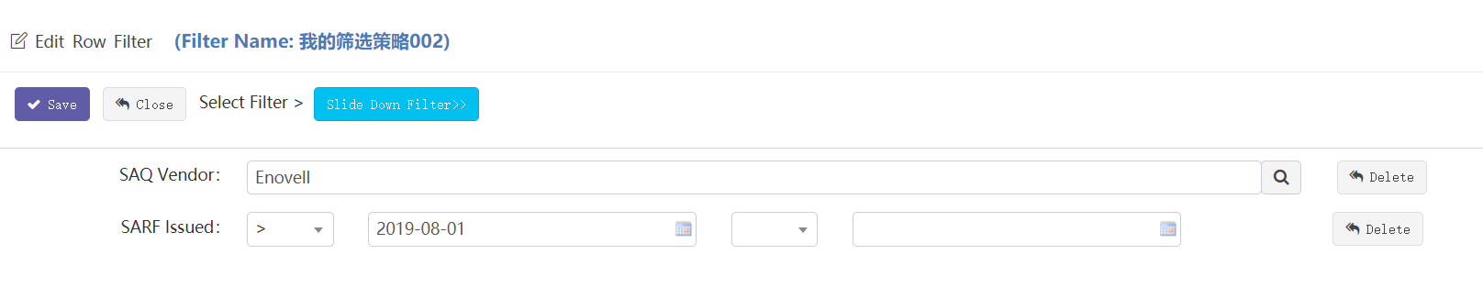

日期可以选起始日期，也可以只选开始日期。

You can select the start date or only the start date

考虑基站最早日期不会早于2019年8月1日，我们可以选择大于开始时间2019-08-01。

Considering that the earliest date of the site will not be earlier than August 1, 2019, we can choose to be greater than the start time 2019-08-01.

**步骤三、**定义完策略，按保存回到主页。回到主页后，点该策略行后面的测试操作按钮，可对刚才建立的策略进行测试，如果测试成功会绿色显示该策略可以正常使用，如果有错误，会红色提示，此时不要使用该策略，可联系管理员排查问题。

**Step 3:** after defining the policy, press save to return to the home page. After returning to the home page, click the test operation button behind the policy line to test the policy just established. If the test is successful, it will be displayed in green that the policy can be used normally. If there is an error, it will be prompted in red. Do not use the policy at this time. You can contact the administrator to troubleshoot the problem.

**步骤四、**策略建好后，即可在基站数据菜单“Site data”中使用。也可以在报表菜单 “Report” 中筛选使用。

**Step 4**: After the policy is established, it can be used in the site data menu "site data". You can also filter in the report menu report.

##### Col filter

列筛选的功能就是让用户在界面上定义想看到基站哪几列数据，而其他的列则隐藏。

简单的说就是从几百个基站字段列中，筛选出一部分我想看的字段列。将这个筛选规则事先定义保存好，下次在功能菜单中可选择这个策略来筛选基站字段列。

The function of column filtering is to allow the user to define which columns of Site data he wants to see on the interface, while other columns are hidden.

In short, it is to filter out some of the fields I want to see from hundreds of site field columns. Save the filter rule defined in advance. Next time, you can select this policy in the function menu to filter the field columns of the site.

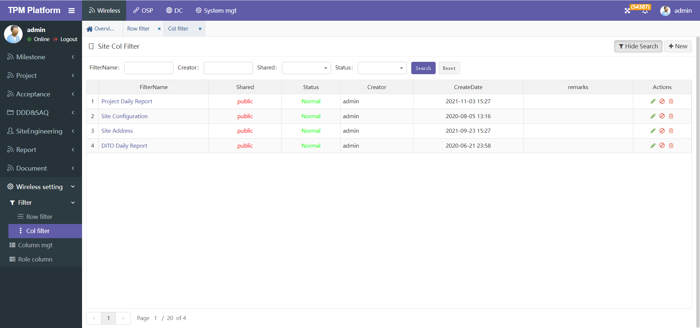

**新建列筛选策略步骤：**

**To create a new column filter policy:**

步骤一、点“New”新建一个策略，此处需策略名称和需要筛选的字段

Step 1. Click "new" to create a new policy, where the policy name and the fields to be filtered are required

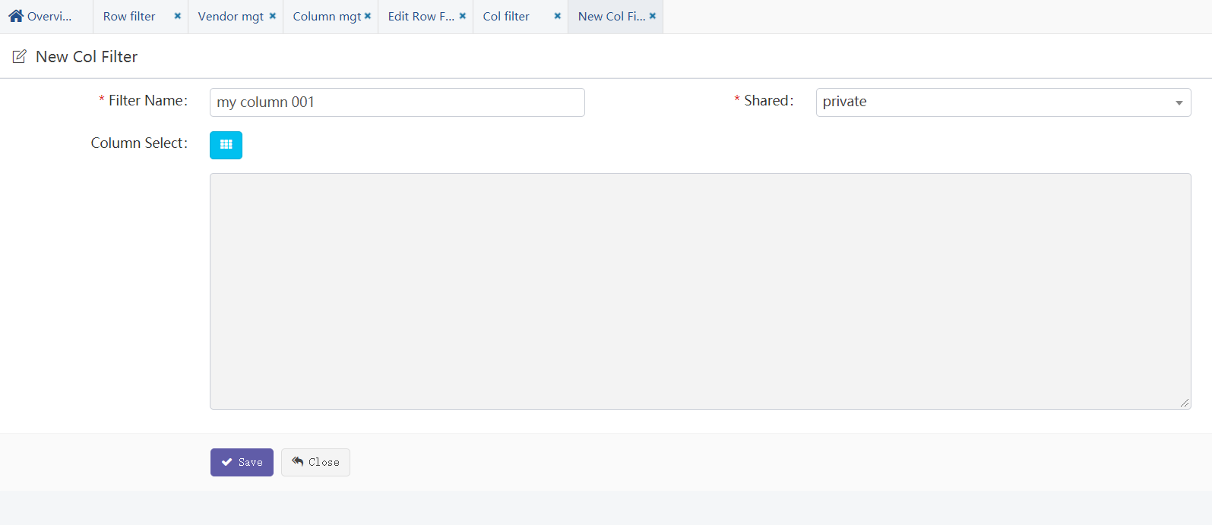

步骤二、输入策略名称

Step 2: enter the policy name

步骤三、选择策略是否公开。private表示私有，只有建策略的用户自己可见。public表示公开，其他人也可见，可使用。

Step 3: select whether the policy is public. Private means private, which is only visible to the user who created the policy. Public means public, visible to others, and can be used.

步骤四：选择字段，如下图：

Step 4: select a field, as shown in the following figure:

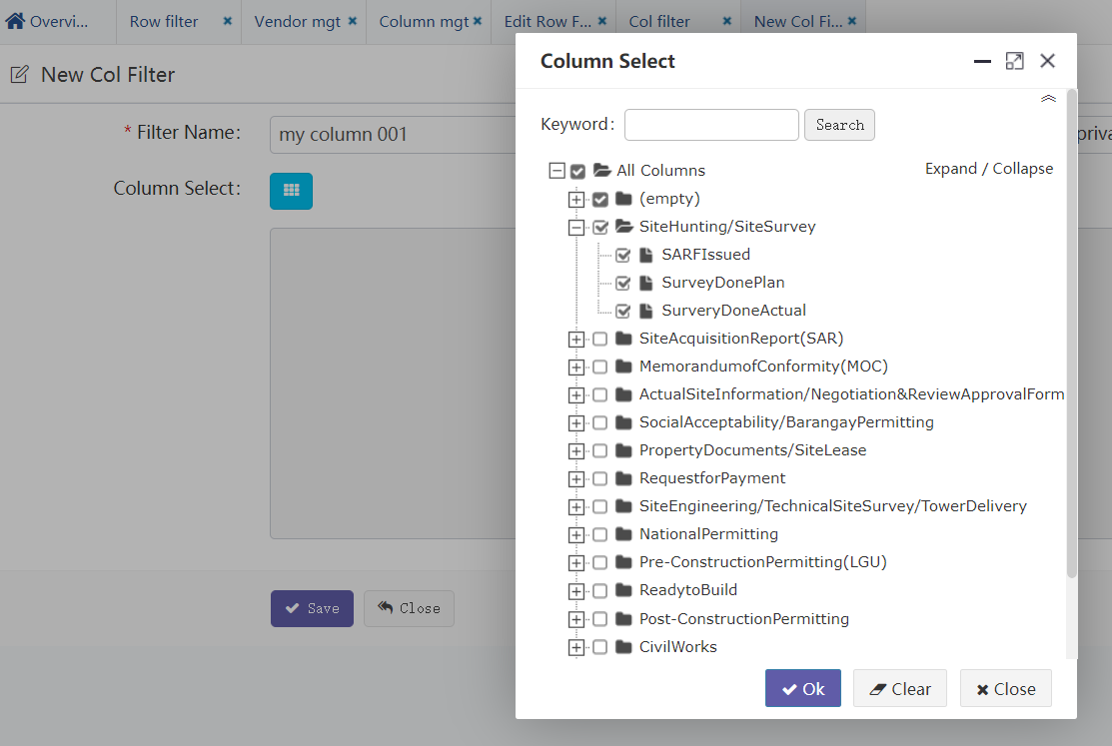

步骤五、按保存，新建策略成功。

Step 5: press save to create a new policy successfully.

步骤六、列策略无需测试，可直接在其他页面使用。

Step 6. The column strategy does not need to be tested and can be used directly on other pages.

#### Column mgt

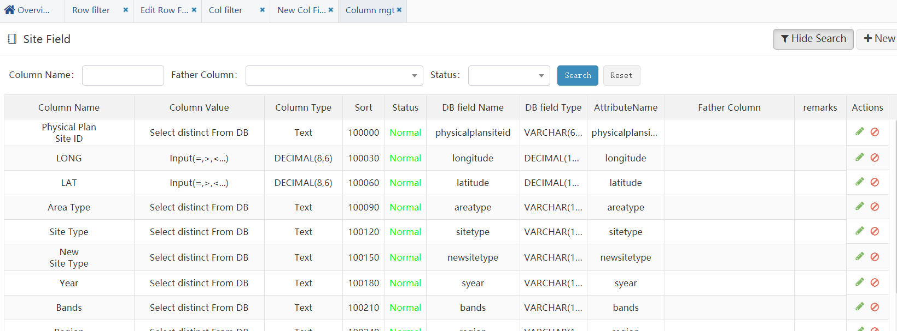

1. 系统中所有基站可供使用的字段均在此维护。

The fields available to all sites in the system are maintained here.

**注意：因为这些字段信息比较重要，要谨慎维护，如果误操作会引起系统不能正常使用。**

**Note: because these field information is important, it should be maintained carefully. If it is misoperated, the system will not work normally.**

1. 字段名称可以随意修改。修改后，系统中其他相关显示的地方也会相应变化。

The field name can be modified at will. After modification, other relevant displays in the system will also change accordingly.

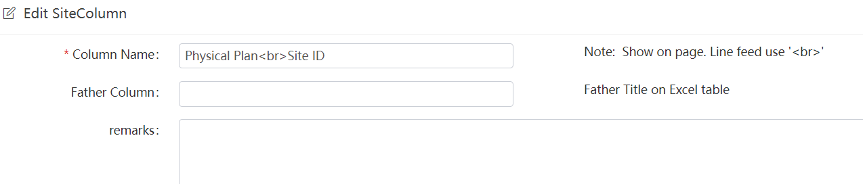

有的名称比较长，如需换行显示，则可以使用换行符号‘<br>’注意不能全角！

Father Column就是父标题，目前系统中使用的地方有：字段选择窗口中，按父标题分级，方便选择。

Some names are relatively long. If line feed is required, you can use the line feed symbol '<br>' and pay attention not to use all corners!

Father column is the parent title. At present, it is used in the system: in the field selection window, it is graded according to the parent title for easy selection.

#### Role column

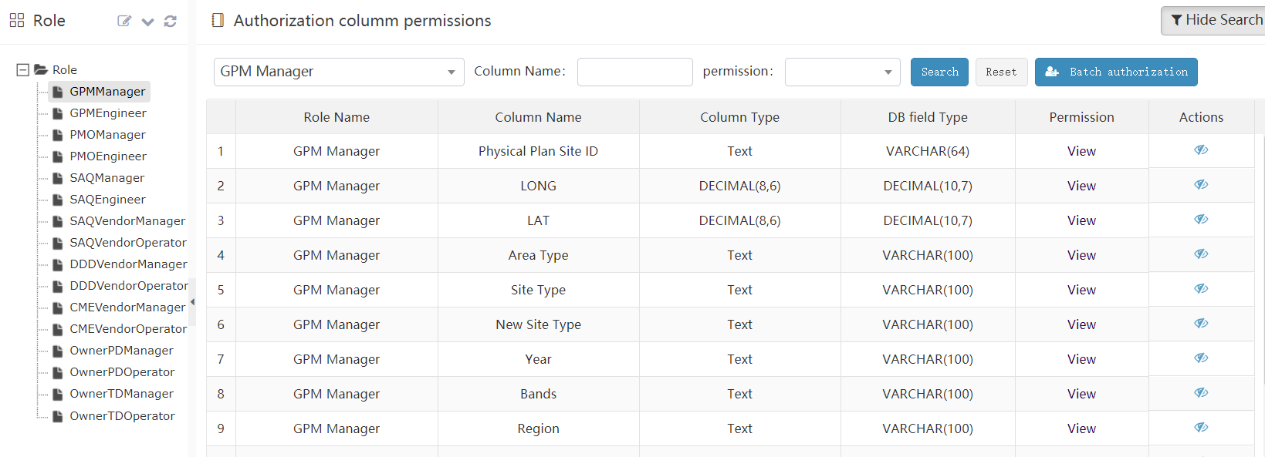

1. 在角色管理中可批量分配用户字段权限，但不能修改。这里可以维护这些字段信息，也可以直接在这里批量分配。

In role management, user field permissions can be assigned in batch, but cannot be modified. These field information can be maintained here or allocated in batch directly here

1. 选中某个角色，点按钮“Batch authorization”可批量针对该角色分配字段权限。

Select a role and click batch authorization to assign field permissions to the role in batch

1. 默认分配的字段权限只能查看，不能修改。当前系统只针对Task日期型的字段可以赋予修改权限，赋予该权限后，在SAQ管理中用户可以：修改日期、上传下载文档等。

The default assigned field permissions can only be viewed and cannot be modified. At present, the system can only grant modification permission to task date fields. After this permission is granted, users can modify dates, upload and download documents, etc. in SAQ management.

1. 如果是Task字段（日期型），可以修改成可编辑状态，点编辑修改按钮可进入修改权限页面：

If it is a task field (date type), it can be modified to editable status. Click Edit to enter the modify permission page

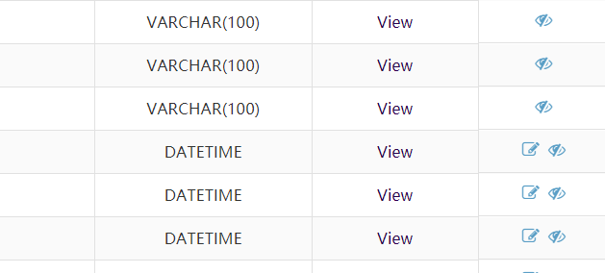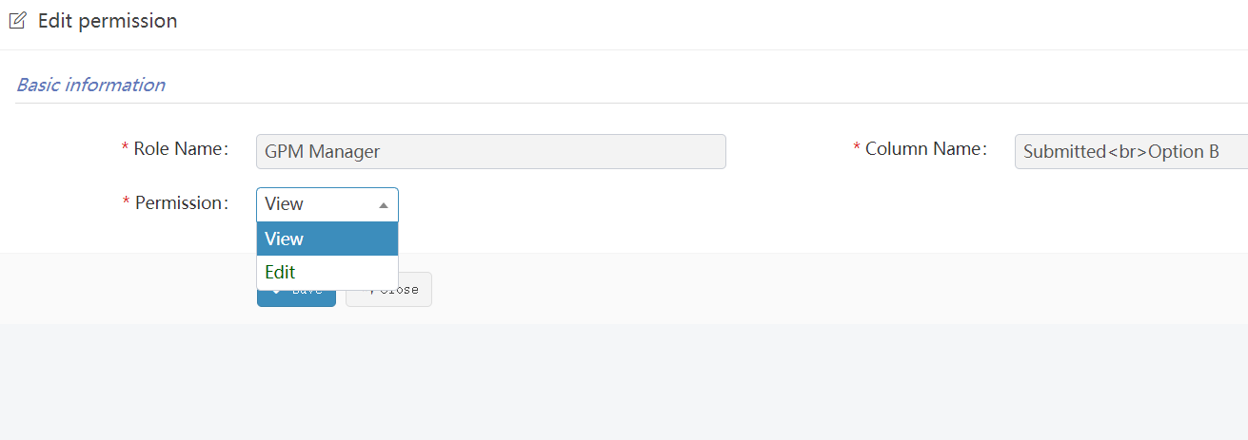

## OSP

### Milestone

OSP Milestone分集合管理，不同的集合对应不同菜单，分别管理不同的Milestone。但功能相同。

OSP milestone is managed by sets. Different sets correspond to different menus, and different milestones are managed respectively. But the functions are the same.

#### Menu A

“Menu A” Milestone管理模块。

"Menu a" milestone management module.

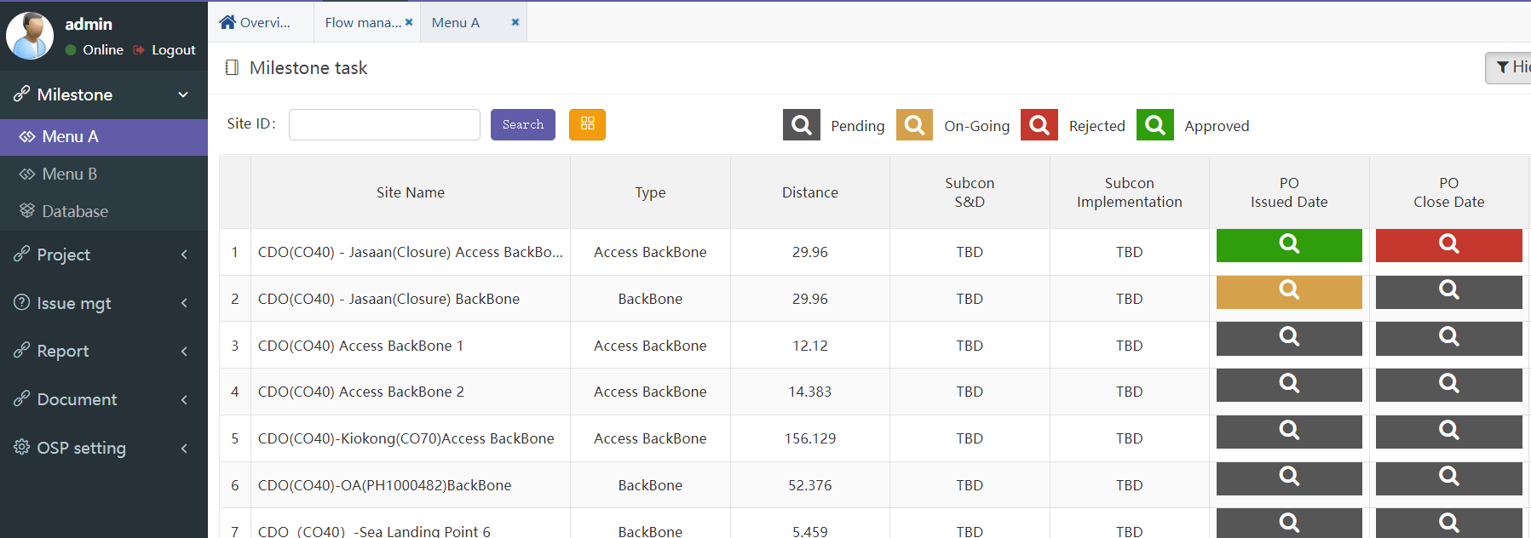

* **功能说明：Function Description:**

1. 每个milestone都会使用不同颜色来表示当前不同的状态。

Each milestone will use different colors to represent different current states

Pending ：还未开始

On-Going ：进行中

Rejected ：审核不通过

Approved ：审核通过

1. 点击上面的单元格，即进入milestone管理界面：

Click the cell above to enter the milestone management interface

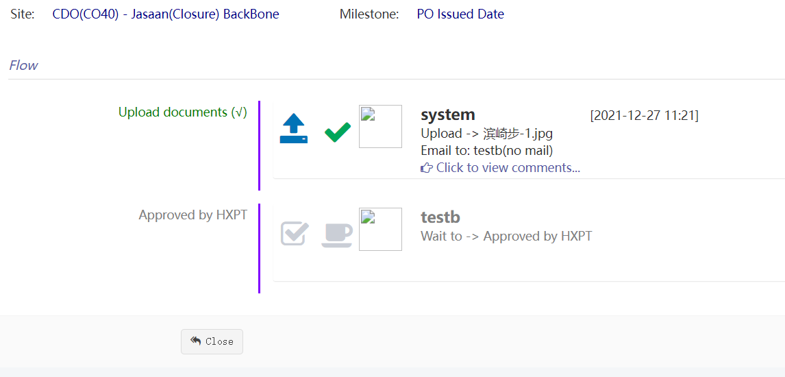

该milestone共两个操作流程：

步骤1、上传文档

步骤2、审核文档

界面会显示相关操作人员、操作时间及操作结果，灰色表示还未开始。

“[Click to view comments...](javascript:void(0))”： 查看备注详细信息。

The milestone has two operation processes:

Step 1: upload documents

Step 2: review documents

The interface will display the relevant operators, operation time and operation results. Gray indicates that it has not started yet.

“Click to view comments...”： View note details.

#### Menu B

同上 the same as above

#### Database

本菜单主要管理OSP基站所有配置参数。

This menu mainly manages all configuration parameters of the OSP Site.

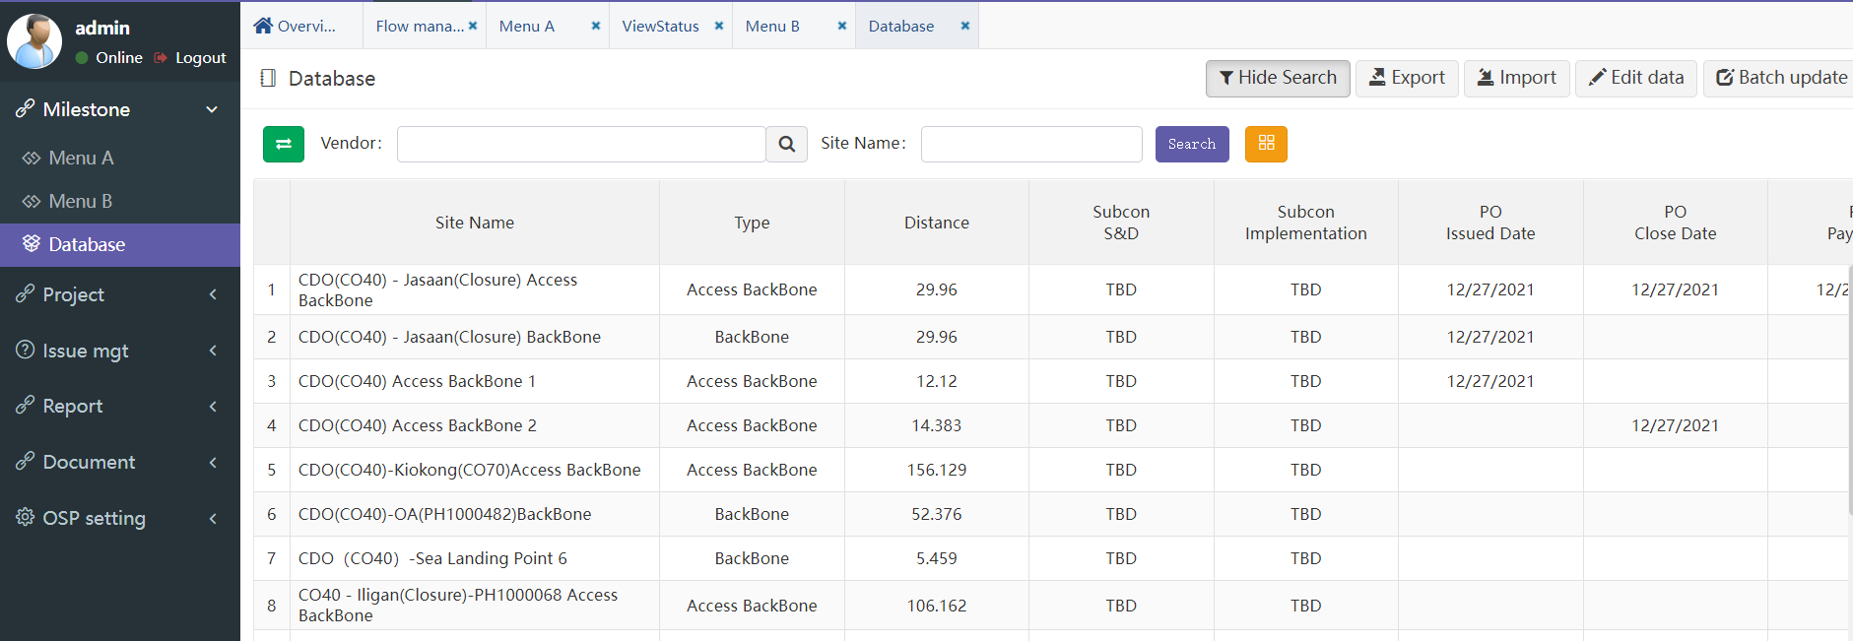

* **功能说明： Function description**

1. 本功能主要为项目组维DDD管理配置参数使用。

This function is mainly used by the project team to maintain and manage DDD configuration parameters

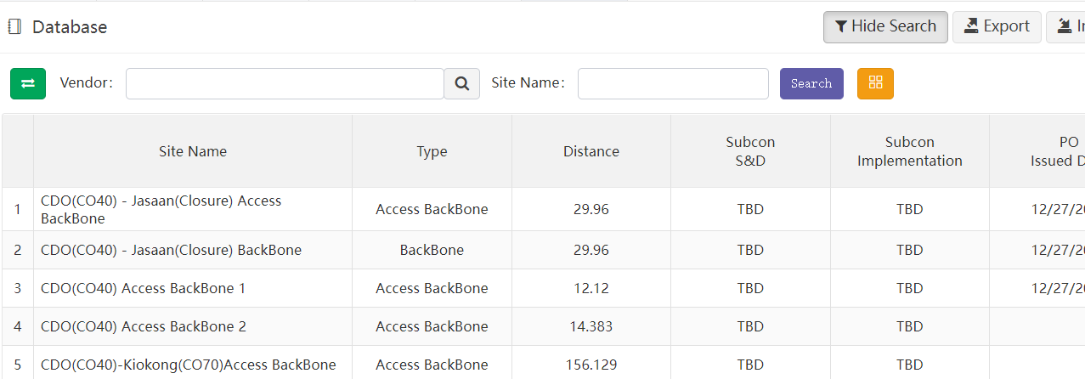

1. 基站查询“Search”功能有两种搜索方式：通过页面左边绿色箭头按钮可以切换。

The BTS query "search" function has two search methods: you can switch through the green arrow button on the left of the page.  
1）一般查询：可通过Vendor（多选）和Site ID（模糊查询）搜索符合条件的基站。

General query: search for qualified sites through vendor (multiple choice) and site ID (fuzzy query).

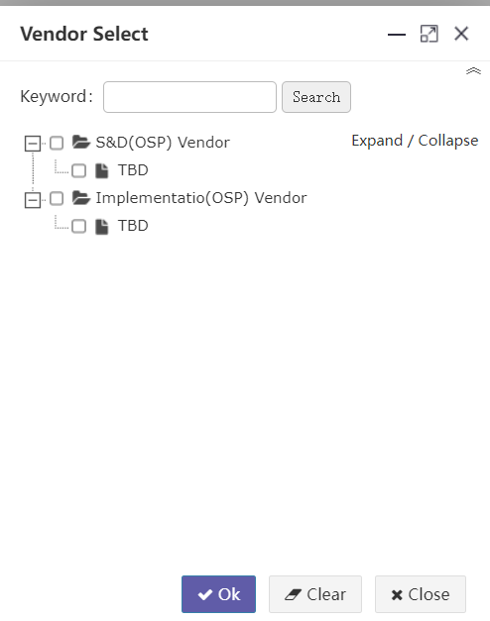

2）自定义查询：可通过预先定义好的“基站搜索策略”和“字段搜索策略”过滤。

User defined query: it can be filtered through predefined "site search strategy" and "field search strategy". 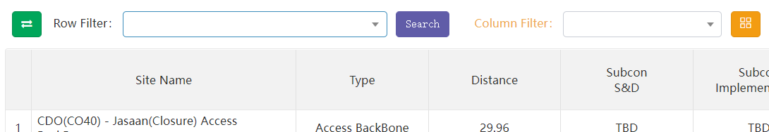

* 选择“Row filter”下拉框中已定义策略，根据权限用户能看到自己定义的和其他人公开的策略，再点search按钮可根据策略过滤搜索基站。策略定义具体见菜单：“OSP”->“OSP setting”-> “Filter” ->“Row filter”。

Select the policies defined in the "row filter" drop-down box. Users can see the policies defined by themselves and disclosed by others according to their permissions, and then click the search button to filter and search the site according to the policies. See the menu for policy definition: “OSP”->“OSP setting”-> “Filter” ->“Row filter”.

* 选择“Column filter”下拉框中已定义的列过滤筛选策略。可以过滤策略中定义的字段。如何建列筛选策略详见菜单：
* “OSP”->“OSP setting”-> “Filter” ->“Col filter”。

Select the defined column filter policy in the column filter drop-down box. You can filter the fields defined in the policy. How to create a filter policy is detailed in the menu:

“OSP”->“OSP setting”-> “Filter” ->“Col filter”。

1. 黄色按钮”Column select”是选择本页面需要显示哪些字段，因为字段数量较多可选择少量显示，便于操作。

The yellow button " Column select" is used to select which fields need to be displayed on this page. Because there are a large number of fields, you can select a small number to display for easy operation.

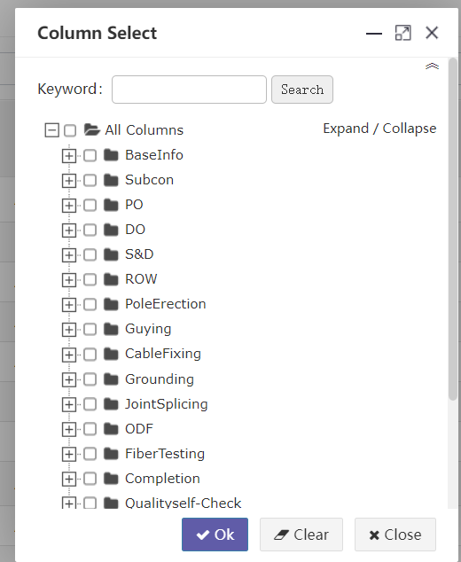

虽然列选择策略已经在列策略中可以自定义，但考虑到本系统基站字段特别多，且平常在工作中可能会经常频繁的想变更查看某些字段信息，所以可以随时筛选你想查下的字段，但不会保留记忆，如需记忆，在自定义中定义。

Although the column selection strategy can be customized in the column strategy, considering that there are many fields in the site of the system, and you may often want to change and view some field information in your work, you can filter the fields you want to check at any time, but the memory will not be retained. If you need to remember, define it in customization

1. “Export” 导出所有基站数据（Excel文档）到本地。根据页面所筛选的数据行和数据列，点导出时，系统会导出当前页面所有分页的基站数据，所见即所得。

"Export" exports all site data (excel document) to the local. According to the data rows and columns filtered on the page, when clicking export, the system will export the site data of all pages on the current page, What you see is what you get.

1. “Import” 导如基站数据（Excel文档）到平台。可选项：覆盖导入 和 追加导入。如果是覆盖导入，则根据Site ID匹配覆盖原有数据。此功能慎用！有可能会导致数据被误操作清除。导入时除非勾选了是否覆盖导入，否则都是追加导入数据。

"Import" imports the site data (Excel document) to the platform. Optional: overwrite import and append import. If it is an overwrite import, the original data will be overwritten according to the Site ID match. Use this function with caution! It may cause the data to be cleared by misoperation. During import, the imported data is appended unless overwrite import is checked.

**举例：**导入基站数据步骤

**Example**: importing site data

* **步骤一 Step 1**

导入基站前先下载EXCEL数据模板，点击按钮“Import”在弹出窗口中点击“Download template”：

Download the Excel data template before importing the Site, click "import" and click "download template" in the pop-up window:



* **步骤二 Step 2**

在下载的模板文档中，拷贝基站数据，并检查数据正确性：

检查这些字段不能为空：“Site Name”

In the downloaded template document, copy Site data and check the correctness of the data:

Check that these fields cannot be empty: “Site Name”

* **步骤三 Step 3**

点击选择文件，选择你要导入的excel文件。

Click Select File and select the excel file you want to import.

* **步骤四 Step 4**

选择是否勾选“是否根据基站ID替换已存在的数据”。如勾选则会覆盖相同Site Name的基站数据。如果不勾选，则当遇到相同ID时提示且全部数据导入失败。

注：导入时系统会验证每个字段是否正确，只要有一个验证不通过，则全部导入失败，待修改正确后重新导入。

Select whether to check "replace existing data according to Site Name". If checked, the site data with the same site ID will be overwritten. If unchecked, a prompt will appear when the same ID is encountered and all data import fails.

Note: when importing, the system will verify whether each field is correct. As long as one of the fields fails to pass the verification, all the fields will fail to import. Import again after the modification is correct.

1. 编辑基站：点击编辑按钮，页面进入编辑模式，再次点击退出编辑模式：

Edit site: click the Edit button, the page will enter the edit mode, and click again to exit the edit mode:

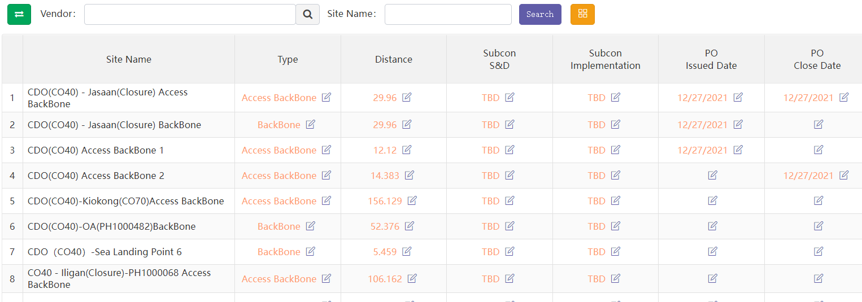

* 点击任何一个单元格，即可进入编辑该单元格的详情页，除“Site Name”外其他字段均可编辑。

“Site Name”不能修改是因为它是唯一标识基站编号的数据。

Click any cell to enter the details page of editing the cell. Other fields can be edited except "Site Name". " Site Name " cannot be modified because it is the data that uniquely identifies.

* 当前权限只有管理员与项目组可以修改。

Current permissions can only be modified by administrators and project groups

* 不同单元格数据类型会有不同的展示，类型有：文本、整数、日期、小数。

Different cell data types have different displays, including text, integer, date and decimal



系统会对输入的数据类型做验证，整数字段输入框不能输入字母等。

The system will verify the input data type. Letters cannot be entered in the integer field input box.

1. “Batch update” 更新指定基站配置参数数据（Excel文档）。如果需要对某些基站的某几个字段更新值，则可以选择此功能。

"Batch update" updates the specified site configuration parameter data (excel document). You can select this function if you need to update the values of some fields of some sites.

### Project

管理基站配置参数。

分不同菜单管理不同的基站配置参数。

共4个菜单，4批基站参数： Backbone、Site Access、ROW、RTA

#### Backbone

本菜单主要管理OSP基站Backbone配置参数。

This menu mainly manages all Backbone configuration parameters of the OSP Site.

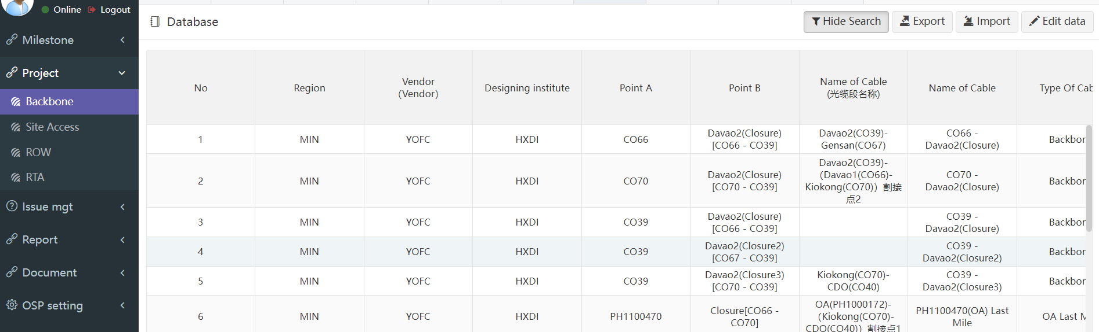

* **功能说明： Function description**

1. “Export” 导出所有基站配置参数数据（Excel文档）到本地。根据页面所筛选的数据行和数据列，点导出时，系统会导出当前页面所有分页的基站数据，所见即所得。

"Export" exports all site configuration parameters data (excel document) to the local. According to the data rows and columns filtered on the page, when clicking export, the system will export the site data of all pages on the current page, What you see is what you get.

1. “Import” 导如基站数据（Excel文档）到平台。可选项：覆盖导入 和 追加导入。如果是覆盖导入，则根据Site ID匹配覆盖原有数据。此功能慎用！有可能会导致数据被误操作清除。导入时除非勾选了是否覆盖导入，否则都是追加导入数据。

"Import" imports the site data (Excel document) to the platform. Optional: overwrite import and append import. If it is an overwrite import, the original data will be overwritten according to the Site ID match. Use this function with caution! It may cause the data to be cleared by misoperation. During import, the imported data is appended unless overwrite import is checked.

**举例：**导入基站数据步骤

**Example**: importing site data

* **步骤一 Step 1**

导入基站前先下载EXCEL数据模板，点击按钮“Import”在弹出窗口中点击“Download template”：

Download the Excel data template before importing the Site, click "import" and click "download template" in the pop-up window:



* **步骤二 Step 2**

在下载的模板文档中，拷贝基站数据，并检查数据正确性：

检查这些字段不能为空：“Site Name”

In the downloaded template document, copy Site data and check the correctness of the data:

Check that these fields cannot be empty: “Site Name”

* **步骤三 Step 3**

点击选择文件，选择你要导入的excel文件。

Click Select File and select the excel file you want to import.

* **步骤四 Step 4**

选择是否勾选“是否根据基站ID替换已存在的数据”。如勾选则会覆盖相同Site Name的基站数据。如果不勾选，则当遇到相同ID时提示且全部数据导入失败。

注：导入时系统会验证每个字段是否正确，只要有一个验证不通过，则全部导入失败，待修改正确后重新导入。

Select whether to check "replace existing data according to Site Name". If checked, the site data with the same site ID will be overwritten. If unchecked, a prompt will appear when the same ID is encountered and all data import fails.

Note: when importing, the system will verify whether each field is correct. As long as one of the fields fails to pass the verification, all the fields will fail to import. Import again after the modification is correct.

1. 编辑基站：点击编辑按钮，页面进入编辑模式，再次点击退出编辑模式：

Edit site: click the Edit button, the page will enter the edit mode, and click again to exit the edit mode:

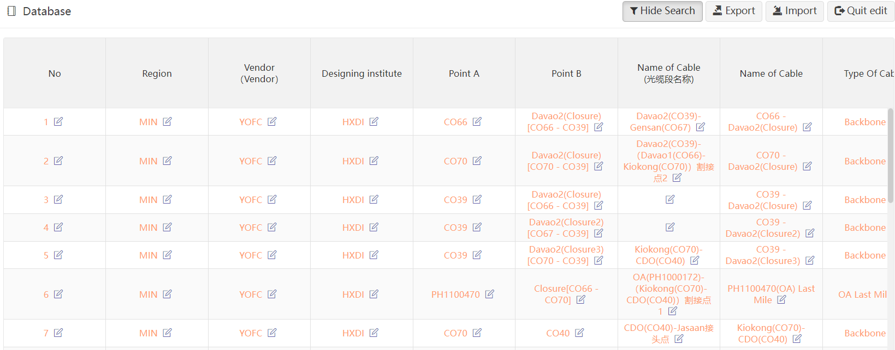

* 点击任何一个单元格，即可进入编辑该单元格的详情页，除“Site Name”外其他字段均可编辑。

“Site Name”不能修改是因为它是唯一标识基站编号的数据。

Click any cell to enter the details page of editing the cell. Other fields can be edited except "Site Name". " Site Name " cannot be modified because it is the data that uniquely identifies.

* 当前权限只有管理员与项目组可以修改。

Current permissions can only be modified by administrators and project groups

* 不同单元格数据类型会有不同的展示，类型有：文本、整数、日期、小数。

Different cell data types have different displays, including text, integer, date and decimal



系统会对输入的数据类型做验证，整数字段输入框不能输入字母等。

The system will verify the input data type. Letters cannot be entered in the integer field input box.

#### Site Access

同上 the same as above

#### ROW

同上 the same as above

#### RTA

同上 the same as above

### Issue mgt

#### issues

事件管理模块 是一个独立的模块，用户可以发起一个事件，然后按流程流转，直到事件关闭。

The Issue management module is an independent module. Users can initiate an Issue, and then flow it according to the process until the Issue is closed.

* 事件发起 Issue initiation：

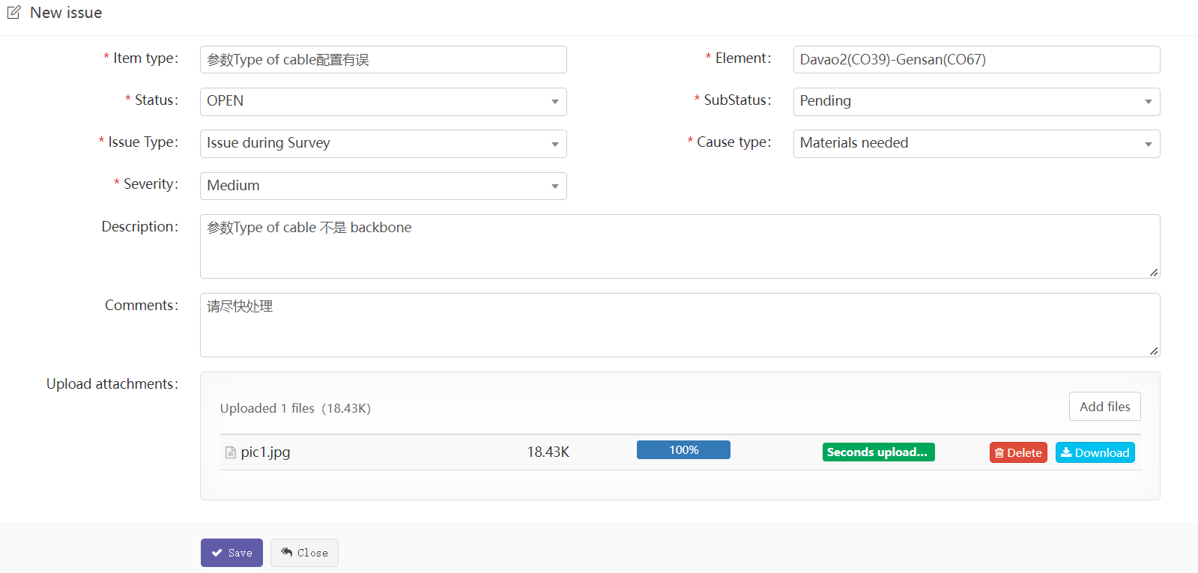

* 事件处理Issue processing：

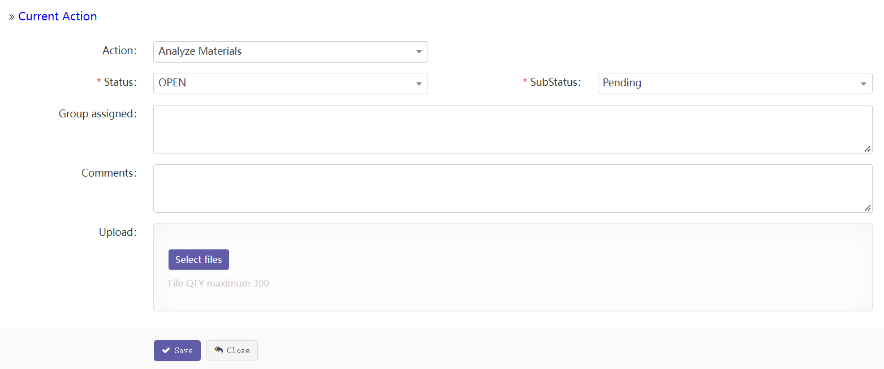

对于已经发起的事件，相关用户可以直接在事件action中处理，可以输入：处理备注、处理结果，以及下一步处理意见等信息。

For an Issue that has been initiated, the relevant user can directly process it in the Issue action, and can enter: Processing comments, processing results, and next step processing opinions.

如果状态选择关闭，则事件处理结束。

If the status is off, the Issue processing ends.

### Report

OSP报表前期做成可导入、导出两个功能即可。

共三份报表：TotalROWA、TotalROWB、DailyTracker

#### TotalROWA

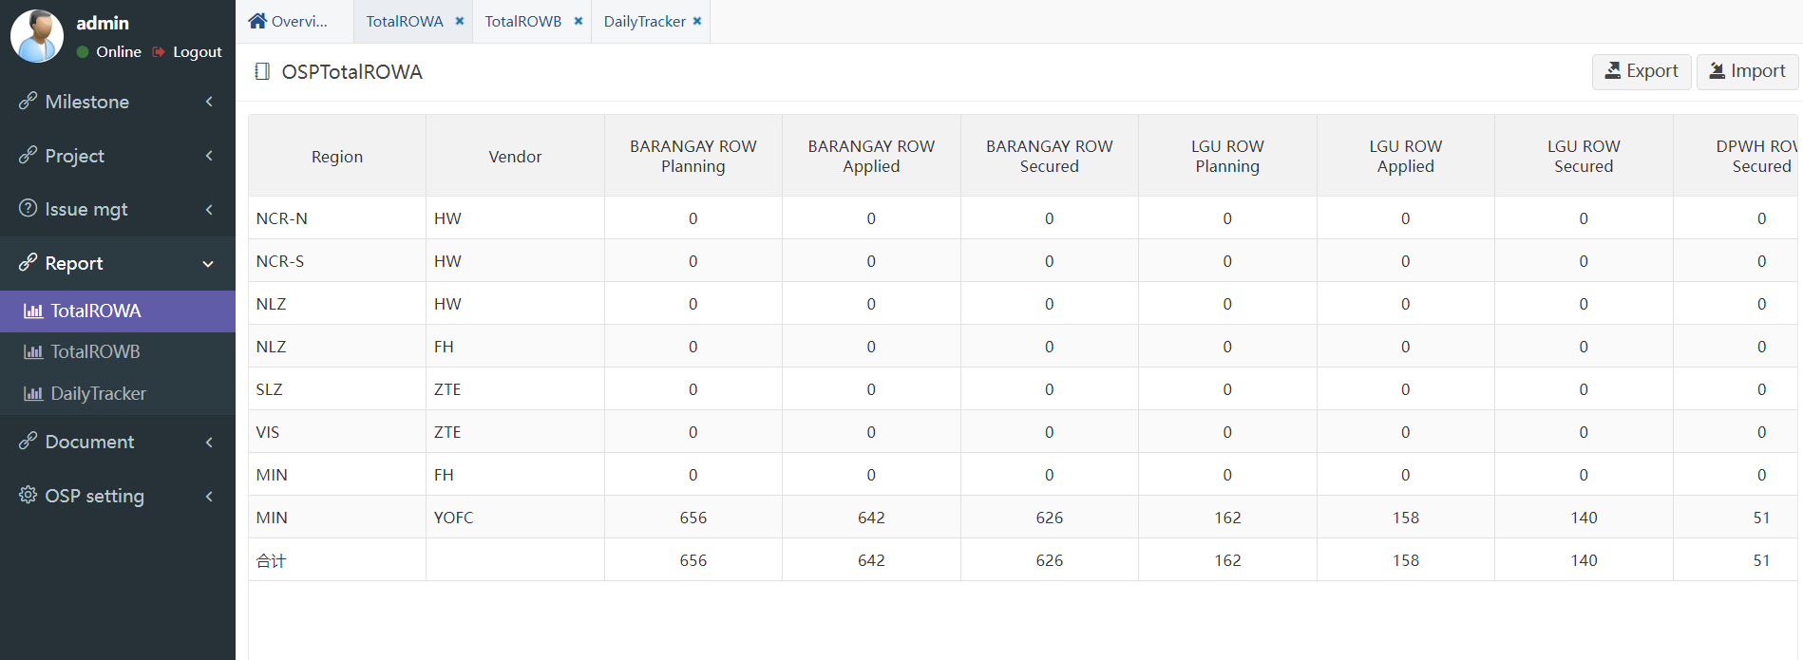

#### TotalROWB

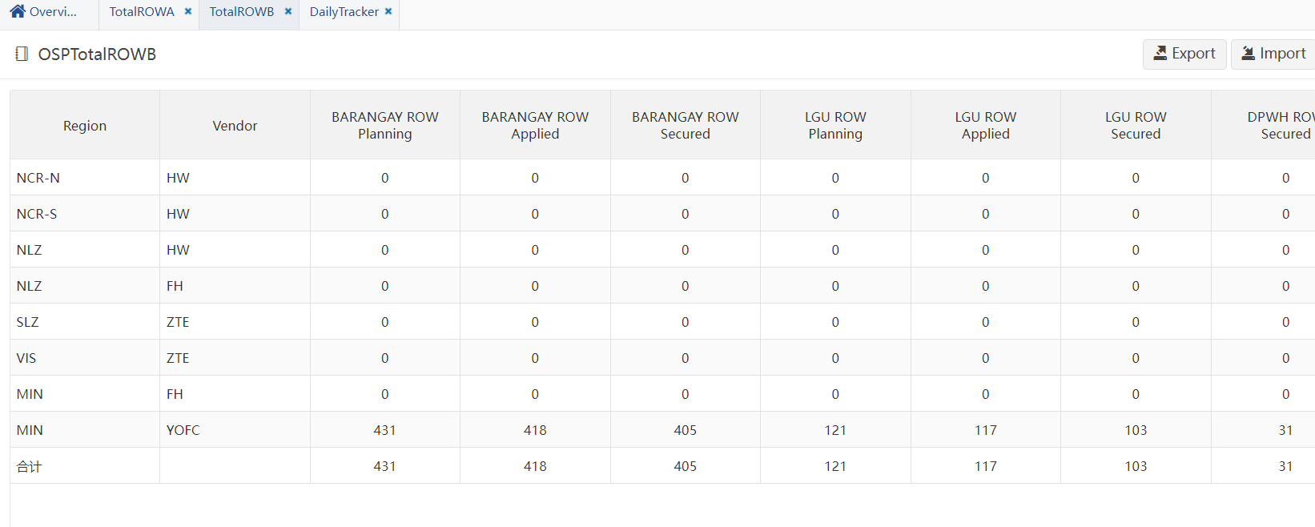

#### DailyTracker

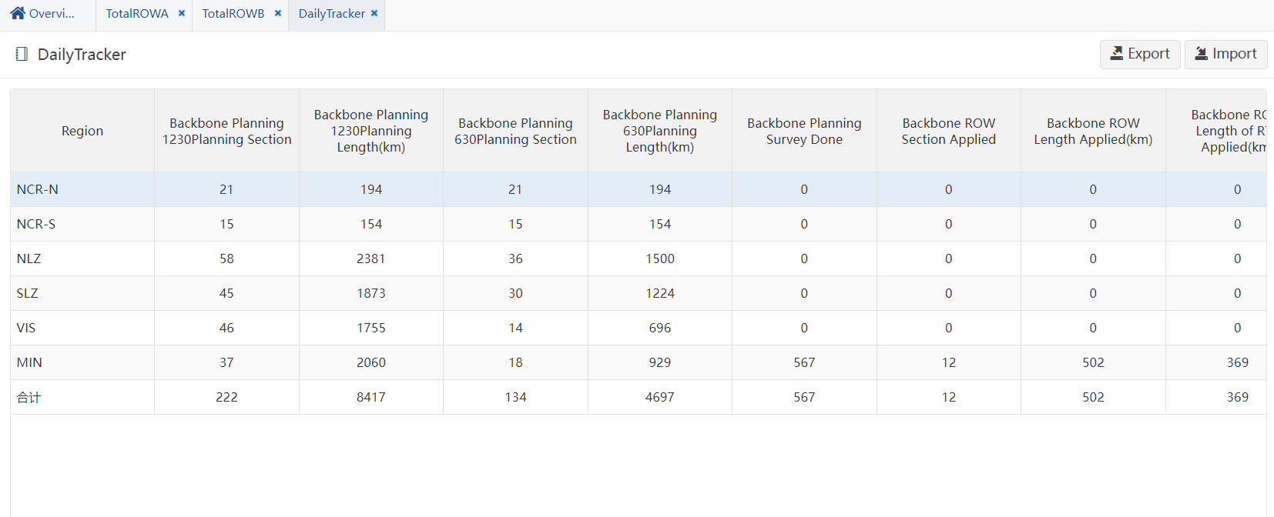

### Document

#### Download

此处统一维护所有OSP基站Milestone上传的相关文档。

Relevant documents uploaded by milestone of all OSP Sites are maintained here.

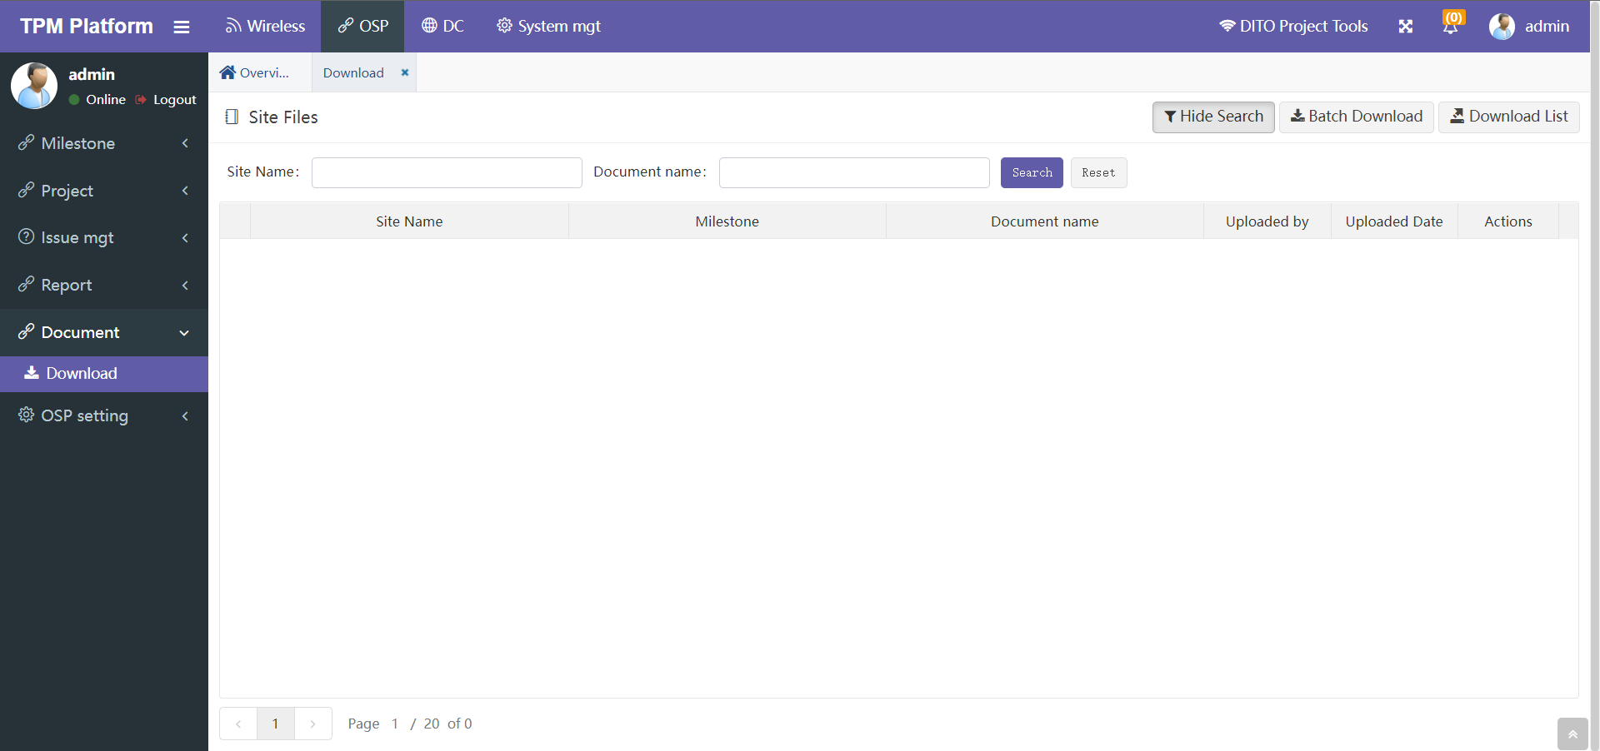

* Search

通过”Site Name”可搜索出所有该基站下的文档列表。

Use "Site Name" to search the list of all documents under the site.

通过” Document name”可通过名称模糊搜索文档。

"Document name" allows you to search for documents by name blur.

* Batch download

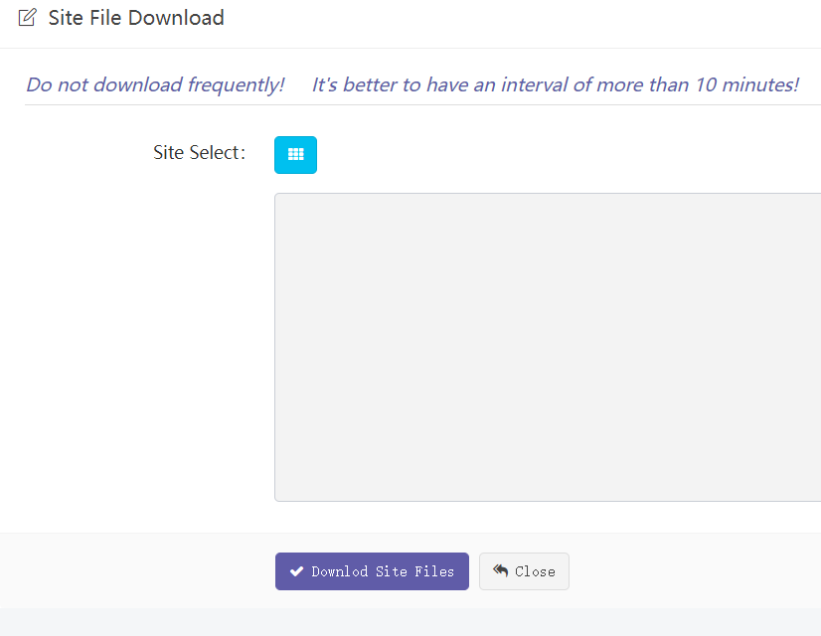

可选择指定基站的指定Milestone下载相应的文档。文档将被压缩打包后下载到本地。

You can select the specified milestone of the specified site to download the corresponding document. The document will be compressed, packaged and downloaded locally.

* Download list

下载所有文档EXCEL清单。

Download excel list of all documents

### OSP setting

#### Filter

##### Row filter

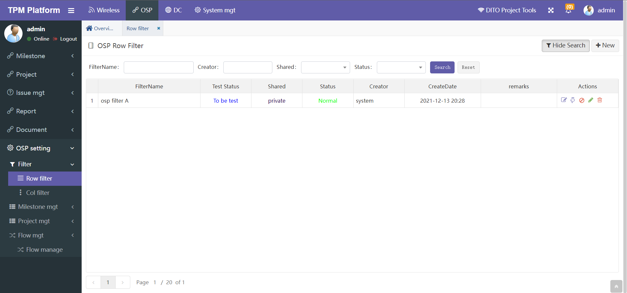

Row Filter是根据基站已有字段过滤基站数据。

简单的说就是从所有基站中，筛选出一部分我想看的基站子集。将这个筛选规则事先定义保存好，下次在功能菜单中可选择这个策略来筛选基站。

Row filter is used to filter the site according to the existing fields of the site.

To put it simply, select a subset of the sites I want to see from all sites. Save the filter rule defined in advance. Next time, you can select this policy in the function menu to filter the site.

* **新建策略步骤：**

**步骤一、**点“New”新建一个策略，此处只需输入一个策略名称“osp filter”，保存。

**步骤二、**回到主页后，点该策略行后面的第一个操作编辑按钮，即进入编辑具体的策略页面。

Step 1. Click "new" to create a new policy. Here, just enter a policy name "osp filter "

and save it.

Step 2. After returning to the home page, click the first operation Edit button behind the policy

line to enter the edit specific policy page.

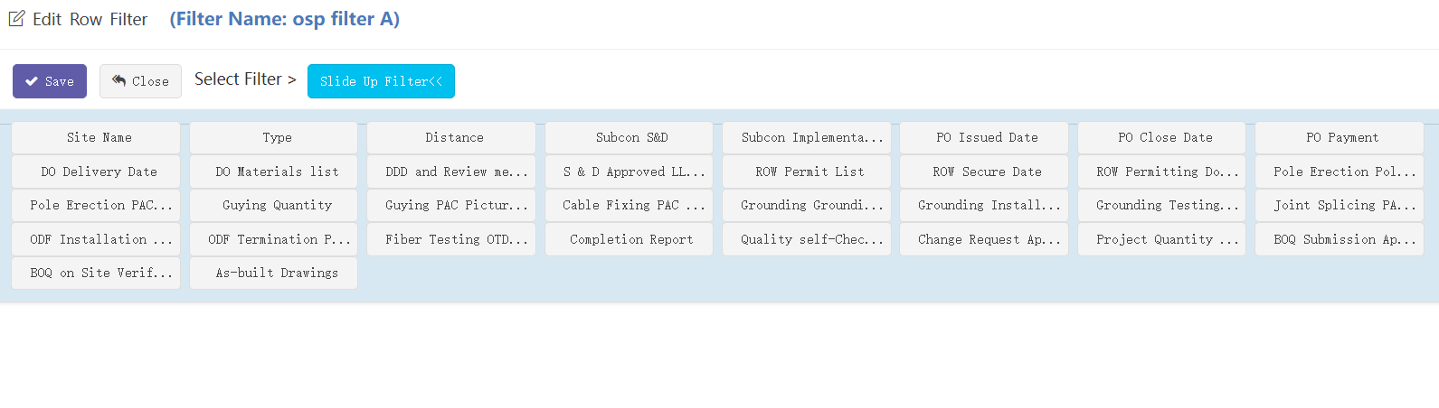

在策略筛选定义中理论上可定义每个基站字段，根据不同的基站字段筛选基站数据。

点击“Slide Up Filter”可选择可供筛选的所有字段。不同的字段数据会不一样，有“日期”型、“文本”型等，系统会自动根据不同类型，提供不同的筛选条件选项。

In the policy filtering definition, each site field can be defined theoretically to filter the site data according to different site fields.

Click "slide up filter" to select all fields available for filtering. Different field data will be different, including date type and text type. The system will automatically provide different filter criteria options according to different types.

* 日期型：按起始日期筛选，可以自选一个日期。

Date type: filter by start date; you can select a date.



* 文本型：将系统中所有的数据罗列出来，可多选。下图是系统查询到Area Type有三个值，然后列出供选择。

Text type: lists all the data in the system. Multiple choices are allowed. The following figure shows that the system finds that there are three values of area type, and then lists them for selection





* 数字型：手工输入数字筛选。

Numeric type: enter numeric filter manually.



日期可以选起始日期，也可以只选开始日期。

You can select the start date or only the start date

考虑基站最早日期不会早于2019年8月1日，我们可以选择大于开始时间2019-08-01。

Considering that the earliest date of the site will not be earlier than August 1, 2019, we can choose to be greater than the start time 2019-08-01.

**步骤三、**定义完策略，按保存回到主页。回到主页后，点该策略行后面的测试操作按钮，可对刚才建立的策略进行测试，如果测试成功会绿色显示该策略可以正常使用，如果有错误，会红色提示，此时不要使用该策略，可联系管理员排查问题。

**Step 3:** after defining the policy, press save to return to the home page. After returning to the home page, click the test operation button behind the policy line to test the policy just established. If the test is successful, it will be displayed in green that the policy can be used normally. If there is an error, it will be prompted in red. Do not use the policy at this time. You can contact the administrator to troubleshoot the problem.

**步骤四、**策略建好后，即可在基站数据菜单“Site data”中使用。也可以在报表菜单 “Report” 中筛选使用。

**Step 4**: After the policy is established, it can be used in the site data menu "site data". You can also filter in the report menu report.

##### Col filter

列筛选的功能就是让用户在界面上定义想看到基站哪几列数据，而其他的列则隐藏。

简单的说就是从所有基站字段列中，筛选出一部分我想看的字段列。将这个筛选规则事先定义保存好，下次在功能菜单中可选择这个策略来筛选基站字段列。

The function of column filtering is to allow the user to define which columns of Site data he wants to see on the interface, while other columns are hidden.

In short, it is to filter out some of the fields I want to see from all sites field columns. Save the filter rule defined in advance. Next time, you can select this policy in the function menu to filter the field columns of the site.

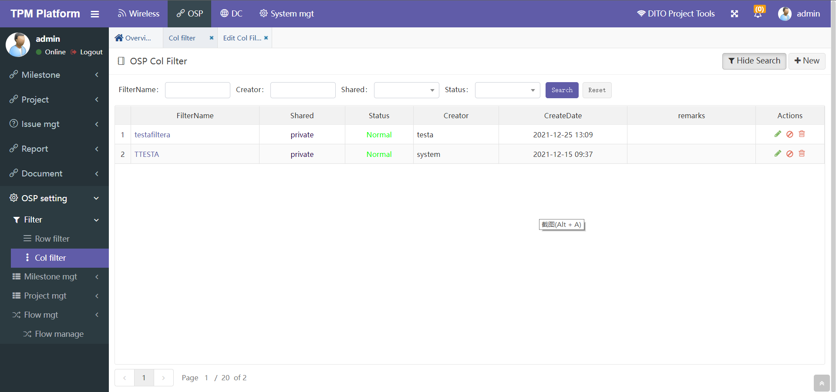

* **新建列筛选策略：**

**To create a new column filter policy:**

步骤一、点“New”新建一个策略，先选择菜单，也就是此策略适用哪个菜单字段数据。

Step 1. Click "new" to create a new policy, Select the menu first, that is, which menu field data this policy applies to.

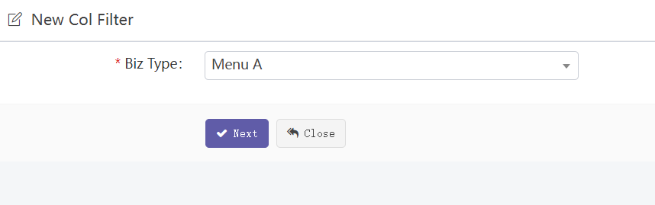

步骤二、点下一步，再输入策略名称和需要筛选的字段：

Step 2. Click “Next” to where the policy name and the fields to be filtered are required.

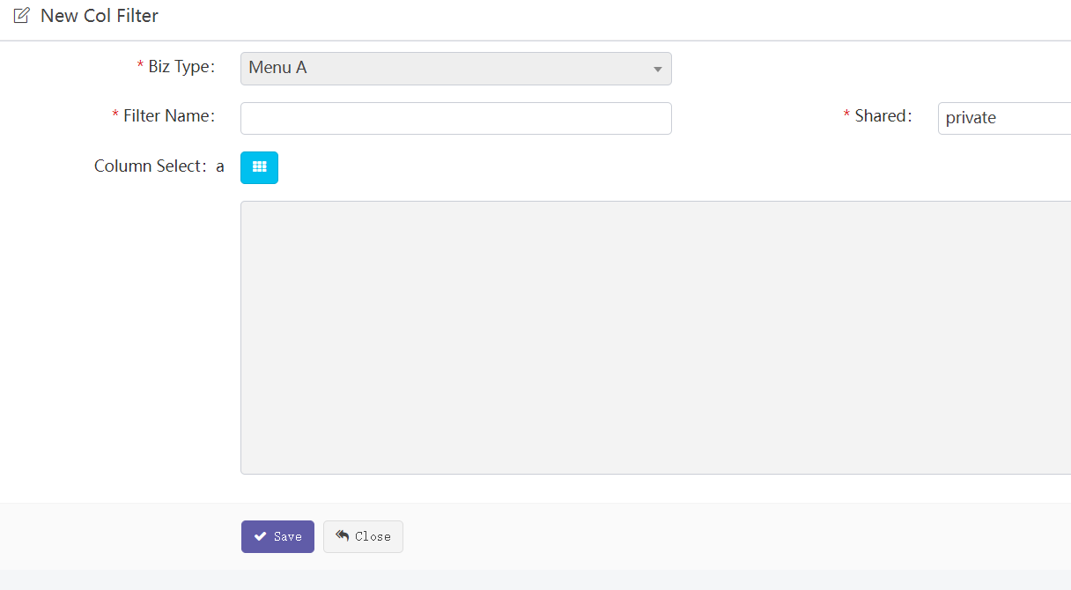

“Shared”: private/public 表示私有（只有建策略的用户自己可见），公开（其他人也可见，可使用）

"Shared": private/public means private (visible only to the user who created the policy) and public (visible to others, and can be used)

“Column Select”: to select fields, as shown in the following figure:

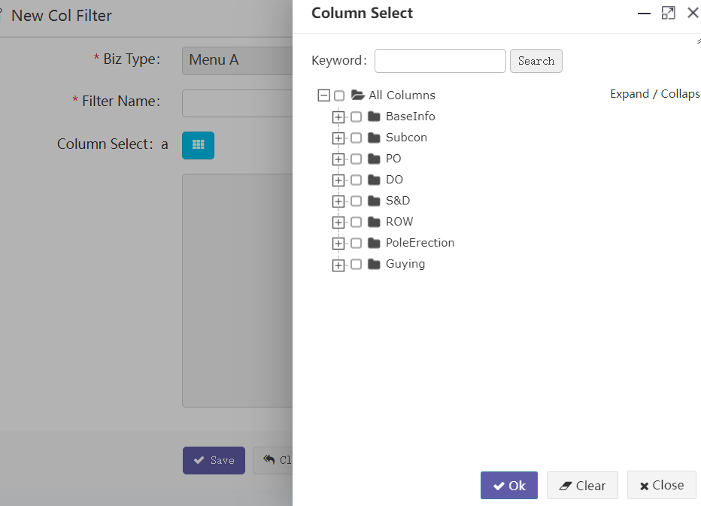

步骤三、按保存，新建策略成功。

Step 3: press save to create a new policy successfully.

步骤四、列策略无需测试，可直接在其他页面使用。

Step 4. The column strategy does not need to be tested and can be used directly on other pages.

#### Milestone mgt

##### Column

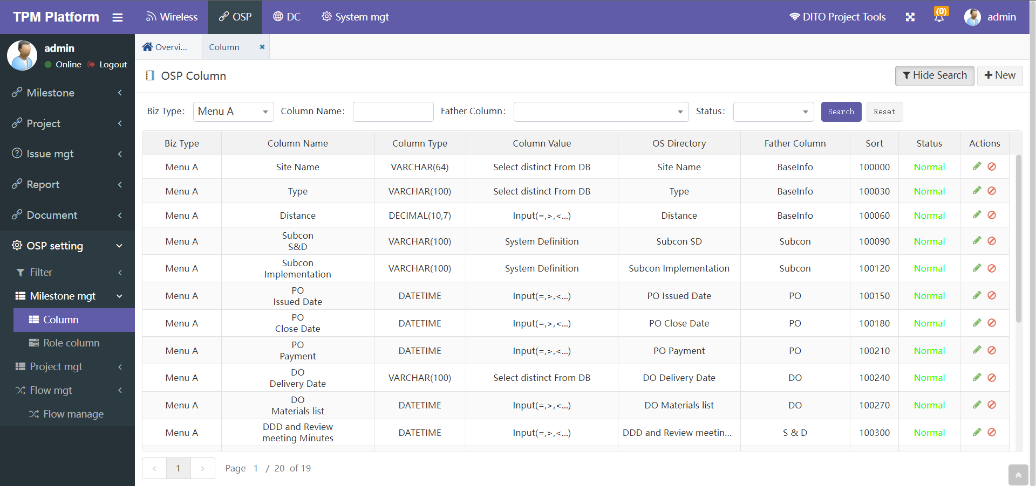

1. 系统中所有OSP基站可供使用的字段均在此维护。

The fields available to all OSP sites in the system are maintained here.

**注意：因为这些字段信息比较重要，要谨慎维护，如果误操作会引起系统不能正常使用。**

**Note: because these field information is important, it should be maintained carefully. If it is misoperated, the system will not work normally.**

1. “Biz Type”: 字段维护是分业务菜单的，这里选择要维护筛选Biz Type对应的字段。

"Biz type": field maintenance is divided into business menus. Here, select the field corresponding to the biz type to be maintained and filtered.

1. 字段名称可以修改。但修改后，系统中其他相关显示的地方也会相应变化。

The field name can be modified. But after modification, other relevant displays in the system will also change accordingly.

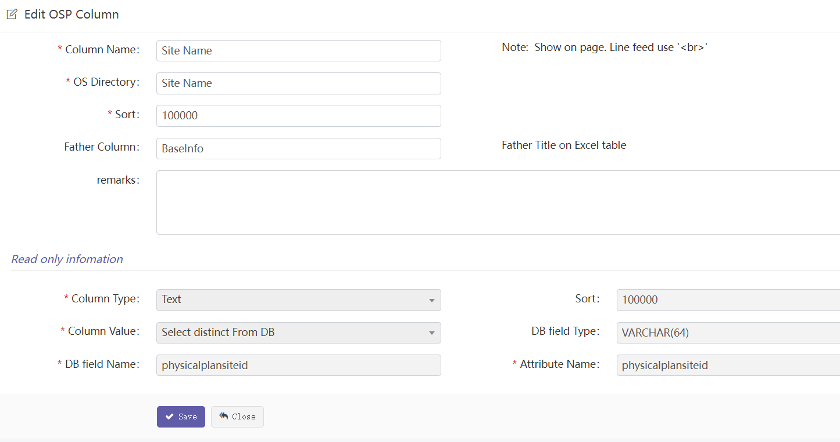

有的名称比较长，如需换行显示，则可以使用换行符号‘<br>’注意不能全角！

Father Column就是父标题，目前系统中使用的地方有：字段选择窗口中，按父标题分级，方便选择。

Some names are relatively long. If line feed is required, you can use the line feed symbol '<br>' and pay attention not to use all corners!

Father column is the parent title. At present, it is used in the system: in the field selection window, it is graded according to the parent title for easy selection.

##### Role column

这里控制角色对菜单及下属milestone字段的权限。也就是不同的菜单用户权限不一样，同一个菜单下不同milestone字段，用户的权限也可以不一样。

Here, the role's permissions on the menu and subordinate milestone fields are controlled. That is to say, different menu users have different permissions, and different milestone fields in the same menu can have different permissions.

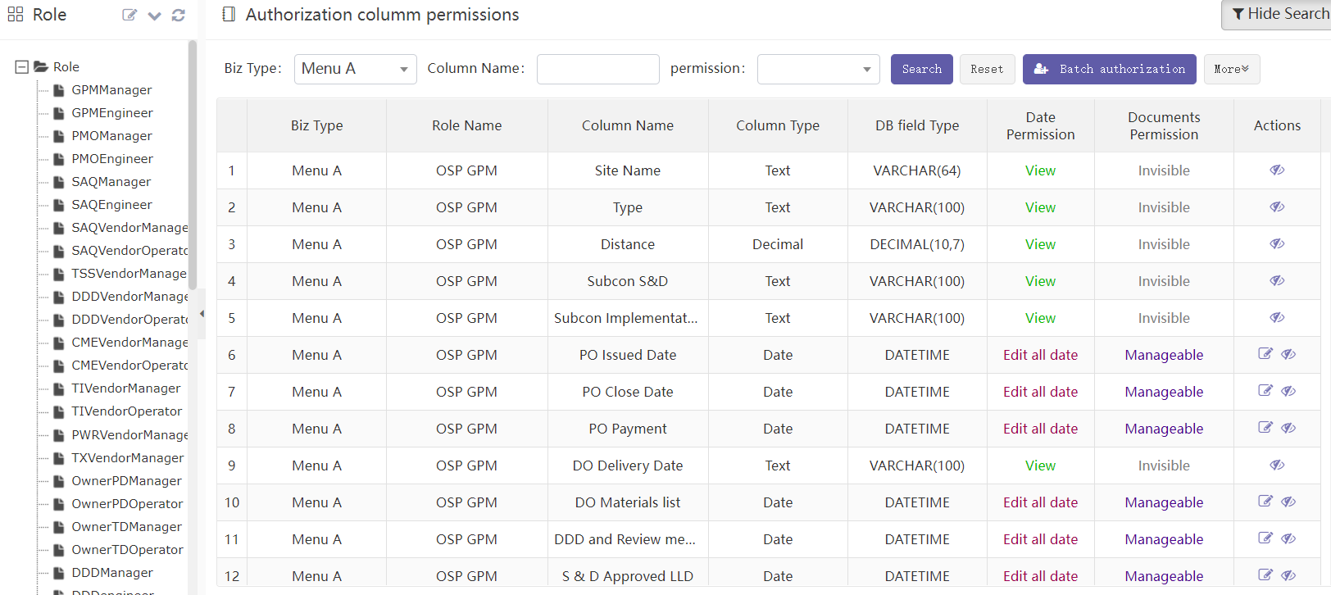

1. 选中某个角色，点按钮“Batch authorization”可针对该角色批量新增分配字段权限。

Select a role and click batch authorization to assign new field permissions to the role in batch

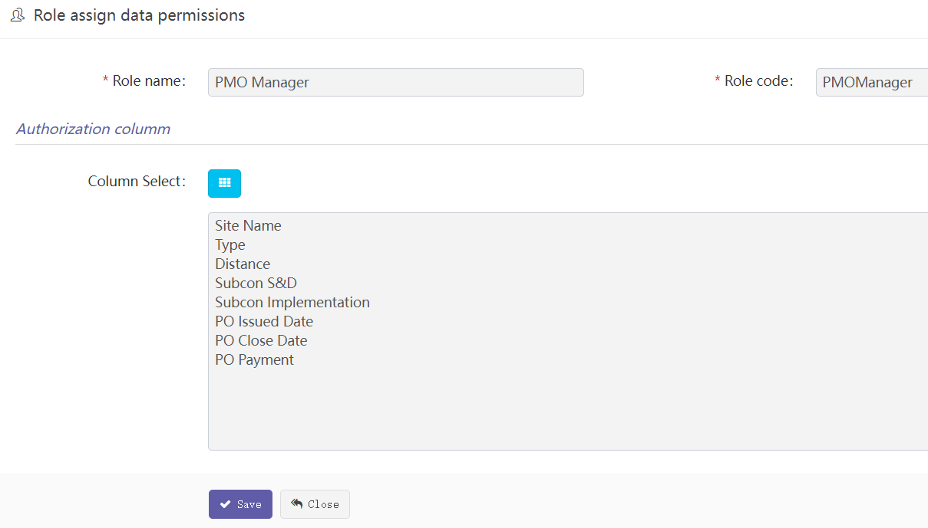

1. 新增字段后，点击字段行尾的眼睛图标，可删除该字段，注：这里仅仅是删除字段权限，并非真实删除字段。

After adding a field, click the eye icon at the end of the field line to delete the field. Note: This is only to delete the field permission, not to delete the field

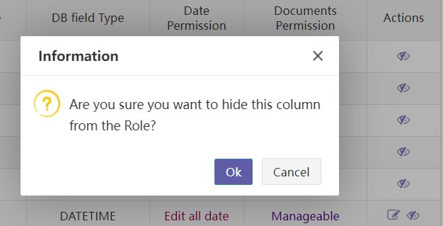

1. 每个字段权限分：Data Permission和Document Permission。分别是数据权限和文档权限。

Each field permission is divided into data permission and document permission. Data permission and document permission.

Date Permission：数据权限分类

View: View only，Cannot modify只能查看不能修改

Edit today: It can only be modified to today 只能修改成今天，不能修改成其他

Edit all date: Can be modified to any date 可以修改成任意日期

Documents Permission： 文档权限分类

Invisible：不可见

Downloadable：can download but cannot upload可下载文档但不能上传

Manageable：can upload and can download 可上传可下载

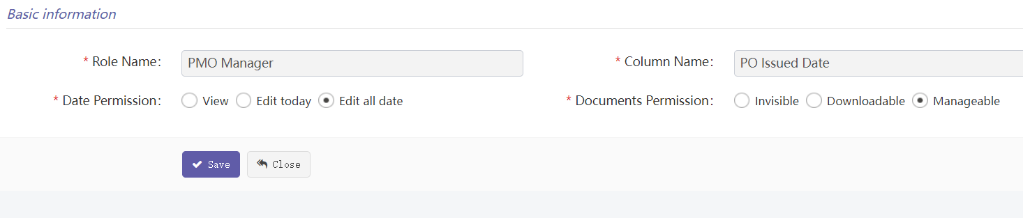

1. 对于非日期型字段，只有对数据的View权限和对文档Invisible权限，且不能修改。

For non date fields, only view permission on data and invisible permission on document can be modified.

#### Project mgt

##### Backbone column mgt

Backbone配置参数维护。（可新增/删除/编辑字段）

Backbone configuration parameter maintenance. (fields can be added / deleted / edited)

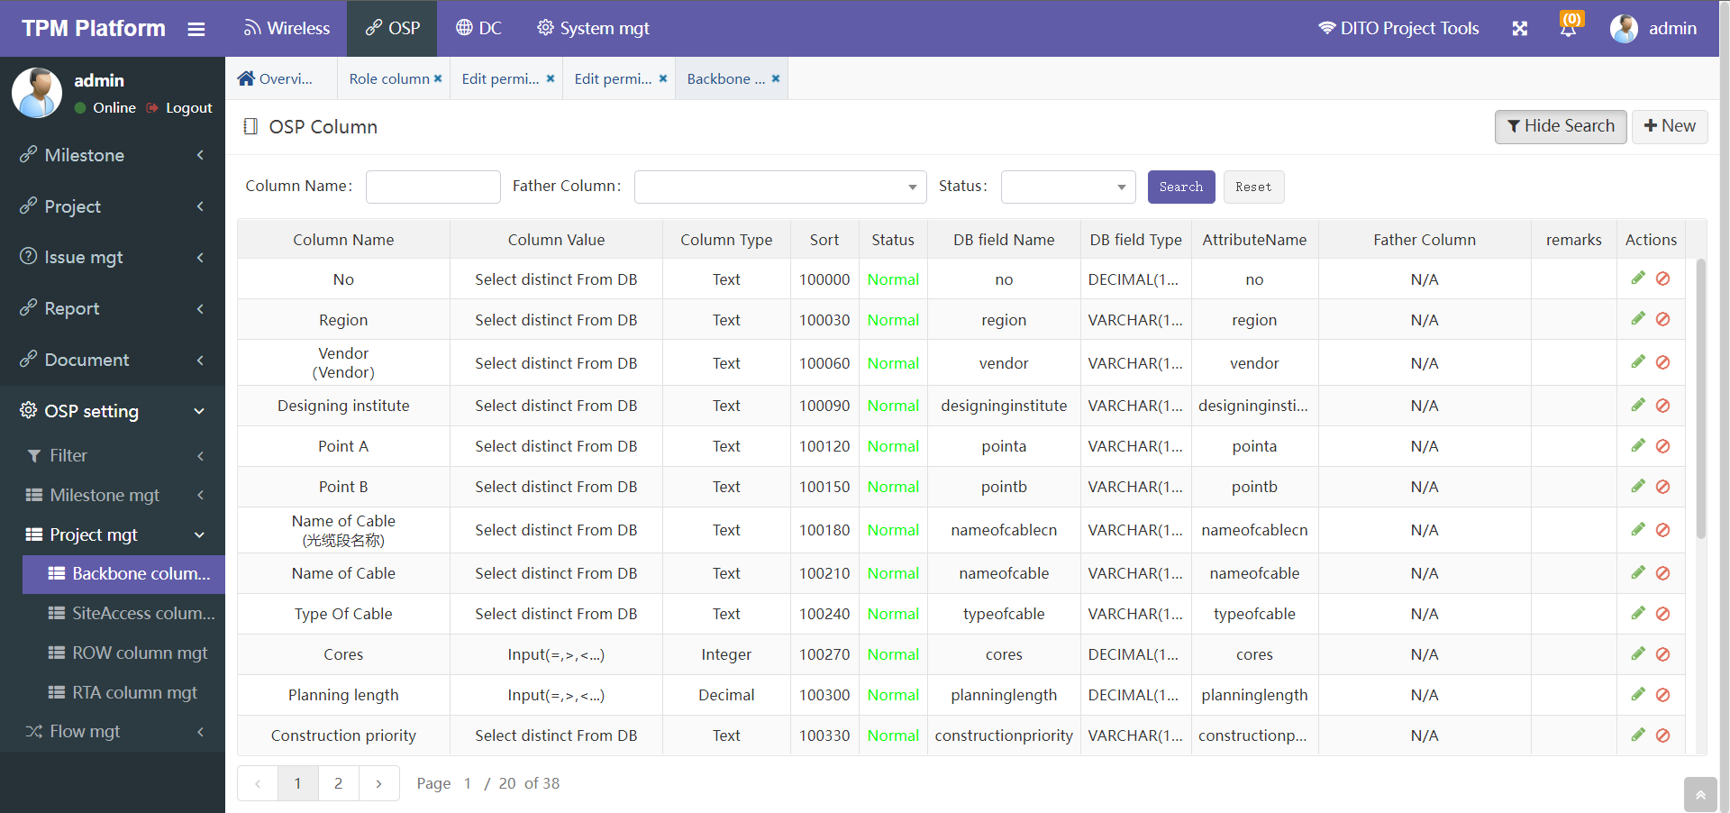

##### SiteAccess column mgt

SiteAccess配置参数维护。（可新增/删除/编辑字段）

SiteAccess configuration parameter maintenance. (fields can be added / deleted / edited)

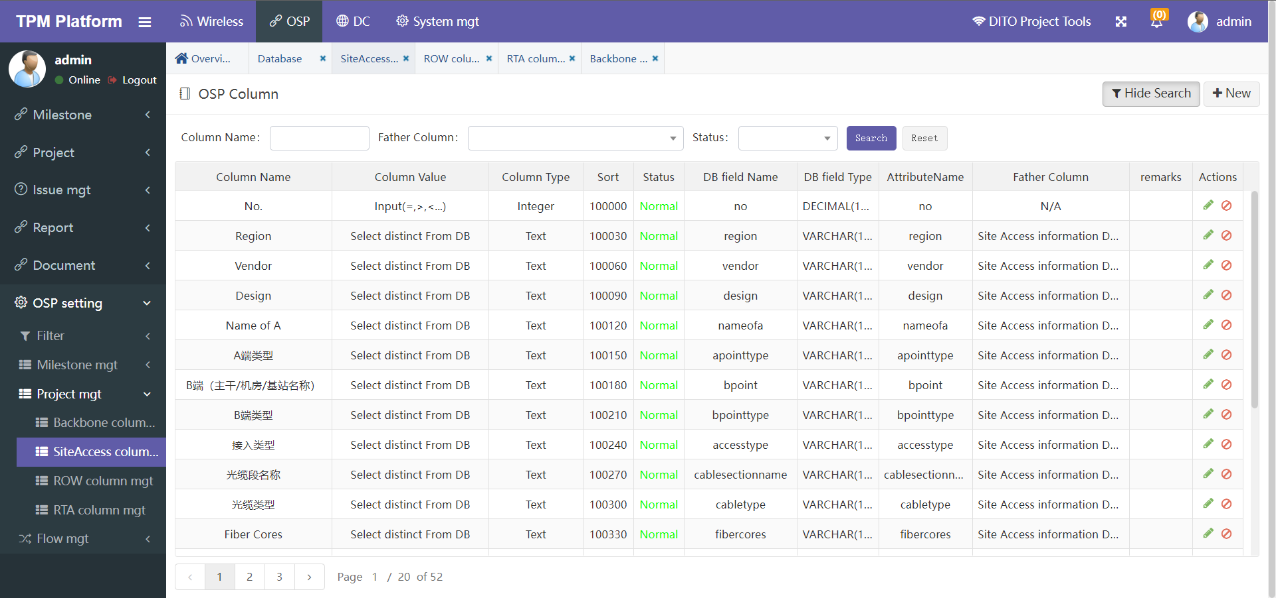

##### Row column mgt

Row配置参数维护。（可新增/删除/编辑字段）

Row configuration parameter maintenance. (fields can be added / deleted / edited)

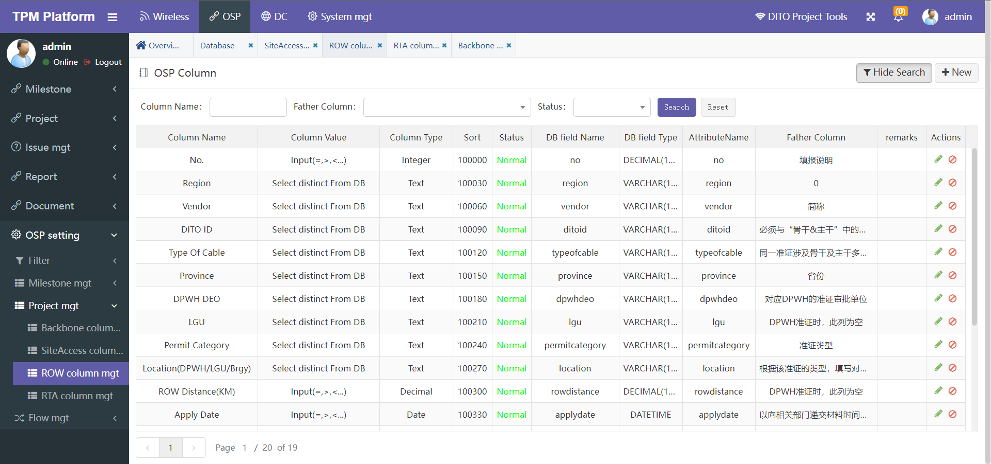

##### RTA column mgt

RTA配置参数维护。（可新增/删除/编辑字段）

RTA configuration parameter maintenance. (fields can be added / deleted / edited)

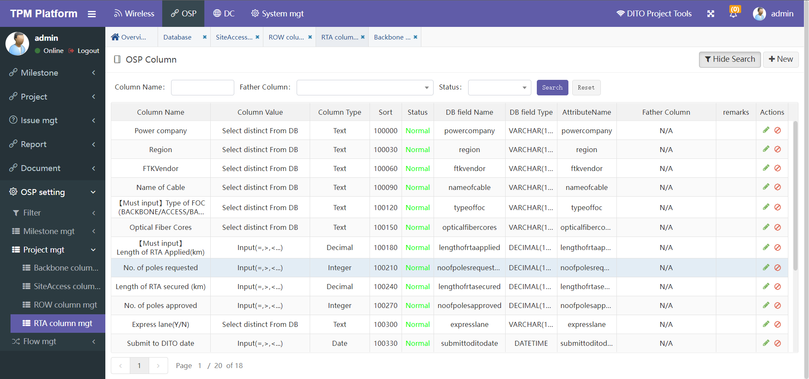

## DC

### Milestone

#### Milestone task

**DC工作里程碑管理**

**DC Work Milestone Management**

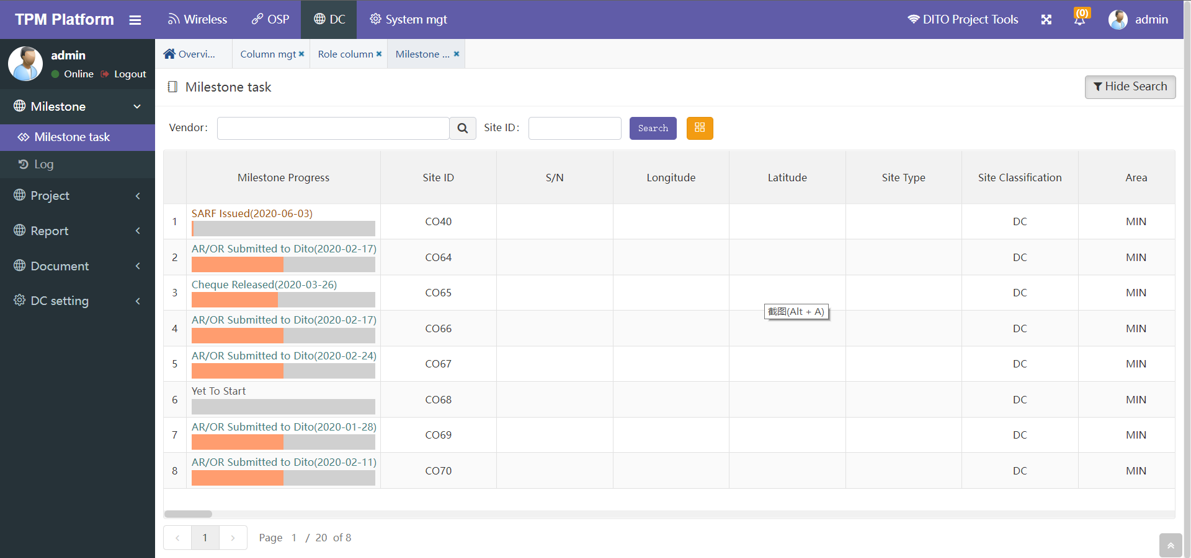

* **功能说明：Function Description:**

1. 本功能主要为项目组和分包商管理DC日常工作使用。
2. 首列显示的是该基站当前最新的里程碑及日期。黄色进度条表示当前进度情况。  
   计算公式：当前已完成里程碑数量 / 所有里程碑数量 * 100%
3. 基站会更加用户角色过滤，仅展示该角色权限下的基站。目前分项目组业主组 和 分包商组，前者可以看到所有基站，后者只能看到归属于自己分包商的基站。

对于分包商的身份判断逻辑说明：用户归属哪个分包商，在用户属性：Office中控制；用户归属的分包商类别（SAQ\DDD\CME），在用户属性：角色中控制。

1. 项目组和分包商登录后可查看到各自可以管理的Milestone字段信息，橙色表示可以操作，可操作的内容有：修改日期，上传文档、上传图片、下载文档、下载图片。  
   角色与字段权限对应关系，详见菜单：“DC Setting” -> ”Role column”。
2. “Search”功能：可通过Vendor和Site ID搜索符合条件的基站。
3. 黄色按钮”Column select”是选择本页面需要显示哪些Milestone，因为Milestone数量较多可选择少量显示，便于操作。
4. This function is mainly used by the project team and vendors to manage the daily work of the DC project process.
5. The first column shows the latest milestone and date of the site. The Yellow progress bar indicates the current progress.

Calculation formula: number of currently completed milestones / number of all milestones * 100%

1. The SITE will be more user role filtering, and only the Site under the permission of the role will be displayed. At present, the owner group and the vendor group of the sub project group can see all sites, while the latter can only see the sites belonging to its own vendors.

For the logic description of vendor identity judgment: which vendor the user belongs to is controlled in user attribute: office; The vendor category (SAQ \ DDD \ CME) to which the user belongs is controlled in user attribute: role.

1. After logging in, the project team and vendors can view the milestone field information that they can manage. Orange indicates that they can operate. The operable contents include: modification date, upload document, upload picture, Download document and download picture.

For the corresponding relationship between roles and field permissions,

see the menu: “DC Setting” -> ”Role column”

1. "Search" function: search qualified sites through vendor and site ID.
2. The yellow button "Column select" is used to select which milestones need to be displayed on this page. Because there are a large number of milestones, you can select a small number to display for easy operation.

* **Milestone的操作界面：Operation interface of milestone:**

点击下图橙色日期后的编辑图标，可进入该Milestone的操作界面

Click the edit icon after the orange date in the figure below to enter the milestone operation interface

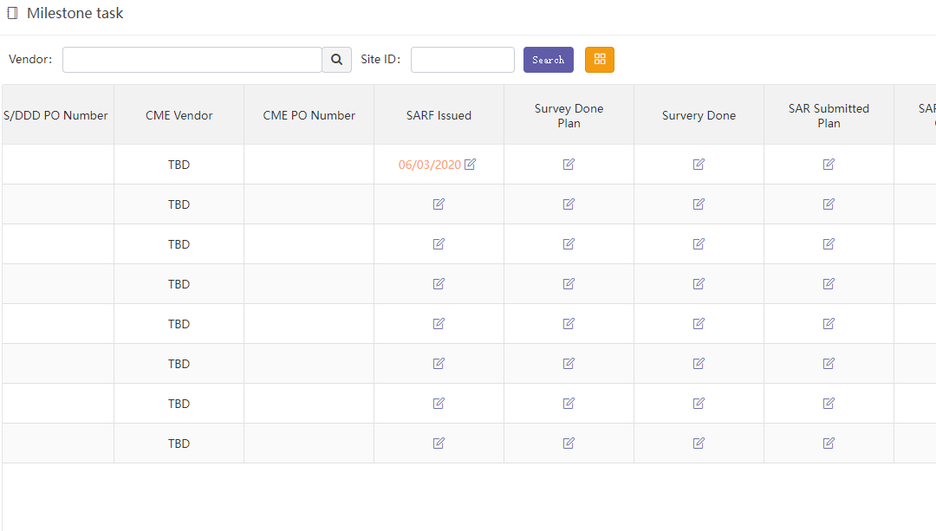

* **操作界面 Operation page**

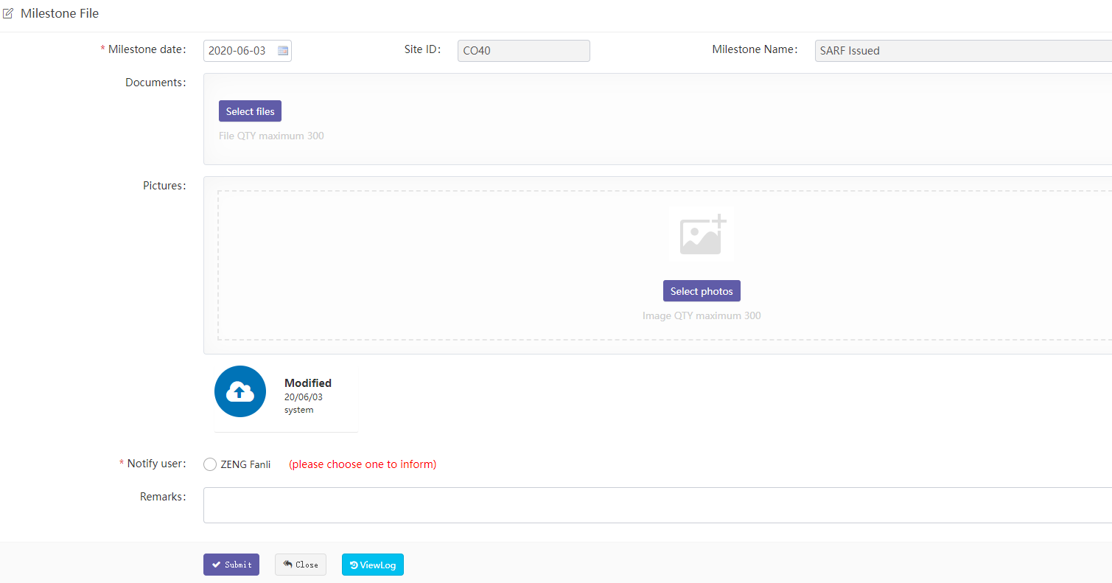

1. “Site ID” 和 “Milestone Name”不可编辑。
2. “Milestone Date” 是Milestone完成日期，与下面的”N/A”两者必选一项。
3. “N/A表示该Milestone不需要输入日期，无日期概念。
4. “Documents”表示该Milestone需要上传的文档。
5. “Pictures”表示该Milestone需要上传的图片。
6. “Notify user”表示需要邮件通知的用户。
7. “Remarks”可输入备注信息。
8. “Site ID” and “Milestone Name” are not editable.
9. "Milestone Date " is the Milestone completion date, which must be selected from”N/A” below.
10. ”N/A” means that the Milestone does not need to enter a date, and there is no date concept.
11. "Documents" indicates the documents to be uploaded by the milestone.
12. "Pictures" indicates the pictures to be uploaded by the milestone.
13. “Notify user” indicates mail notification to user.
14. "Remarks" to enter comments.

* **Milestone流程 Milestone process**

1. Milestone的文档上传、审批等每次流程信息，只要有数据就会展示在操作页面：

Milestone's document upload, approval and other process information will be displayed on the operation page as long as there is data:



1. “ViewLog”可查看所有历史流程操作记录。

" ViewLog " can view all historical process operation records.

#### Log

DC模块日志信息。

DC module Log information.

可通过：日期、基站ID、Milestone、操作用户名查询所有历史操作记录。

All historical operation records can be queried through date, site ID, milestone and operation user name.

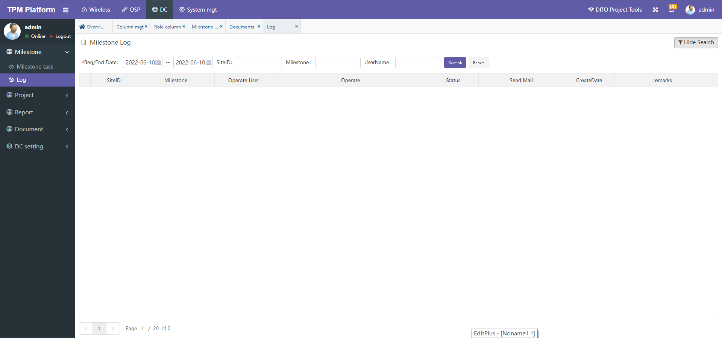

### Project

管理基站配置参数。

Manage Site configuration parameters.

#### Database

本菜单主要管理DC基站配置参数。

This menu mainly manages all configuration parameters of the DC Site.

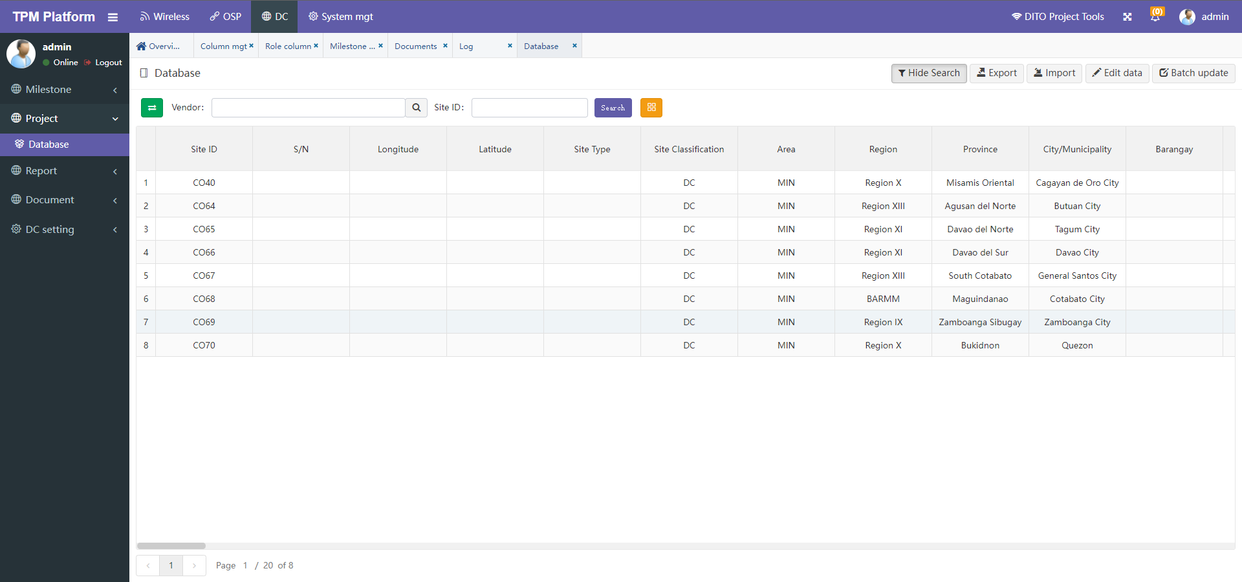

* **功能说明： Function description**

1. “Export” 导出所有基站配置参数数据（Excel文档）到本地。根据页面所筛选的数据行和数据列，点导出时，系统会导出当前页面所有分页的基站数据，所见即所得。

"Export" exports all site configuration parameters data (excel document) to the local. According to the data rows and columns filtered on the page, when clicking export, the system will export the site data of all pages on the current page, What you see is what you get.

1. “Import” 导如基站数据（Excel文档）到平台。可选项：覆盖导入 和 追加导入。如果是覆盖导入，则根据Site ID匹配覆盖原有数据。此功能慎用！有可能会导致数据被误操作清除。导入时除非勾选了是否覆盖导入，否则都是追加导入数据。

"Import" imports the site data (Excel document) to the platform. Optional: overwrite import and append import. If it is an overwrite import, the original data will be overwritten according to the Site ID match. Use this function with caution! It may cause the data to be cleared by misoperation. During import, the imported data is appended unless overwrite import is checked.

**举例：**导入基站数据步骤

**Example**: importing site data

* **步骤一 Step 1**

导入基站前先下载EXCEL数据模板，点击按钮“Import”在弹出窗口中点击“Download template”：

Download the Excel data template before importing the Site, click "import" and click "download template" in the pop-up window:



* **步骤二 Step 2**

在下载的模板文档中，拷贝基站数据，并检查数据正确性：

检查这些字段不能为空：“Site Id”

In the downloaded template document, copy Site data and check the correctness of the data:

Check that these fields cannot be empty: “Site Id”

* **步骤三 Step 3**

点击选择文件，选择你要导入的excel文件。

Click Select File and select the excel file you want to import.

* **步骤四 Step 4**

选择是否勾选“是否根据基站ID替换已存在的数据”。如勾选则会覆盖相同Site Id的基站数据。如果不勾选，则当遇到相同ID时提示且全部数据导入失败。

注：导入时系统会验证每个字段是否正确，只要有一个验证不通过，则全部导入失败，待修改正确后重新导入。

Select whether to check "replace existing data according to Site Id". If checked, the site data with the same site ID will be overwritten. If unchecked, a prompt will appear when the same ID is encountered and all data import fails.

Note: when importing, the system will verify whether each field is correct. As long as one of the fields fails to pass the verification, all the fields will fail to import. Import again after the modification is correct.

1. 编辑基站：点击编辑按钮，页面进入编辑模式，再次点击退出编辑模式：

Edit site: click the Edit button, the page will enter the edit mode, and click again to exit the edit mode:

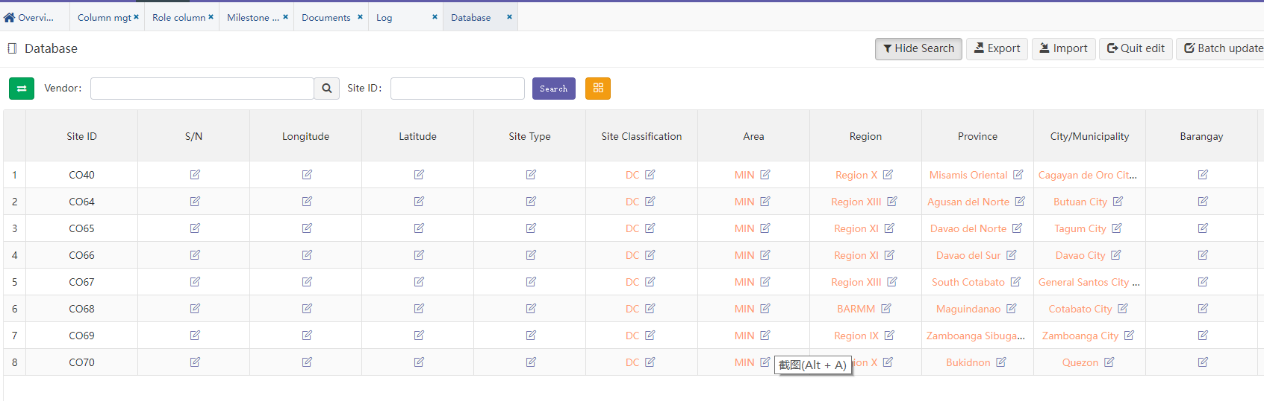

* 点击任何一个单元格，即可进入编辑该单元格的详情页，除“Site Id”外其他字段均可编辑。

“Site Id”不能修改是因为它是唯一标识基站编号的数据。

Click any cell to enter the details page of editing the cell. Other fields can be edited except "Site Id". " Site Id " cannot be modified because it is the data that uniquely identifies.

* 当前权限只有管理员与项目组可以修改。

Current permissions can only be modified by administrators and project groups

* 不同单元格数据类型会有不同的展示，类型有：文本、整数、日期、小数。

Different cell data types have different displays, including text, integer, date and decimal



系统会对输入的数据类型做验证，整数字段输入框不能输入字母等。

The system will verify the input data type. Letters cannot be entered in the integer field input box.

### Report

#### Daily rpt

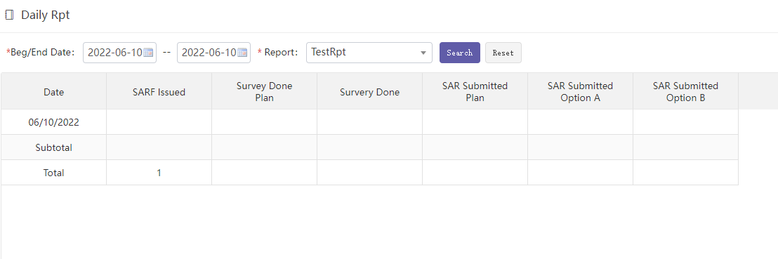

1. 条件选项：

开始日：报表统计的开始时间

结束日：报表统计的结束时间

自定义的报表：预先已经自定义的报表，这里必须要选一个。

1. 报表内容数据：

第一列：前面选择的日期天，从开始日到结束日的每一天数据，一天一行。

其他列：自定义报表中每一列所对应的统计信息数据。

**注：**目前系统统计的时间范围是从2019年10月1日到2020年12月31日

1. Condition options:

Start date: the start time of report statistics

End date: the end time of report statistics

Custom report: a report that has been customized in advance. You must select one here.

1. Report content data:

The first column: the previously selected date, each day from the start date to the end date, one row per day.

Other columns: customize the statistics data corresponding to each column in the report.

Note: at present, the time range of system statistics is from October 1, 2019 to December 31, 2020

#### Weekly rpt

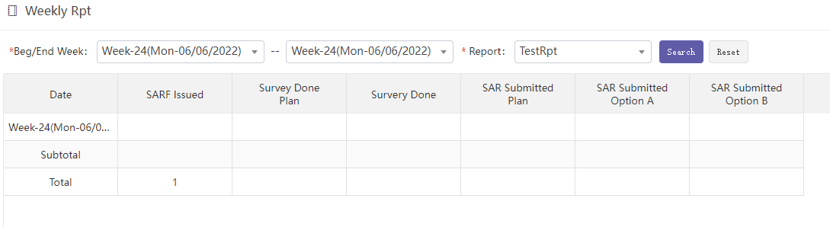

1. 条件选项：

开始周：报表统计开始周

结束周：报表统计结束周

自定义的报表：预先已经自定义的报表，这里必须要选一个。

1. 报表内容数据：

第一列：前面选择的日期周，从开始周到结束周的每一周数据，一周一行。

其他列：自定义报表中每一列所对应的统计信息数据。

**注：**目前系统统计的时间范围是从Week-40(Mon-09/30/2019)到Week-53(Mon-12/28/2020)

周的计算是按每周一到周日算一周，跨年的周会少几天。

1. Condition options:

Start week: report statistics start week

End week: the end week of report statistics

Custom report: a report that has been customized in advance. You must select one here.

1. Report content data:

The first column: the date week selected earlier, the data of each week from the start week to the end week, and one week row.

Other columns: customize the statistics data corresponding to each column in the report.

Note: at present, the time range of system statistics is from week-40 (mon-09 / 30 / 2019) to week-53 (mon-12 / 28 / 2020),The week is calculated from Monday to Sunday, and the week in the new year will be a few days less.

#### Monthly rpt

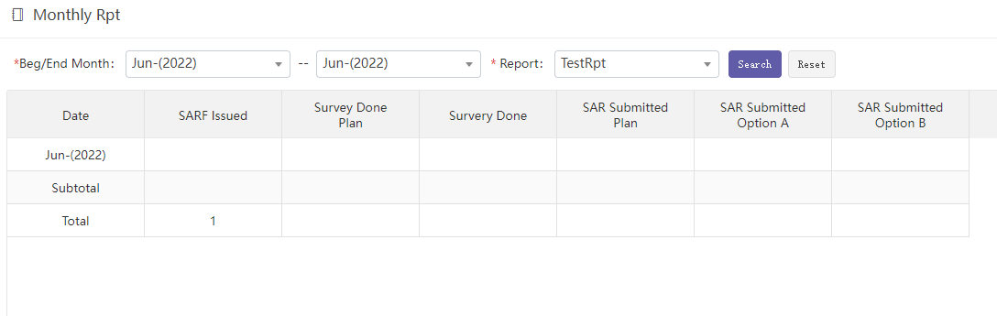

1. 条件选项：

开始月：报表统计开始月

结束月：报表统计结束月

自定义的报表：预先已经自定义的报表，这里必须要选一个。

1. 报表内容数据：

第一列：前面选择的日期月，从开始月到结束月的每一月数据，一月一行。

其他列：自定义报表中每一列所对应的统计信息数据。

**注：**目前系统统计的时间范围是从Oct-(2019)到Dec-(2020)

1. Condition options:

Start month: the start month of report statistics

End month: end month of report statistics

Custom report: a report that has been customized in advance. You must select one here.

1. Report content data:

First column: the date and month selected earlier, the data of each month from the start month to the end month, with one row for each month.

Other columns: customize the statistics data corresponding to each column in the report.

Note: at present, the time range of system statistics is from Oct - (2019) to Dec - (2020)

#### Report design

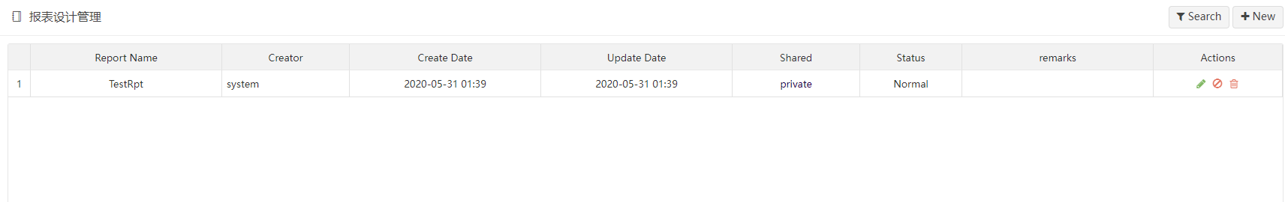

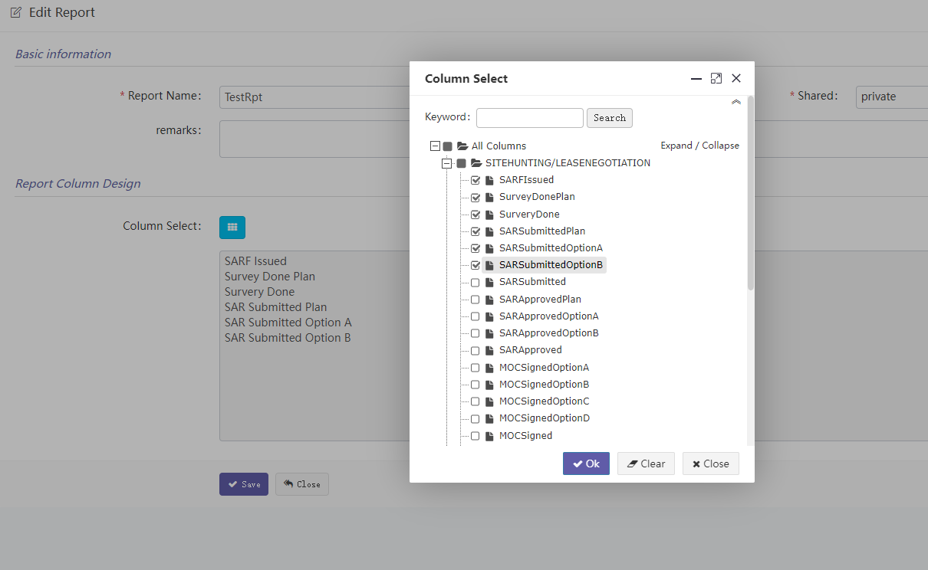

报表的已定义，只定义报表显示的字段，至于统计的时间跨度、基站范围，均在各个日报、周报、月报中来灵活筛选。

* 新建自定义报表步骤：

1. 定义报表名称。
2. 选择需要统计的字段列表。

目前可供统计的字段列表均为日期型字段。

统计逻辑：该字段日期为具体哪一天的，即统计该天计数1。

The report has been defined. Only the fields displayed in the report are defined. The statistical time span and site range are flexibly filtered in each daily, weekly and monthly report.

* To create a new custom report:

1. Define the report name.
2. Select the field list to be counted.

At present, the fields available for statistics are all date fields.

Statistical logic: the date of this field is the specific day, that is, the count of this day is 1.

### Document

#### Download

此处统一维护DC基站Milestone上传的相关文档。

Relevant documents uploaded by milestone of DC Sites are maintained here.

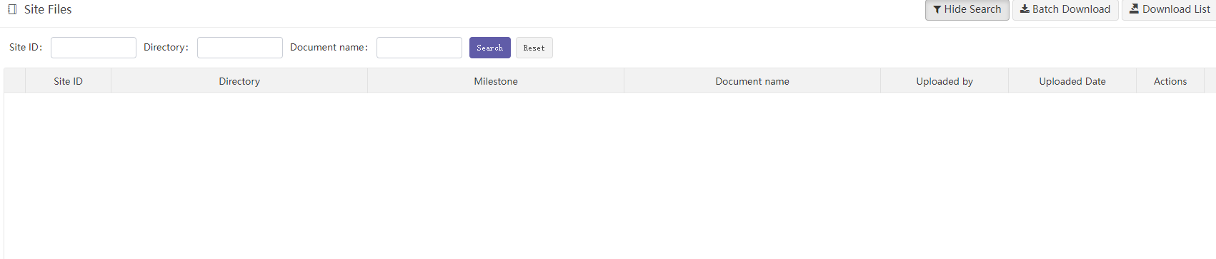

* Search

通过”Site ID”可搜索出所有该基站下的文档列表。

Use "site ID" to search the list of all documents under the site.

通过” Directory”可搜索所有对应的Milestone下的文档列表。

Use "directory" to search the document list under all corresponding milestone.

通过” Document name”可通过名称模糊搜索文档。

"Document name" allows you to search for documents by name blur.

* Batch download



可选择指定基站的指定Milestone下载相应的文档。文档将被压缩打包后下载到本地。

You can select the specified milestone of the specified site to download the corresponding document. The document will be compressed, packaged and downloaded locally.

* Download list

下载所有文档EXCEL清单。

Download excel list of all documents

### DC setting

#### Filter

##### Row filter

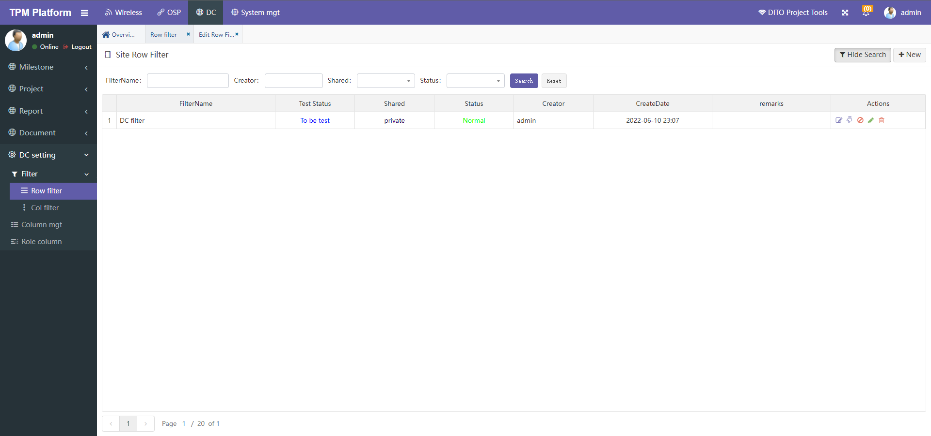

Row Filter是根据基站已有字段过滤基站数据。

简单的说就是从所有基站中，筛选出一部分我想看的基站子集。将这个筛选规则事先定义保存好，下次在功能菜单中可选择这个策略来筛选基站。

Row filter is used to filter the site according to the existing fields of the site.

To put it simply, select a subset of the sites I want to see from all sites. Save the filter rule defined in advance. Next time, you can select this policy in the function menu to filter the site.

* **新建策略步骤：**

**步骤一、**点“New”新建一个策略，此处只需输入一个策略名称“dc filter”，保存。

**步骤二、**回到主页后，点该策略行后面的第一个操作编辑按钮，即进入编辑具体的策略页面。

Step 1. Click "new" to create a new policy. Here, just enter a policy name "dc filter "

and save it.

Step 2. After returning to the home page, click the first operation Edit button behind the policy

line to enter the edit specific policy page.

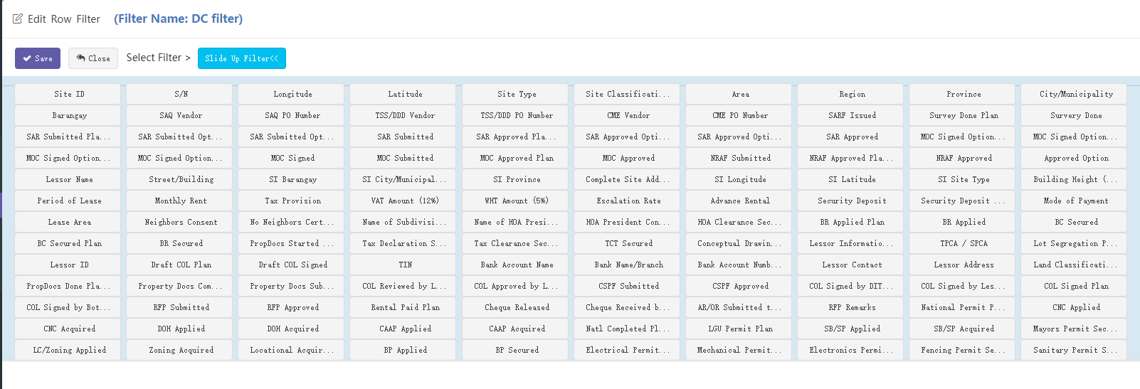

在策略筛选定义中理论上可定义每个基站字段，根据不同的基站字段筛选基站数据。

点击“Slide Up Filter”可选择可供筛选的所有字段。不同的字段数据会不一样，有“日期”型、“文本”型等，系统会自动根据不同类型，提供不同的筛选条件选项。

In the policy filtering definition, each site field can be defined theoretically to filter the site data according to different site fields.

Click "slide up filter" to select all fields available for filtering. Different field data will be different, including date type and text type. The system will automatically provide different filter criteria options according to different types.

* 日期型：按起始日期筛选，可以自选一个日期。

Date type: filter by start date; you can select a date.



* 文本型：将系统中所有的数据罗列出来，可多选。下图是系统查询到Area Type有三个值，然后列出供选择。

Text type: lists all the data in the system. Multiple choices are allowed. The following figure shows that the system finds that there are three values of area type, and then lists them for selection





* 数字型：手工输入数字筛选。

Numeric type: enter numeric filter manually.



日期可以选起始日期，也可以只选开始日期。

You can select the start date or only the start date

考虑基站最早日期不会早于2019年8月1日，我们可以选择大于开始时间2019-08-01。

Considering that the earliest date of the site will not be earlier than August 1, 2019, we can choose to be greater than the start time 2019-08-01.

**步骤三、**定义完策略，按保存回到主页。回到主页后，点该策略行后面的测试操作按钮，可对刚才建立的策略进行测试，如果测试成功会绿色显示该策略可以正常使用，如果有错误，会红色提示，此时不要使用该策略，可联系管理员排查问题。

**Step 3:** after defining the policy, press save to return to the home page. After returning to the home page, click the test operation button behind the policy line to test the policy just established. If the test is successful, it will be displayed in green that the policy can be used normally. If there is an error, it will be prompted in red. Do not use the policy at this time. You can contact the administrator to troubleshoot the problem.

**步骤四、**策略建好后，即可在基站数据菜单“Site data”中使用。也可以在报表菜单 “Report” 中筛选使用。

**Step 4**: After the policy is established, it can be used in the site data menu "site data". You can also filter in the report menu report.

##### Col filter

列筛选的功能就是让用户在界面上定义想看到基站哪几列数据，而其他的列则隐藏。

简单的说就是从所有基站字段列中，筛选出一部分我想看的字段列。将这个筛选规则事先定义保存好，下次在功能菜单中可选择这个策略来筛选基站字段列。

The function of column filtering is to allow the user to define which columns of Site data he wants to see on the interface, while other columns are hidden.

In short, it is to filter out some of the fields I want to see from all sites field columns. Save the filter rule defined in advance. Next time, you can select this policy in the function menu to filter the field columns of the site.

* **新建列筛选策略：**

**To create a new column filter policy:**

步骤一、点“New”新建一个策略，输入策略名称和需要筛选的字段：

Step 1. Click “New” to Create a new policy, enter the policy name and the fields to be filtered

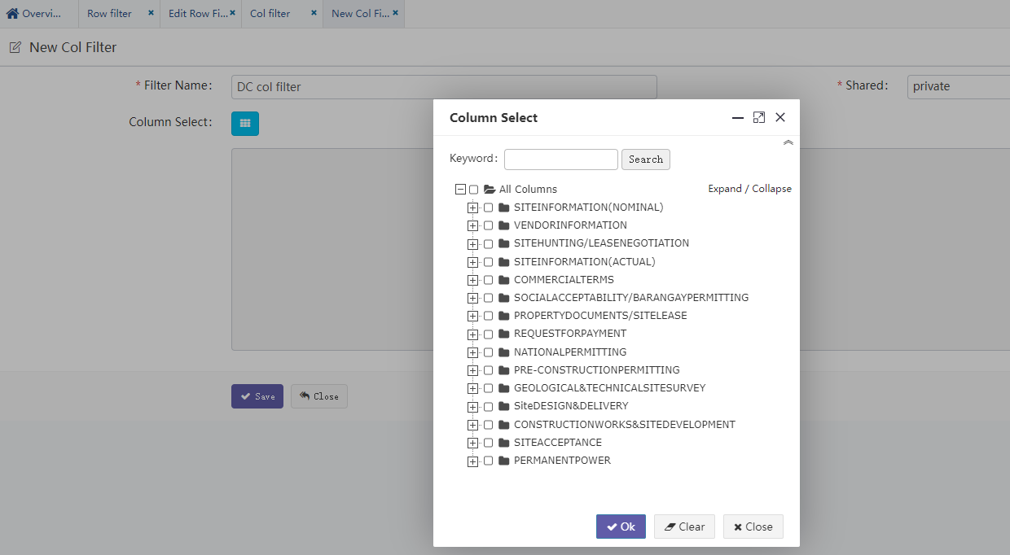

“Shared”: private/public 表示私有（只有建策略的用户自己可见），公开（其他人也可见，可使用）

"Shared": private/public means private (visible only to the user who created the policy) and public (visible to others, and can be used)

“Column Select”: to select fields, as shown in the following figure:

步骤二、按保存，新建策略成功。

Step 2: press save to create a new policy successfully.

步骤三、列策略无需测试，可直接在其他页面使用。

Step 3. The column strategy does not need to be tested and can be used directly on other pages.

#### Column mgt

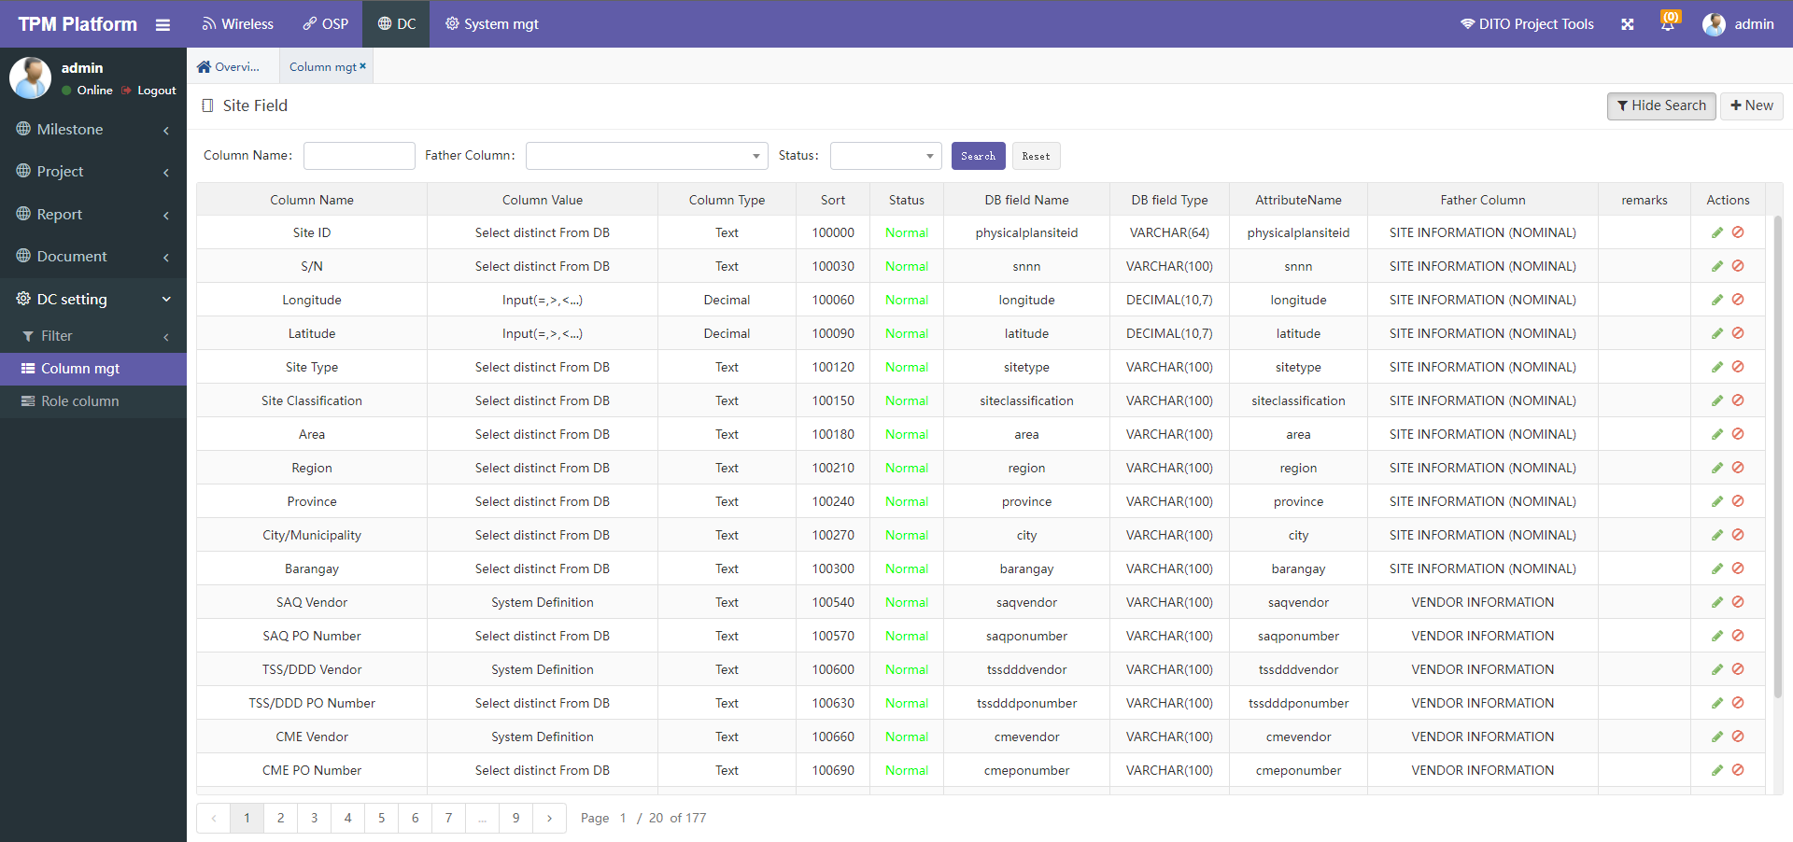

1. 系统中所有DC基站可供使用的字段均在此维护。

The fields available to all DC sites in the system are maintained here.

**注意：因为这些字段信息比较重要，要谨慎维护，如果误操作会引起系统不能正常使用。**

**Note: because these field information is important, it should be maintained carefully. If it is misoperated, the system will not work normally.**

1. 字段名称可以修改。但修改后，系统中其他相关显示的地方也会相应变化。

The field name can be modified. But after modification, other relevant displays in the system will also change accordingly.

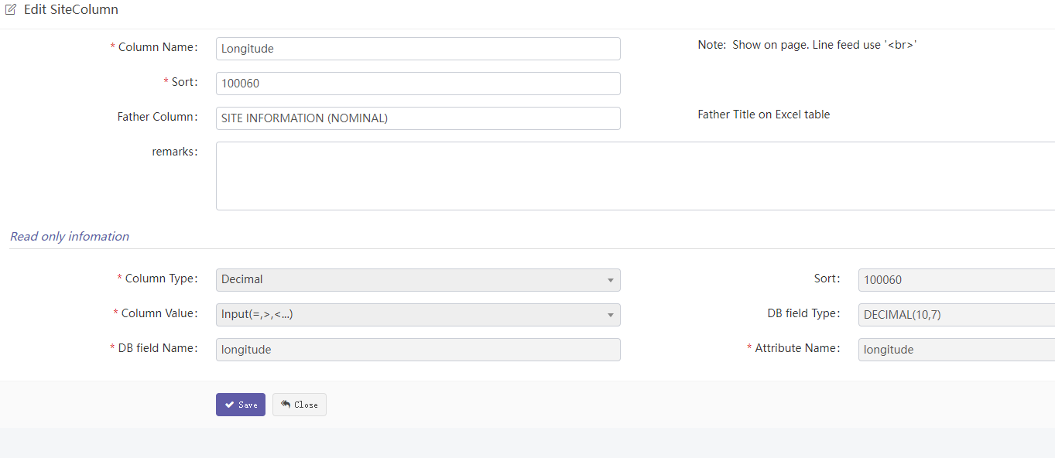

有的名称比较长，如需换行显示，则可以使用换行符号‘<br>’注意不能全角！

Father Column就是父标题，目前系统中使用的地方有：字段选择窗口中，按父标题分级，方便选择。

Some names are relatively long. If line feed is required, you can use the line feed symbol '<br>' and pay attention not to use all corners!

Father column is the parent title. At present, it is used in the system: in the field selection window, it is graded according to the parent title for easy selection.

#### Role column

这里控制角色对字段的权限。

Here, the role's permissions on milestone fields are controlled.

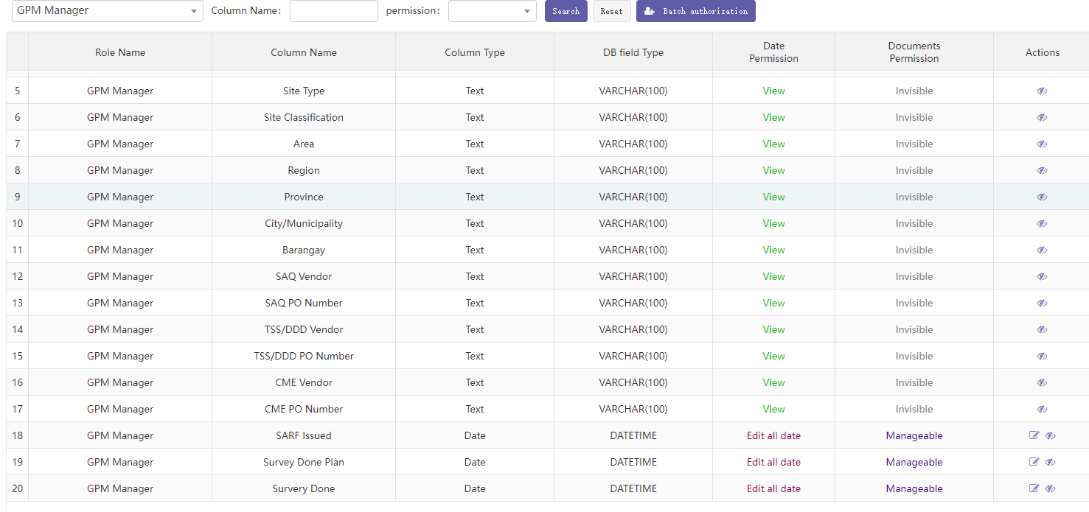

1. 选中某个角色，点按钮“Batch authorization”可针对该角色批量新增分配字段权限。

Select a role and click batch authorization to assign new field permissions to the role in batch

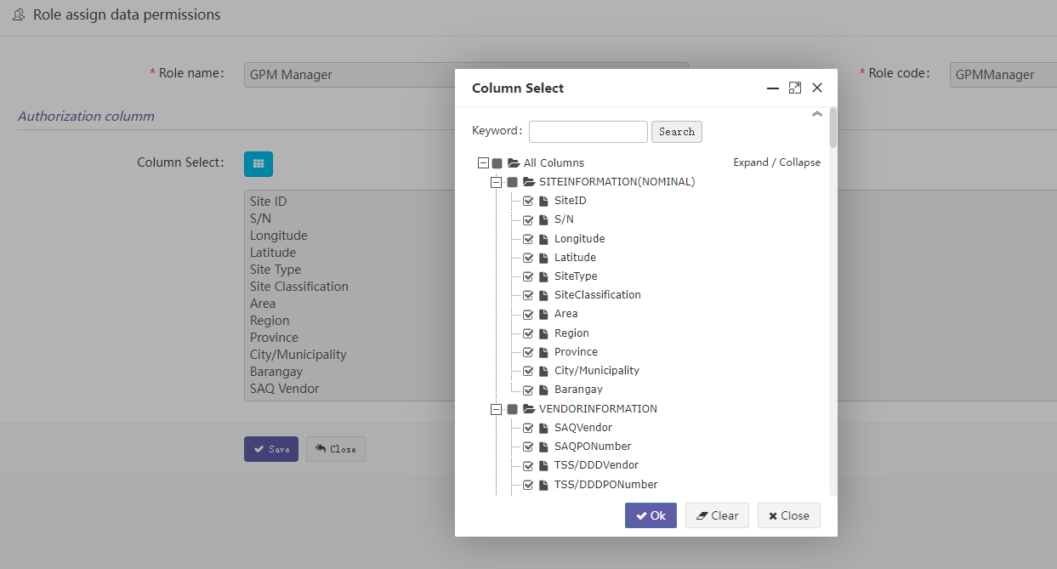

1. 新增字段后，点击字段行尾的眼睛图标，可删除该字段，注：这里仅仅是删除字段权限，并非真实删除字段。

After adding a field, click the eye icon at the end of the field line to delete the field. Note: This is only to delete the field permission, not to delete the field



1. 每个字段权限分：Data Permission和Document Permission。分别是数据权限和文档权限。

Each field permission is divided into data permission and document permission. Data permission and document permission.

Date Permission：数据权限分类

View: View only，Cannot modify只能查看不能修改

Edit today: It can only be modified to today 只能修改成今天，不能修改成其他

Edit all date: Can be modified to any date 可以修改成任意日期

Documents Permission： 文档权限分类

Invisible：不可见

Downloadable：can download but cannot upload可下载文档但不能上传

Manageable：can upload and can download 可上传可下载



1. 对于非日期型字段，只有对数据的View权限和对文档Invisible权限，且不能修改。

For non date fields, only view permission on data and invisible permission on document can be modified.

## System mgt

### Project setting

#### Log

本平台日志信息模块。

Log information module of this platform.

可通过：日期、基站ID、Milestone、操作用户名查询所有历史操作记录。

All historical operation records can be queried through date, site ID, milestone and operation user name.

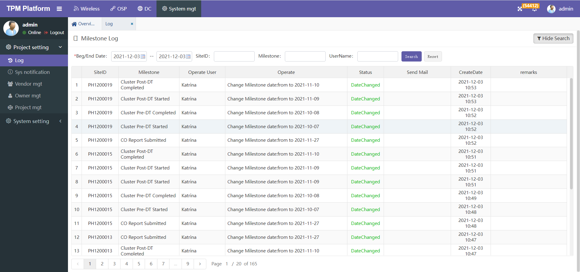

#### Sys notification

本平台系统通知信息模块。

The platform system notification information module.

可通过：日期、基站ID、Title、Status查询所有系统历史通知记录。

All system history notification records can be queried through date, site ID, title and status.

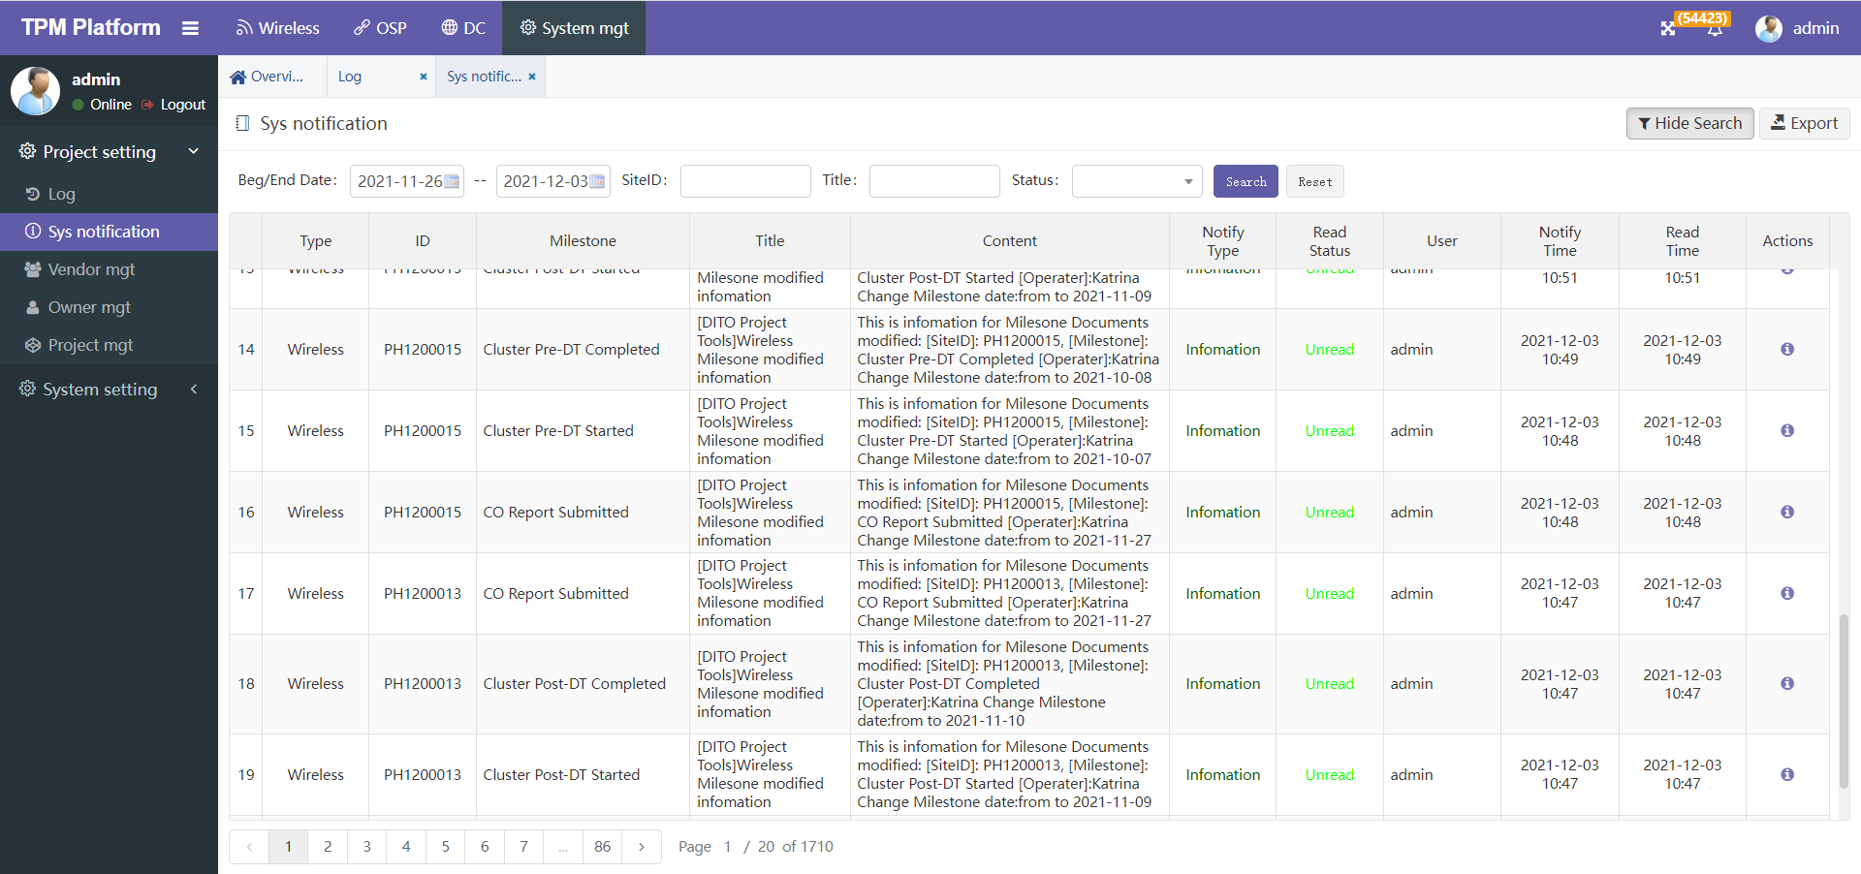

点击该记录行尾操作按钮可查看该条通知详细信息：

Click the operation button at the end of the record line to view the details of the notice:

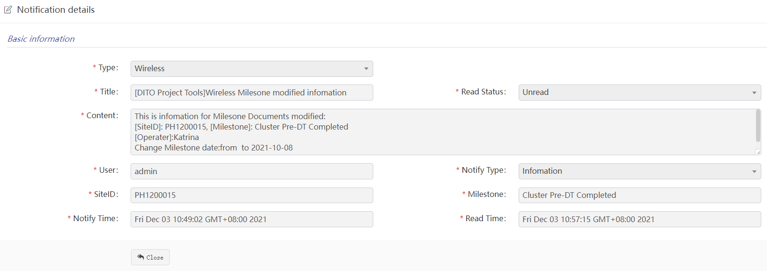

#### Vendor mgt

1. 分包商可以改名称，但不能随意删除，系统隐藏了删除功能。

Subcontractors can change their names, but they cannot delete them at will. The deletion function is hidden in the system.

1. 分包商的类型需要根据业务实际情况选择，比如：“[MJV](http://www.sinohxph.com/yctpm/a/yc/subcontr/form?id=10700)”只分配了CME，也可以同时分配多个。

The type of vendor needs to be selected according to the actual business situation. For example, "MJV" only allocates CME, or multiple vendors can be allocated at the same time

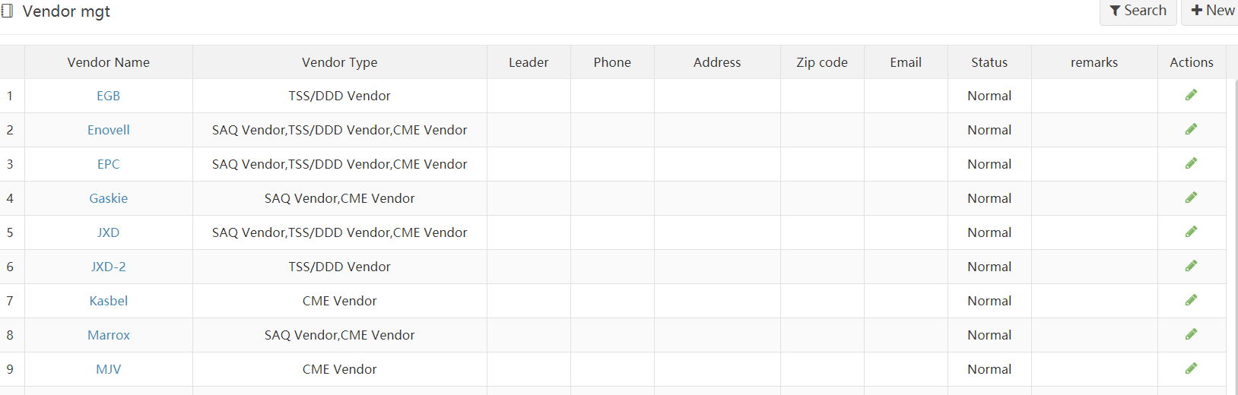

* **新增一个分包商用户 Add a vendor user**

先判断新增分包商是否已存在。

First judge whether the new vendor already exists.

如不存在，则先新建一个分包商，同时新建该分包商的Office：（如存在则跳过这个步骤）

If it does not exist, first create a vendor and create the vendor's office: (if it exists, skip this step)

* **新建分包商步骤：Steps for creating a new vendor**
* 进入分包商管理页面，点击上面的new按钮

Enter the vendor management page and click the new button above

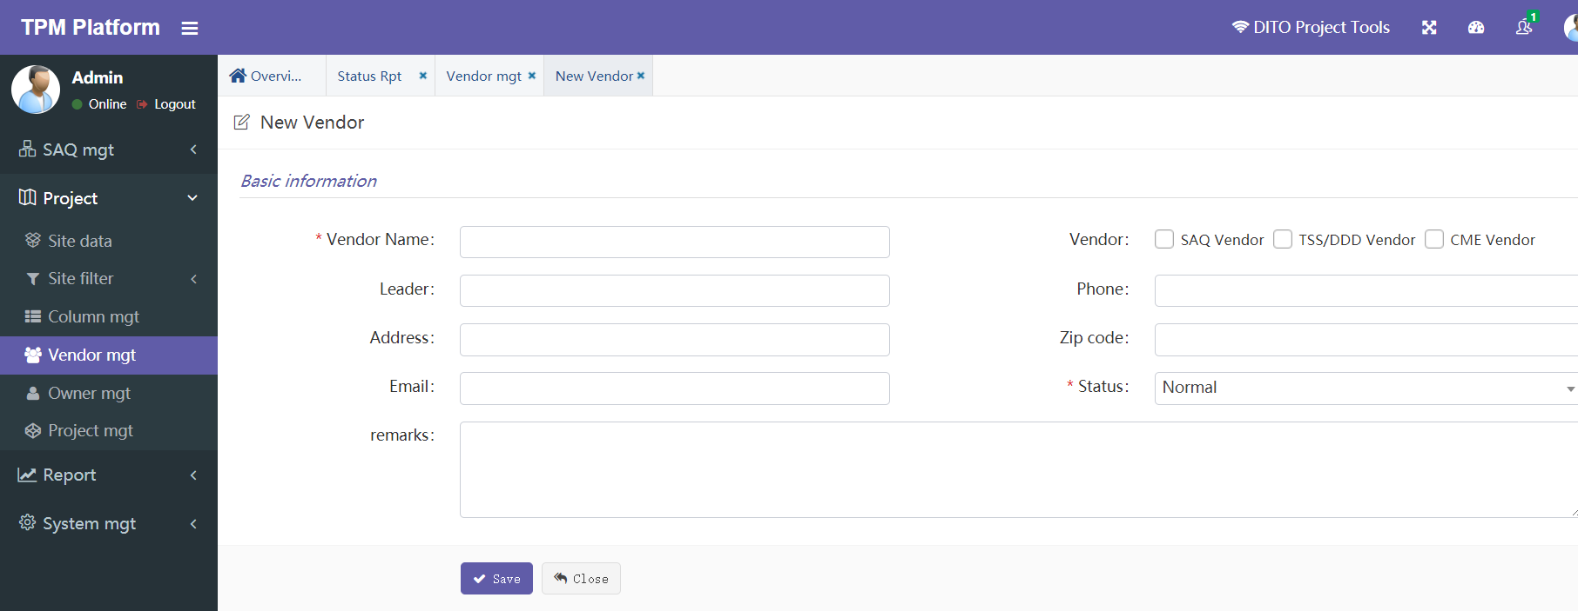

* 输入分包商名称

Enter vendor name

* 选择分包商类型，分包商分类有：Saq 、DDD、CME等。至少选择一个，亦可多选，表示该分包商分别参与哪几种分类。

Select the type of vendor. The classification of vendors includes: SAQ, DDD, CME, etc. Select at least one or more, indicating which classifications the vendor participates in.

* 其他输入框可选输入。

Other input boxes are optional

#### Owner mgt

业主管理对于当前系统无需维护。

The owner management does not need maintenance for the current system.

#### Project mgt

工程管理对于当前系统无需维护，仅登录后操作平台TOP位置会显示该工程名称。

Project management does not need to maintain the current system. Only after logging in, the project name will be displayed at the top of the operating platform.

### System setting

#### User manager

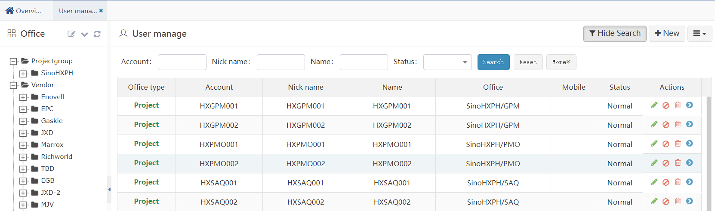

1. 由管理员管理系统能登录的所有用户。

All users who can log in to the system are managed by the administrator

1. 用户可以enable/disable，即启用/停用该用户。

The user can enable / disable, that is, enable / disable the user.

1. 新建用户时，指定该用户的角色。**用户与角色是一对多关系。**

When creating a new user, specify the role of the user. The relationship between user and role is one to many

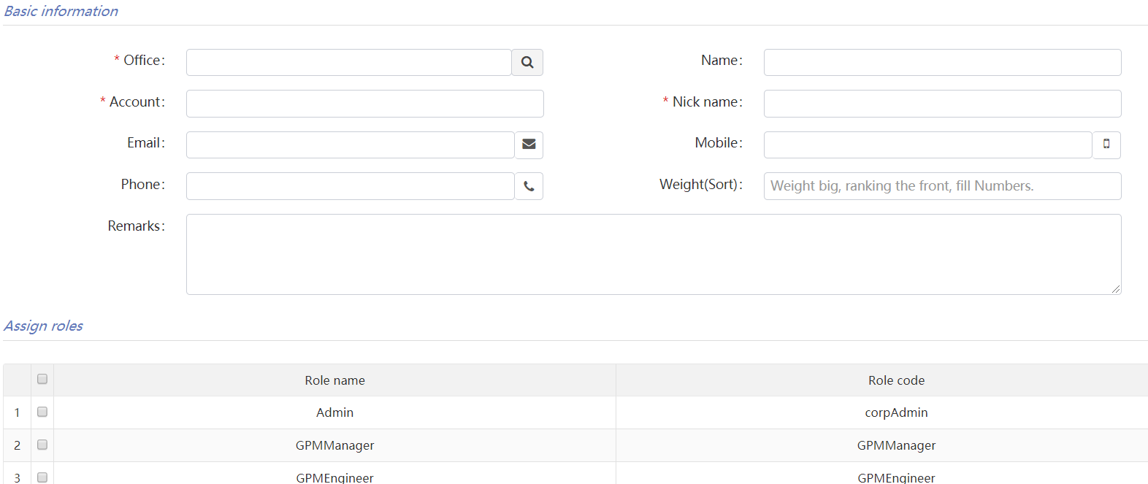

1. 后续修改用户角色，在用户主菜单行尾操作：

Subsequently, modify the user role and operate at the end of the line of the user main menu

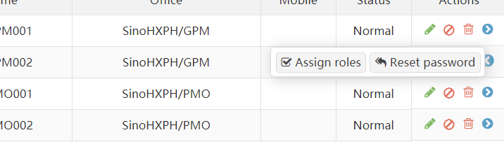

1. 用户行尾可重置用户密码。重置后密码统一为：123456

The user password can be reset at the end of the user line. After reset, the password is: 123456

* **举例：新建分包商用户步骤**

**Example: creating a vendor user**

分包商的角色在系统中已定义，无需更改。共6种：(后期需求有变更，数量有所增加)

The vendor's role has been defined in the system and does not need to be changed. There are 6 kinds in total: (the demand changes and the quantity increases in the later stage)

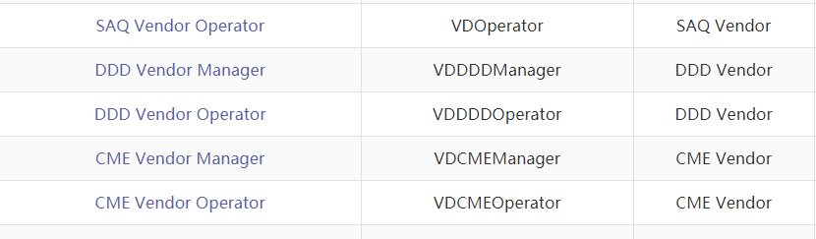

* 进入菜单：“System mgt”-> “System setting” -> “User manager”

Enter menu：“System mgt”-> “System setting” -> “User manager”

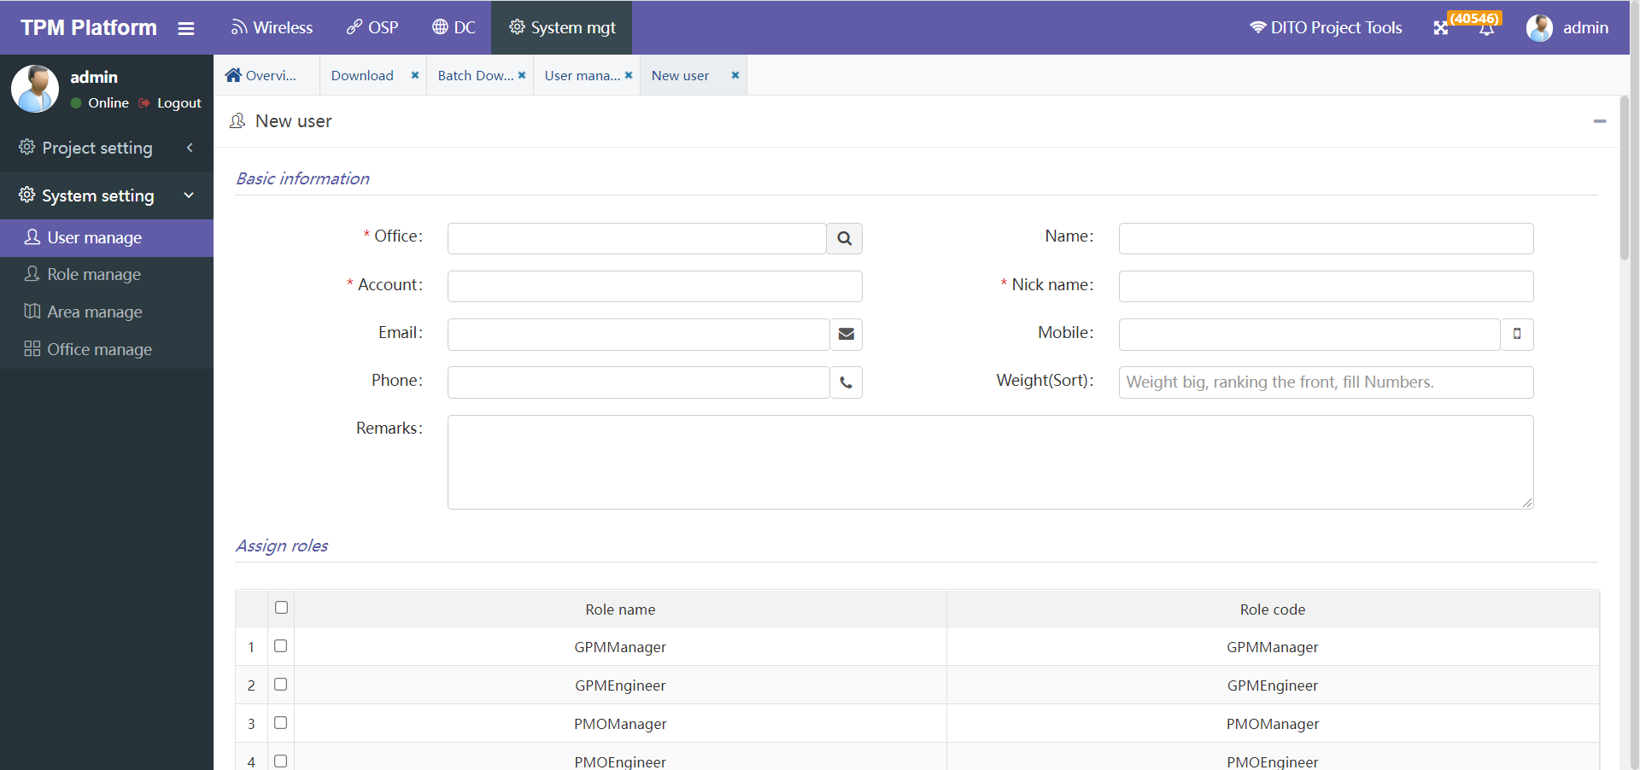

* 选择用户Office：此处选择的该用户所处部门，必须选树图叶子节点，即具体归属某个部门

Select user office: for the Department selected here, you must select a tree leaf node, that is, a department

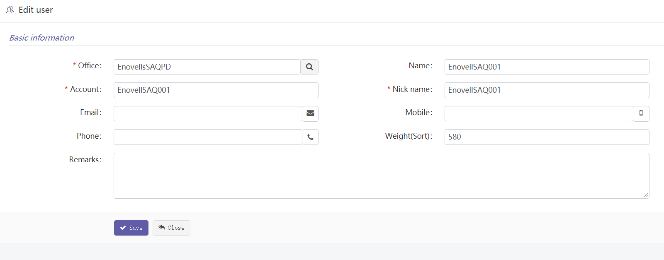

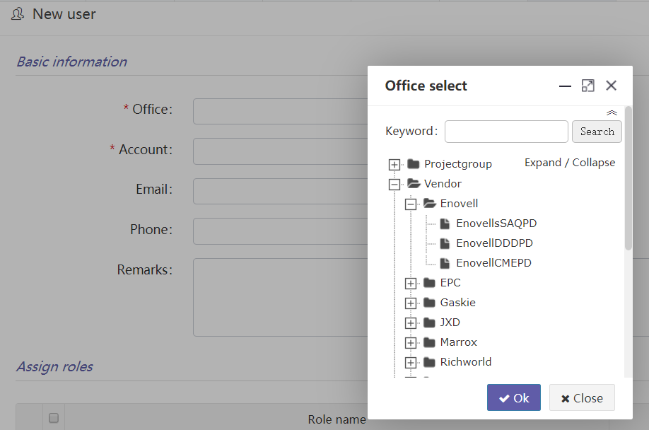

* 输入姓名Name：EnovellSAQ001，显示的名称。

Enter the name: enovellsaq001 to display the name of the

* 输入登录账号Account: EnovellSAQ001，需系统唯一，不能重名。

Enter the login account: enovelsaq001, which must be unique in the system and cannot be duplicate.

* 选择该用户的角色：SAQVendorManager。角色本身可多选，此处因为是分包商单选。

Select the role of the user: saqvendormanager. Multiple roles can be selected, because it is a single choice for vendors.

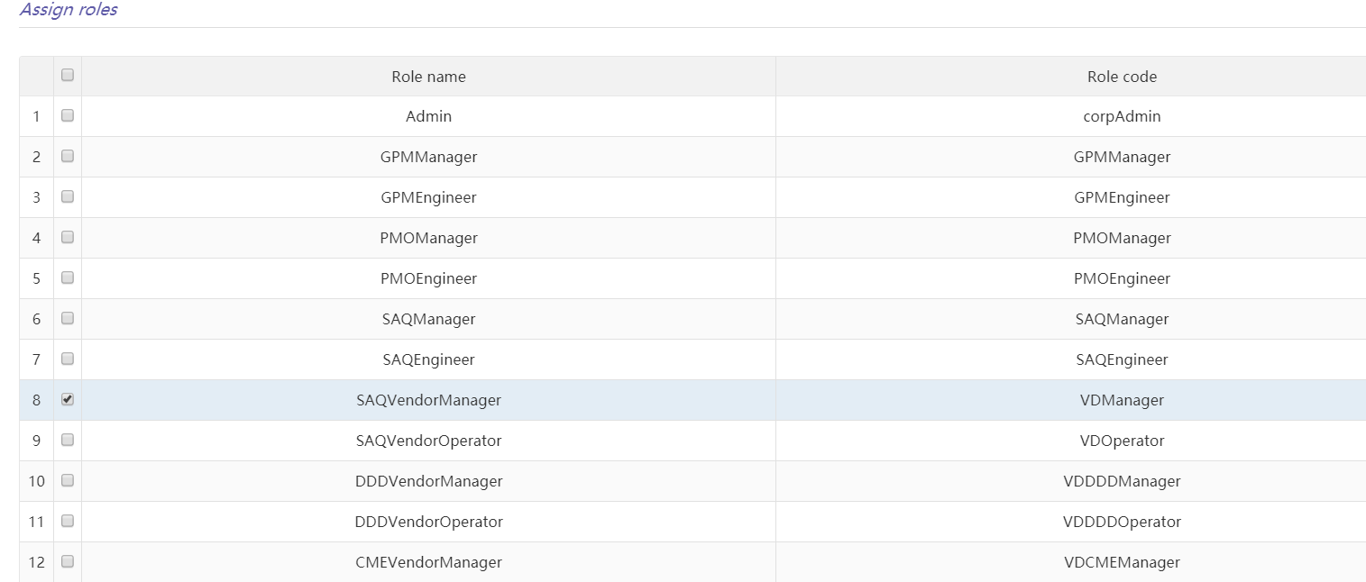

#### Role manager

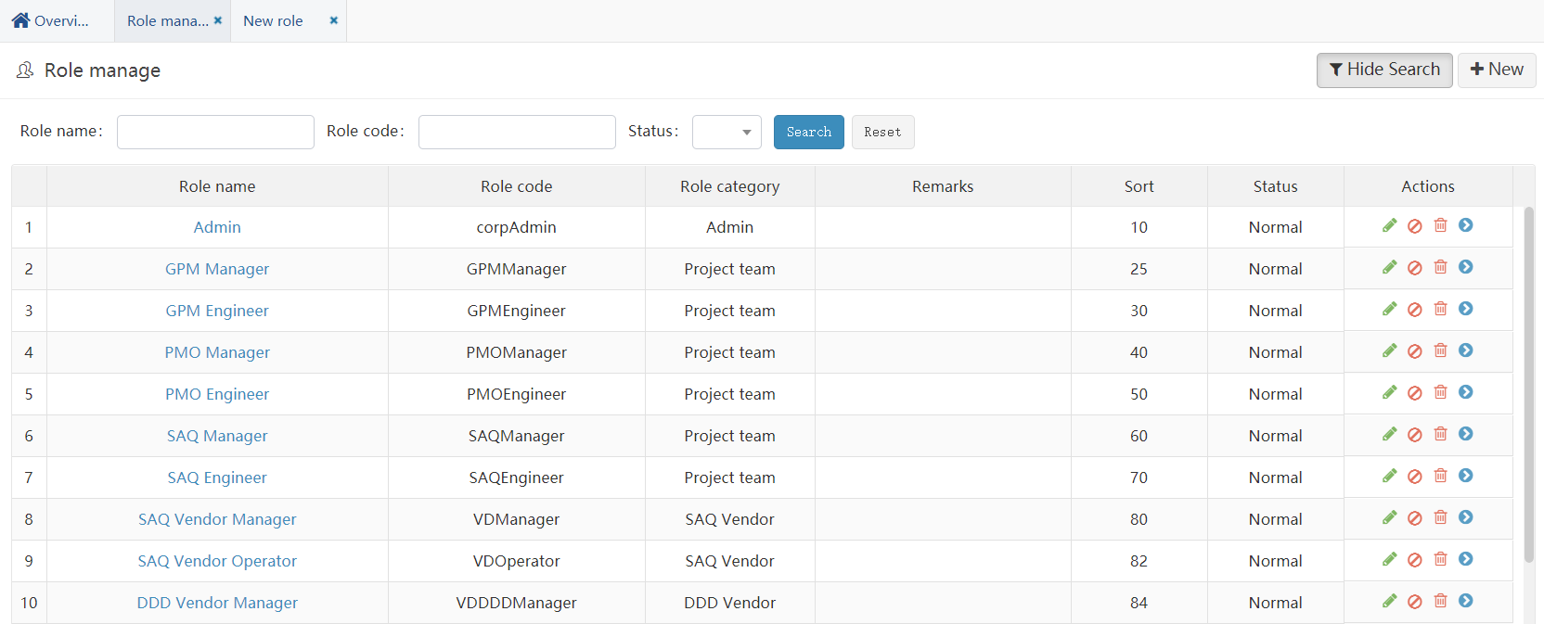

1. 由管理员统一管理角色。

The role is uniformly managed by the administrator

1. 角色可以enable/disable，即启用/停用该角色。

A role can be enabled / disabled, that is, it can be enabled / disabled.

1. 新增角色时：

When adding a role:

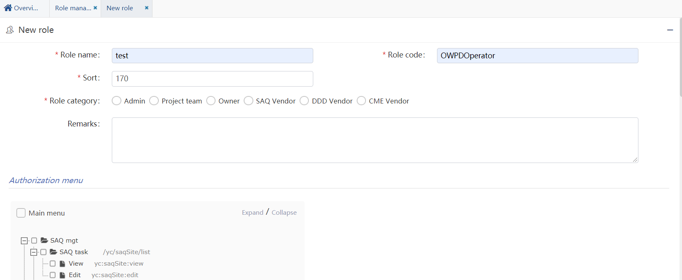

* 1. 角色名字建议能一目了然可以看出是什么身份。

The role name suggestion can be seen at a glance

* 1. 角色编码Code字段建议按一定规则。比如：“身份编码+分类+名称”。分包商按’VD’字母开头。举例：VDDDDManager，VD表示vendor分包商，DDD表示分类是DDD分包商，Manager表示管理员角色。

The role code field is suggested to follow certain rules. For example: "ID code + classification + name". Subcontractors start with the letter 'VD'. For example: vddddmmanager, VD indicates vendor vendor, DDD indicates DDD vendor, and manager indicates administrator role.

* 1. 名称不要包含特殊字符。如：&。

The name should not contain special characters. For example: &

* 1. Role category表示该角色分类，只能单选。

Role category indicates the role category. Only one choice is allowed.

* 1. 菜单选项即可选择该角色能看到的菜单，其中有的菜单下有两个选项：view和edit，分别表示：可以查看但不能操作，可以查看也可以操作。对于不能操作的角色，系统会屏蔽“新增”、“修改”等操作按钮。

Menu options: you can select the menu that the role can see. There are two options under some menus: view and edit, which respectively mean that you can view but not operate, and you can view or operate. For roles that cannot be operated, the system will shield the "add", "modify" and other operation buttons.

1. 可以给已建立的角色统一批量：分配菜单、分配字段权限、分配用户：

You can assign a unified batch to established roles: assign menus, assign field permissions, and assign users

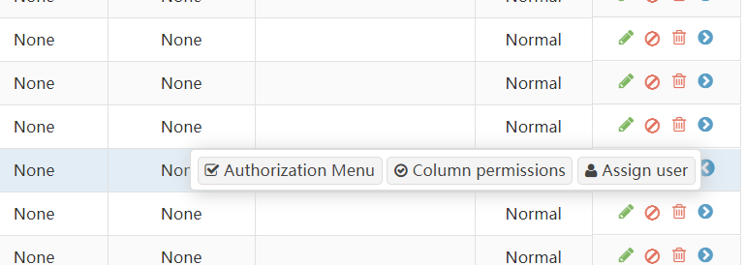

1. 分配字段权限：

Assign field permissions

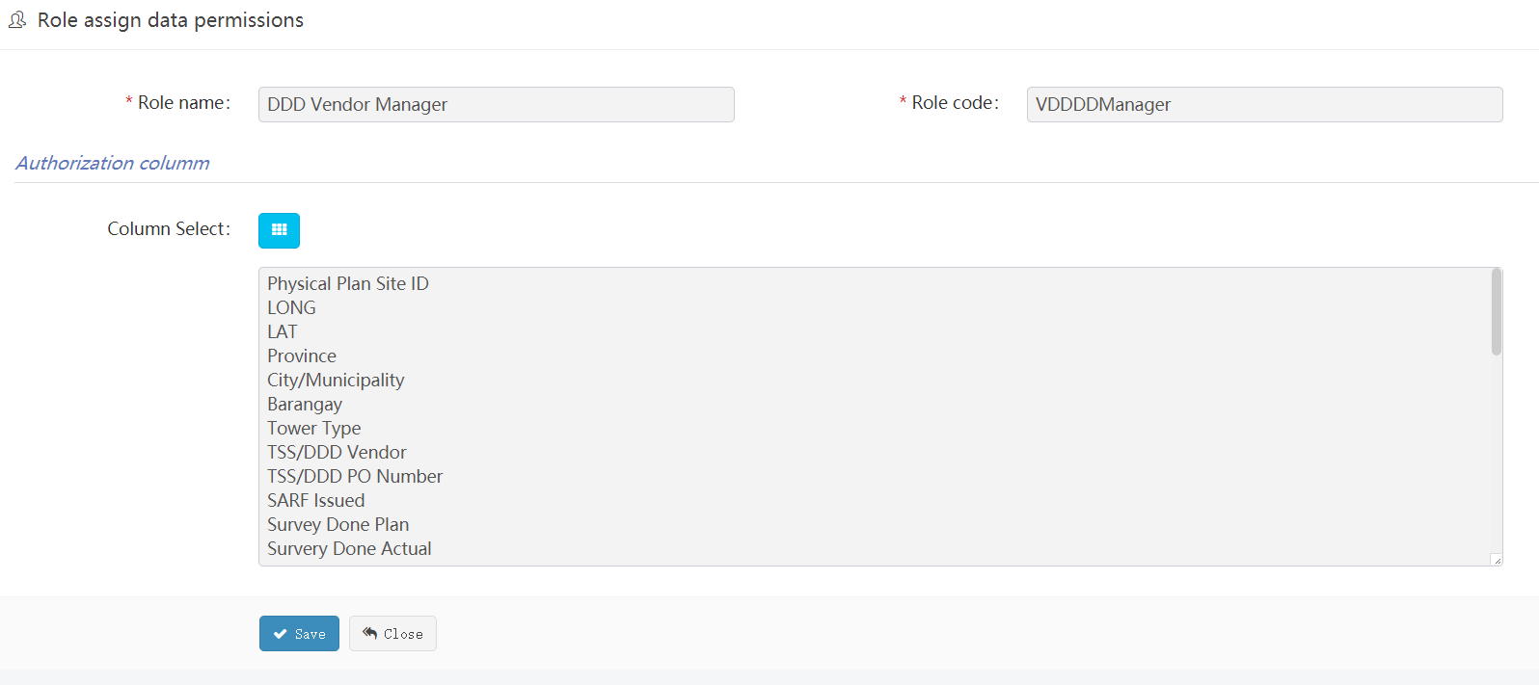

1. 角色对字段的权限，主要生效在SAQ task功能中，不同的角色进入该菜单后只能看到给他分配的字段，界面可选的字段筛选范围也仅限于这些字段。

The permissions of roles on fields are mainly effective in the SAQ task function. After entering the menu, different roles can only see the fields assigned to them, and the optional field filtering range in the interface is limited to these fields.

1. 每个角色都要分配字段，否则该角色下用户登录后，只能默认看到site id一列字段。

Each role must be assigned a field. Otherwise, users in this role can only see the field of site ID by default after logging in.

#### Area manager

系统基础功能，无需维护。

Basic functions of the system, no maintenance required.

#### Office manager

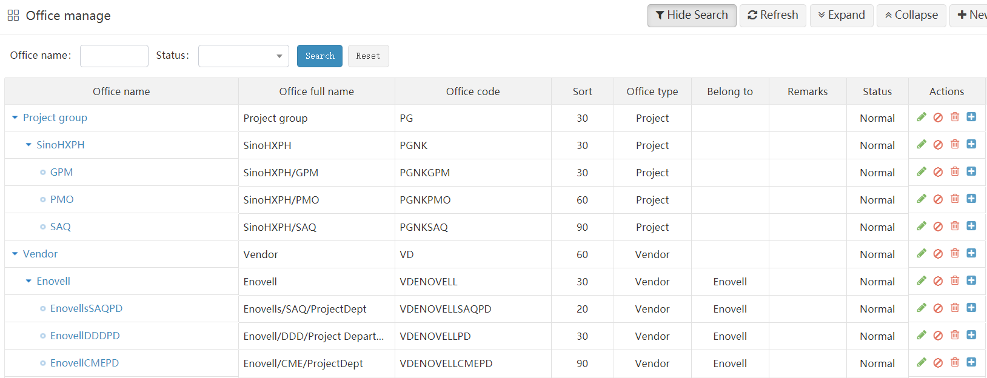

1. 属于系统基础功能。

It belongs to the basic function of the system

1. 当有新增部门时需要维护。比如新增项目组下属部门、新增分包商等。

It needs to be maintained when there is a new department. For example, add subordinate departments of the project team, add vendors, etc

1. 新增编辑时下面字段需要注意：

Note the following fields when adding and editing

* 1. Office type：这个分类对应 This category corresponds to

Project –> 项目组

Vendor–> 分包商

Owner –> 业主

* 1. 如果Parent office 和Office type均是Vendor，则会自动弹出Vendor选择下拉框供选择，必须选一个对应的分包商。

If both Parent office and Office type are Vendor, the Vendorselection drop-down box will pop up automatically for selection. You must select a corresponding vendor.

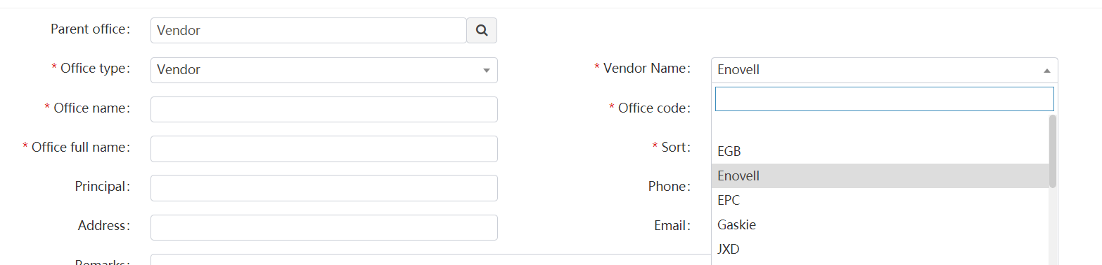

当某个分包商用户归属于这个office后，该用户就属于这个分包商下属用户，在基站权限中会用到。

When a vendor user belongs to this office, the user belongs to the vendor's subordinate users, which will be used in the site permissions.

* **举例：新建分包商公司步骤**

**Example: steps for creating a new vendor company**

* 进入菜单：“System mgt”-> “System setting” -> “Office manage”，点击上面的new按钮

Enter menu：“System mgt”-> “System setting” -> “Office manage”，Click the new button above

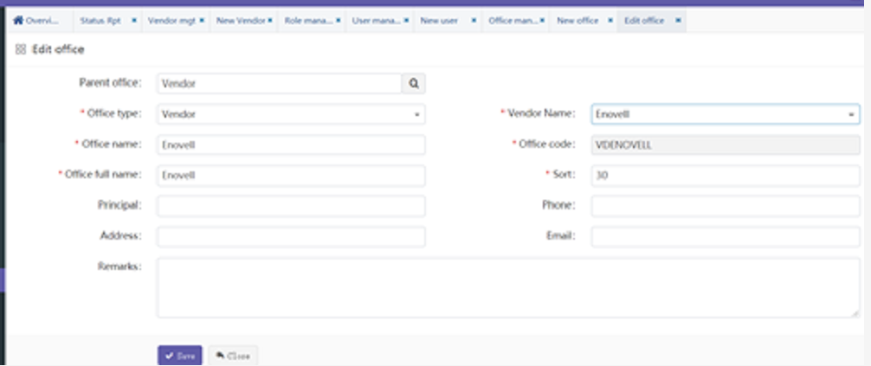

* 选择Parent Office，因为是分包商，所以必选选择Vendor，如下图：

Select Parent Office, because it is a vendor, it is required to select vendor, as shown in the following figure:

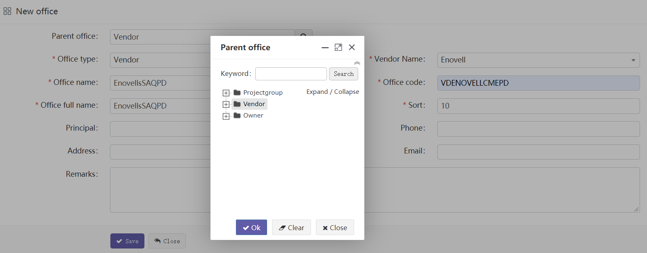

* 选择Office Type，同样必须选Vendor

select Office Type, you must also select vendor

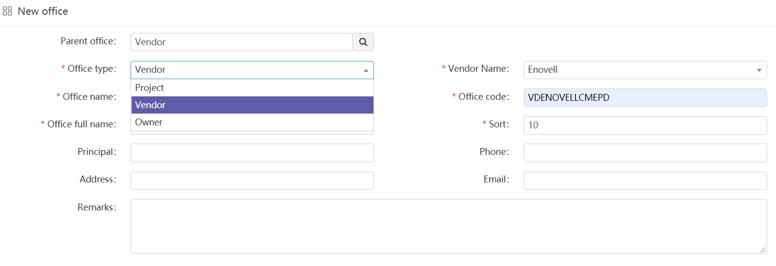

* 选择Vendor Name，下拉框选之前新建的分包商：Enovell。

Select Vendor Name，Select the newly created Subcontractor from the drop-down box: Enovell

* 输入Office Name，此处输入分包商名称：Enovell，表示分包商公司名称。

Enter Office Name. Here, enter the vendor Name: Enovell, indicating the vendor company name.

* 输入Office Full Name，分包商公司全称，同上即可。

Enter Office Full Name, the full name of the vendor, as above

* 输入Office Code，这里是唯一编号，按规则：VD+名称，如：VDENOVELL，字母全部大写。

Enter the Office Code. Here is the unique number. According to the rule: VD + name, such as VDENOVELL, all letters are capitalized

* 输入Sort，排序。在所有涉及到的页面中，此分包商与其他分包商显示时的排序顺序，从小到大升序。

Enter Sort to sort. In all involved pages, the sorting order between this vendor and other vendors is ascending from small to large

* 其他输入可选。

Other inputs are optional.

* **举例：新建分包商部门步骤**

**Example: creating a vendor Department**

* 进入菜单：“System mgt”-> “System setting” -> “Office manage”，点击上面的new按钮

Enter the menu: “System mgt”-> “System setting” -> “Office manage”，, and click the new button above

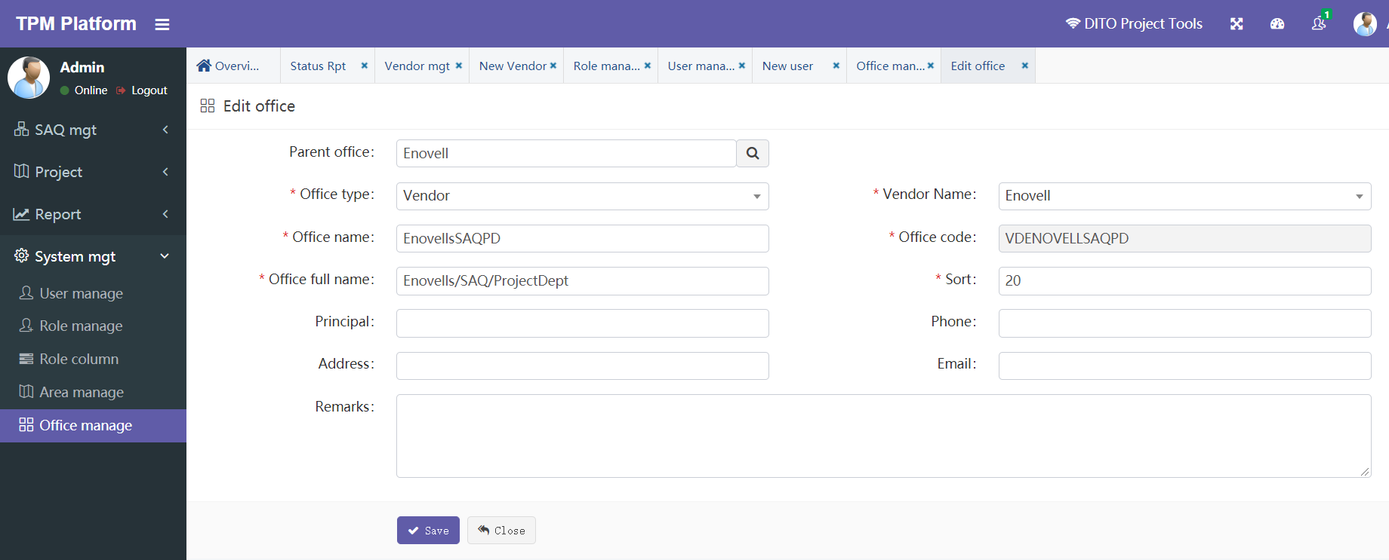

* 选择Parent Office，此处选择刚才建立的分包商公司Enovell，如下图：

Select Parent Office, and here select Enovell, the vendor company just established, as shown in the following figure:



* 选择Office Type，同样必须选Vendor

select Office Type you must also select vendor



* 选择Vendor Name，下拉框选之前新建的分包商：Enovell。

Select Vendor Name and select the previously created vendor: Enovell from the drop-down box

* 输入Office Name，此处输入分包商部门名称：EnovellsSAQPD，命名规则：分包商名称+类型+部门简称。‘SAQ’表示分类SAQ部门。‘PD’表示工程部

Enter the Office Name. Here, enter the vendor Department Name: EnovellsSAQPD. Naming rules: Subcontractor name + type + Department abbreviation‘ SAQ 'indicates the Classification Department‘ PD 'means Engineering Department

* 输入Office Full Name，分包商部门全称：Enovells/SAQ/ProjectDept，命名规则：分包商名称/类型/部门。

Enter Office Full Name, full name of vendor Department: Enovells/SAQ/ProjectDept, naming rule: Subcontractor name/type/department.

* 输入Office Code，这里是唯一编号：VDENOVELLSAQPD，按规则：VD+名称+类型+部门简称，字母全部大写。

Enter the Office Code. Here is the unique number: VDENOVELLSAQPD. According to the rule: VD + name + type + Department abbreviation, all letters are capitalized.

* 输入Sort，排序。在该分包商下所有部门的排序顺序，从小到大升序。

Enter Sort to sort. The order of all departments under the Subcontractor is ascending from small to large.

* 其他输入可选。

Other inputs are optional.

# APP - Acceptance

验收APP是用户去基站建设现场需要在手机端事先安装的APP。

Acceptance APP is the APP that users need to install on the mobile terminal in advance when they go to the site construction site.

## APP Install (Android)

在Android端浏览器中输入以下网址：

Enter the following web address in the Android browser:

<https://www.pgyer.com/9z5M>

（建议：QQ浏览器、UC浏览器）

(suggestion: QQ browser, UC browser)

会出现以下安装界面：

The following installation interface will appear:



然后直接点安装即可。

Then click to install directly.

## APP Install(IOS)

### IOS正常安装 Normal Install

在苹果Safari浏览器中输入如下网址：

Enter the following URL in Apple Safari browser:

<https://www.pgyer.com/IOkc>

会出现以下安装界面：

The following installation interface will appear:



### IOS Security setting

* **如点安装按钮后可能会出现如下提示：**

**If you click the Install button, the following prompts may appear:**

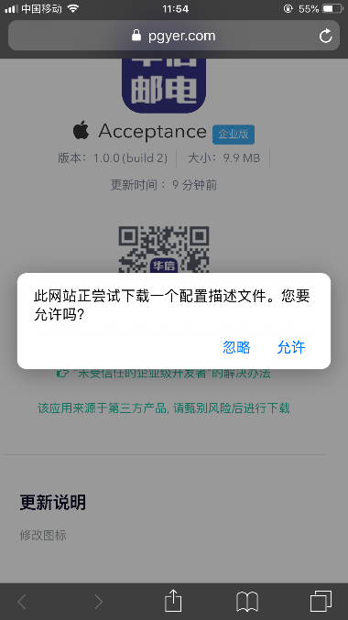

直接点击“允许”。

Click "allow" directly.

* **如果安装过程中出现如下提示：（需要在苹果手机中设置信任该APP）**

**If the following prompts appear during the installation: (you need to set up the trust app in the Apple phone)**



点击“信任开发者”，正常界面会跳转到设备管理：

Click "信任开发者", and the normal interface will jump to device management:

进入“TNB…….”设备管理，点击信任，

Enter "TNB......" Device management, click trust,

如果成功会出现如下界面，“已验证”表示该APP可以正常运行。

If successful, the following interface will appear, "verified" indicates that the app can operate normally.

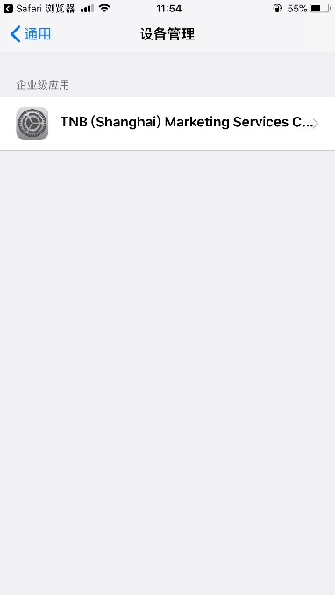 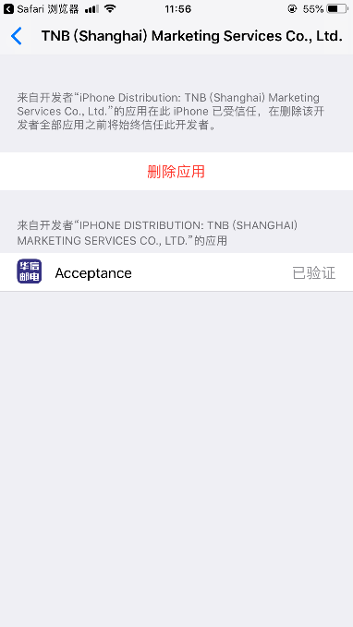

* **如果安装过程中没有自动跳转到信任设置，则可以手工设置：**

**If you do not automatically jump to the trust setting during installation, you can set it manually:**

依次从：“设置”-“通用”-“设备管理”来设置

Set from "Settings" - "general" - "device management"

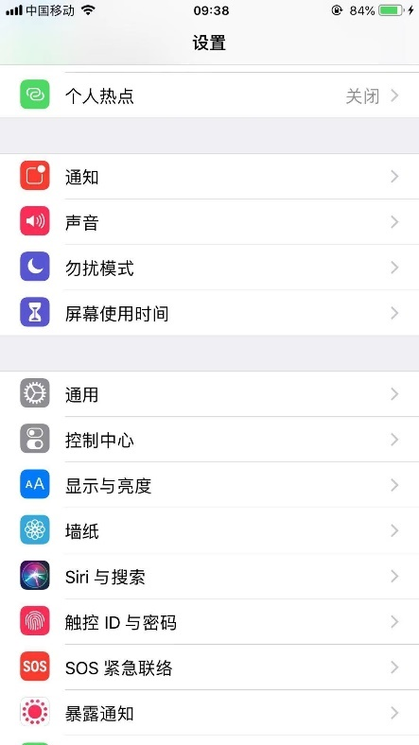 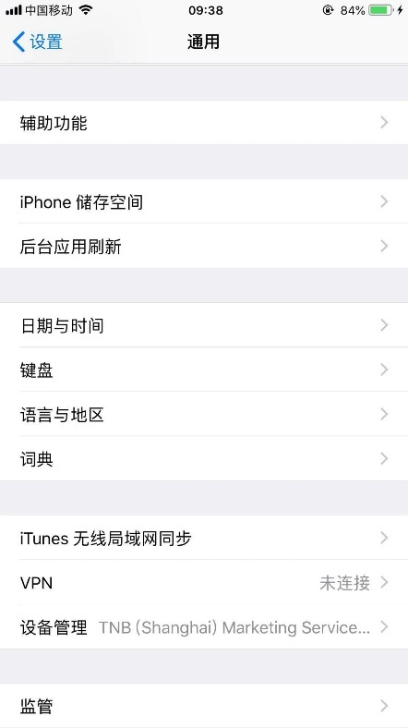

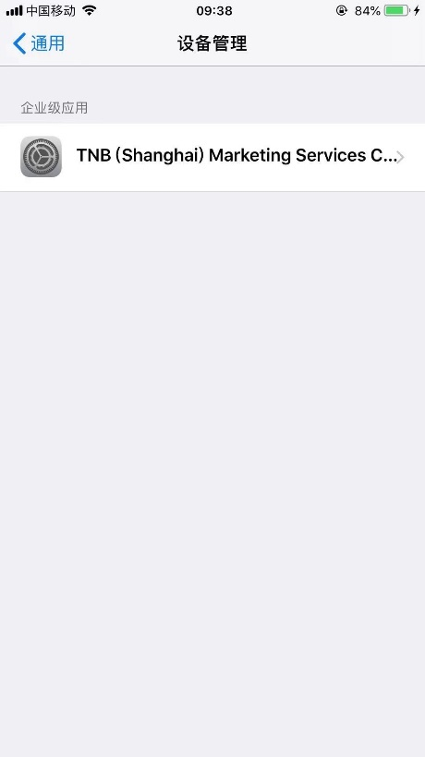 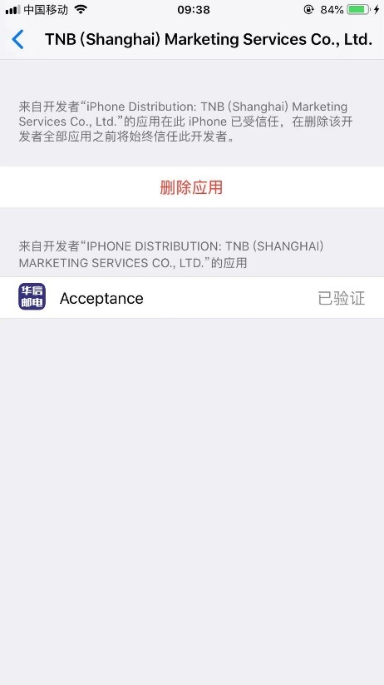

## APPUser manual

|  |  |
| --- | --- |
| * **登录：**   使用前面设置的APP用户账号登录。   * **Sign in:**   Log in with the app user account set above. | C:\Users\Administrator\AppData\Local\Microsoft\Windows\INetCache\Content.Word\01.jpg |

|  |  |
| --- | --- |
| * **登录后主界面：**  1. 第一次登录成功后，可点击按钮“Download all image”下载最新的全部已上传图片和示例图片。 2. 点击中间原形按钮可进入：基站/二级目录/三级目录/上传页面 3. 按钮“Upload offline image”，是将没有网络状态下保存在本地的离线图片在有网络情况下上传到服务器。离线图片不会自动上传，需要此处手工上传。  * **Main interface after login：**  1. After the first login is successful, you can click the button "Download all image" to download all the latest uploaded pictures and sample pictures. 2. Click the middle prototype button to enter: Site / secondary directory / tertiary directory / upload page 3. The button "upload offline image" is to upload the offline image saved locally without network status to the server when there is network. Offline pictures will not be uploaded automatically. You need to upload them manually here. |  |

|  |  |
| --- | --- |
| * **基站选择界面：**  1. 基站选择界面下拉也可以刷新全部数据。 2. （0/13/10）分别：   0：表示离线图片数量  13：表示已上传文件数量(含图片和文档)  10：表示模板规定需上传的文件数量。   1. 状态分别：   To be uploaded：待上传  To be reviewed：待审核  Accepted：审核通过  Rejected：审核不通过   * **Site List:**  1. All data can also be refreshed from the drop-down of the site selection interface. 2. (0 / 13 / 10) respectively:   0: indicates the number of offline pictures  13: Indicates the number of uploaded files (including pictures and documents)  10: Indicates the number of files to be uploaded specified in the template.   1. Status:   To be uploaded  To be reviewed  Accepted  Rejected |  |

|  |  |
| --- | --- |
| * **二级目录选择界面：**  1. （0/13/10）分别：   0：表示离线图片数量  13：表示已上传文件数量(含图片和文档)  10：表示模板规定需上传的文件数量。   1. 状态分别：   To be uploaded：待上传  To be reviewed：待审核  Accepted：审核通过  Rejected：审核不通过   1. 按钮“Submit to approve”表示将当前基站整个递交审核。只有状态是：“To be uploaded”和“Rejected”才可以递交，否则按钮灰色。  * **Secondary level catalog：**  1. (0 / 13 / 10) respectively:   0: indicates the number of offline pictures  13: Indicates the number of uploaded files (including pictures and documents)  10: Indicates the number of files to be uploaded specified in the template.   1. Status:   To be uploaded  To be reviewed  Accepted  Rejected   1. The button "submit to approve" means to submit the whole current Site for approval. Only "to be uploaded" and "rejected" can be submitted, otherwise the button is gray. |  |

|  |  |
| --- | --- |
| * **三级目录选择界面：**  1. （0/13/10）分别：   0：表示离线图片数量  13：表示已上传文件数量(含图片和文档)  10：表示模板规定需上传的文件数量。   1. 状态分别：   To be uploaded：待上传  To be reviewed：待审核  Accepted：审核通过  Rejected：审核不通过   1. 按钮“Submit to approve”表示将当前二级目录整个递交审核。只有状态是：“To be uploaded”和“Rejected”才可以递交，否则按钮灰色。  * **Third level catalog：**  1. (0 / 13 / 10) respectively:   0: indicates the number of offline pictures  13: Indicates the number of uploaded files (including pictures and documents)  10: Indicates the number of files to be uploaded specified in the template.   1. Status:   To be uploaded  To be reviewed  Accepted  Rejected   1. The button "submit to approve" means to submit the entire current secondary directory for approval. Only "to be uploaded" and "rejected" can be submitted, otherwise the button is gray. |  |

|  |  |
| --- | --- |
| * **上传界面：**  1. 点击可上传图片，分别可以拍照上传或者从相册选择上传。 2. 如果长时间未上传成功，可能是网络原因，可以取消后再传。 3. 按钮“Submit to approve”表示将当前三级目录递交审核。只有状态是：“To be uploaded”和“Rejected”才可以递交，否则按钮灰色。同时也只有这两个状态才能上传图片，否则不可以上传。  * **Upload Pictures：**  1. Clickto upload pic，You can take photos to upload or choose to upload from the album. 2. If the upload is not successful for a long time, it may be due to the network. You can cancel and then transfer it。 3. Button“Submit to approve”Indicates that the current three-level directory will be submitted for approval. Only "to be uploaded" and "rejected" can be submitted, otherwise the button is gray. At the same time, only these two statuses can upload pictures, otherwise they cannot be uploaded. |  |
| * **离线上传保存到本地：**  1. 离线情况下上传后会出现右图的黑色提示框，表示已成功。黑框后续会改掉。当前调试暂时保留。 2. 成功后该图片会如下图所示，有红字： no upload。表示离线图片。  * **Offline upload and save to local：**  1. When uploading offline, the black prompt box in the right figure will appear, indicating that it has been successfully uploaded. The black frame will be changed later. Current debugging is temporarily reserved.。 2. After success, the picture will be as shown in the figure below, with red characters: no upload。Represents an offline picture。 | C:\Users\Administrator\AppData\Local\Microsoft\Windows\INetCache\Content.Word\60.jpg |
| * **离线上传到服务器：**  1. 点击按钮“Upload offline image”。APP将没有网络状态下保存在本地的离线图片在有网络情况下上传到服务器。离线图片不会自动上传，需要此处手工上传。 2. 成功后会有提示。  * **Upload offline image：**  1. Click the button "upload offline image". App uploads offline pictures saved locally without network status to the server when there is network. Offline pictures will not be uploaded automatically. You need to upload them manually here. 2. There will be a prompt after success. |  |